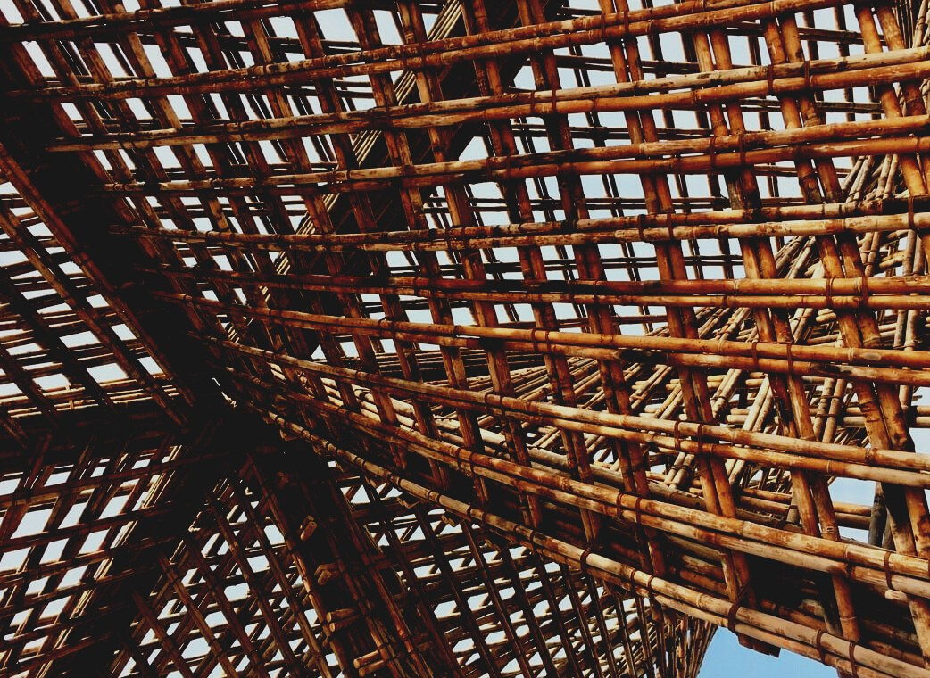

ASSESSMENT MATERIAL

Learning Unit 2
RESTORATION, RECONSTRUCTION AND DISMANTLING
UPWOOD
Up-skilling construction workers in wood construction methods for energy-efficient buildings

UPWOOD-PUU
Rakennustyöläisten ammattitaito energiatehokkaiden rakennusten puurakentamisenmenetelmissä

Table of contents
1. Frequently asked questions 2
2. Multiple choice questions 3
3. Case studies 3
3.1 Case study 1 3

Frequently asked questions
Question: What does a renovation mean?
Answer: Improving the quality level and functionality of the building.
Question: What does reconstruction mean?
Answer: Reconstruction or completion of a building or surface treatment based on preserved documents.

Multiple choice questions
- Wood is suitable for renovation
  - due to its fast and dry construction method, easy fastening and lightness of the material.
  - because it is affortable, complies with sustainable development and it prevents wind and thus unpleasant tonnage in the house.
  - as it is easy to handle regardless of the seasons.
- If unidentified material is found at the site in connection with the demolition work,
  - the authorities must be alerted to the site and the work is suspended.
  - the demolition work is suspended, the is material is identified and dismantled as required by the substances it contains.
  - the demolition work can continue according to plan.

Case studies

Case study 1
Forests affect the earth’s climate. Carbon comes from atmospheric carbon dioxide which is why the world’s forests act as a major carbon sink and curb greenhouse effects and global warming. Carbon is committed not only to trees but also to wood products and structures. For example, a log house can store carbon for up to several hundred years. Environmental efficiency and life-cycle economy do not yet have a decisive influence on construction decision-making. Consider and present possible reasons.

