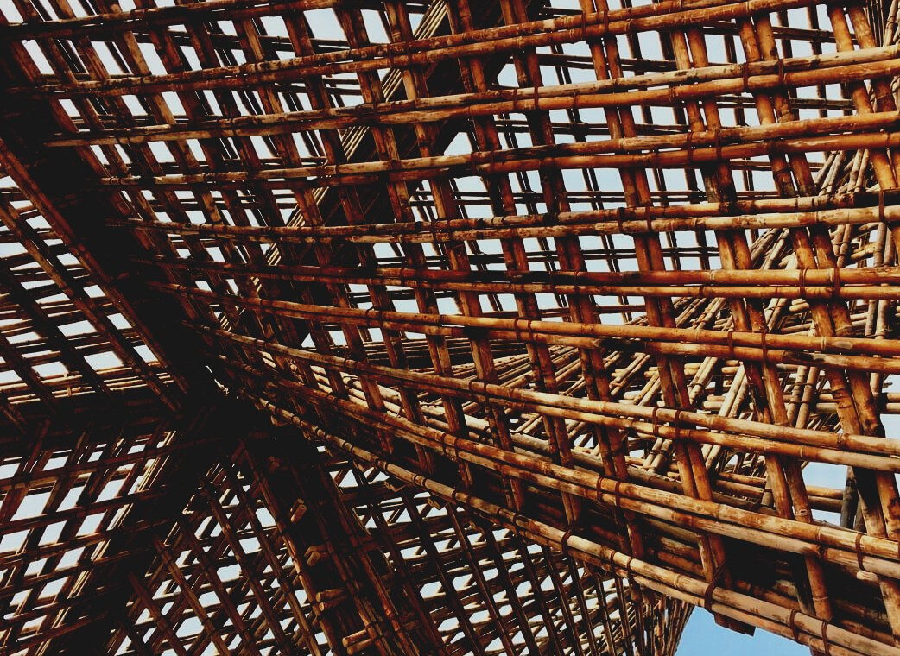

**TRAINING & ASSESSMENT**

**MATERIAL**

Learning Unit 1

Lesson 3: Availability and environmental friendliness of wood as building material.

UPWOOD

*Up-skilling construction workers in wood construction methods for energy-efficient buildings*

UPWOOD

*Up-skilling construction workers in wood construction methods for energy-efficient buildings*

*construction workers in wood construction methods for energy-efficient buildings*

*methods for energy-efficient buildings*

UPWOOD

*Up-skilling construction workers in wood construction methods for energy-efficient buildings*

*methods for energy-efficient buildings*

UPWOOD

*Up-skilling construction workers in wood construction methods for energy-efficient buildings*

*truction methods for energy-efficient buildings*

UPWOOD

*Up-skilling construction workers in wood construction methods for energy-efficient buildings*

*methods for energy-efficient buildings*

UPWOOD

*Up-skilling construction workers in wood construction methods for energy-efficient buildings*

*methods for energy-efficient buildings*

UPWOOD

*Up-skilling construction workers in wood construction methods for energy-efficient buildings*

*methods for energy-efficient buildings*

UPWOOD

*Up-skilling construction workers in wood construction methods for energy-efficient buildings*

**CONTENT**

1. INTRODUCTORY PARAGRAPH 2

2. LECTURE NOTES 3

2.1. The forest and sustainable forestry in partnership countries 3

2.2. Certification schemes in partnership countries 5

2.3. Wood species used as structural timber 5

2.4. Building structural materials – in general 6

2.5. Overview of glued wooden construction materials 9

2.5.1. Lumber-Based Timber Products 10

2.5.2. Wood Based Panels 12

2.5.2.1. Veneer-based materials 13

2.5.2.2. Particle-based materials 15

2.5.2.3. Fiber based materials 17

2.5.3. Wood based material properties (some of) 17

2.5.4. Combined wood-based materials 18

2.5.4.1 I Beams 19

2.5.4.2. Structural Insulated Panel 19

2.5.4.3. Honeycomb 19

2.5.4.4. DendroLight 20

2.5.4.5. Wood plastic composites 21

2.5.4.6. Structural Composite Lumber (SCL) 21

2.5.4.7. Parallel Strand Lumber 21

2.5.4.8. Laminated Strand Lumber (LSL) 22

2.5.5. Building panels systems 22

2.5.5.1. LIGNATUR 22

2.5.5.2. Kerto-Ripa® 23

2.5.5.3. LIGNO 23

2.5.5.4. KIELSTEG 23

3. LIST OF REFERENCES 24

# INTRODUCTORY PARAGRAPH

**One cubic meter of wood in its growing period absorbs a ton of harmful carbon dioxide and releases 0,7 tons of oxygen and it starts to work when timber has gained more than twenty years (Fig.1.48.) (**[www.lvm.lv](http://www.lvm.lv)**)**

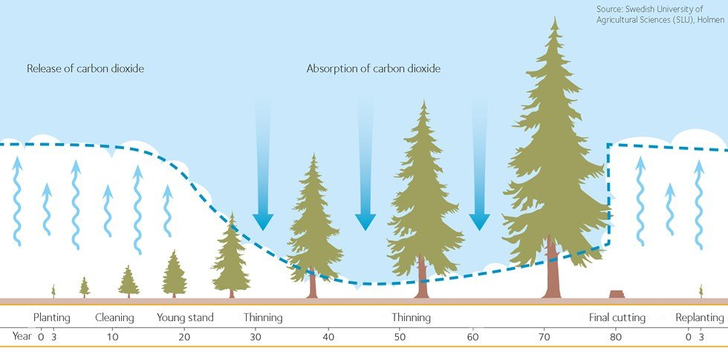

**Fig. 1.48. Carbon storage[1]**

If the wood products are used in buildings, the carbon is stored for a long time. The stored carbon is only released when the products are incinerated at the end of their life (Fig.1.49.).

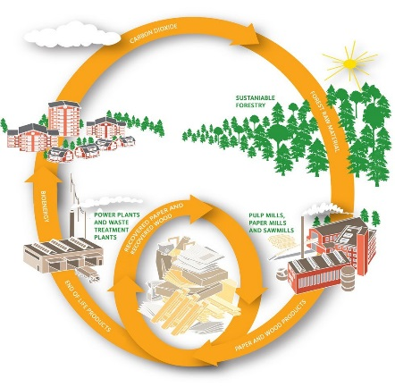

**Fig. 1.49.** **Wood’s natural eco-cycle[2]**

During incineration, the converted solar energy is released as heat, making the process entirely climate neutral. Directly after felling, the cleared area leaks carbon dioxide as needles and discarded branches decay. Once the new trees reach a little over 20 years old, they are able to absorb more carbon dioxide than is leaking from the ground. The trees are harvested in maturity and then processed into products that are able to replace products and energy sources that are harmful to the climate. Making use of the forest is therefore good for the climate.

The world`s most vital formula:

6H2O + 6CO2 + solar energy → C6H12O6 +n 6O2

If we ignore Mother Nature’s rules, we will be sadly disappointed to find that our buildings succumb to Father Time.

# LECTURE NOTES

## 2.1. The forest and sustainable forestry in partnership countries

**Austria** 

In Austria the forest land is approximately 3 878 000 ha and this is 46,2% of the land area or it is 0,5 ha per capita. Austria consists of nine federal provinces. The forest cover per province depends on territorial shape, agriculture and types of settlement and it extends from 32 to 60%. The total Austrian forest area can be classified as follows: private enterprises 65,1%; common forests 8,7%; forests owned by the church 4,2%; forests owned by communities and provinces 5,7%; federal forests 16,3%. Productive forests, that are commercial forests and protective forests in yield, represent 86% of the total forest area. The average growing stock of the productive forests is 292 m³ ha-1 and the total growing stock is 972 million m³. The yearly increment in productive stands is 31,4 million m³ and the yearly amount of felling is about 19,8 million m³.

Forest roads are made not only for logging, but are also required for silviculture, above all in protection forests. On the other hand, truck roads are also used for access to agricultural land and Alpine pastures as well as for tourism and other purposes (for example forest fire control).

Main tree species are: Norway spruce 59,8%; Beech 9,5%; Scots pine 6,2%; European larch 4,8%; Silver fir 2,6% and Oak 2,2%[3]

**Finland** Finland flag image - country flags

Finland is one of the world's most wood abundant countries and the most wooded country in Europe - 71,6%. Finland has the most forest per inhabitant at 4,6 ha. The total area of Finland’s forests is 26,3 million ha, 20,3 million ha of which is good forest land from a perspective of forestry. Of the total area of forests, swamp covers 9.1 million ha (34%).

The private sector owns 60% of the area of forests, the state 26% and the forest industry 9%. The remaining 5% is split between municipalities, parishes, forest collectives and other organisations.

For many years now, the annual growth of standing wood has exceeded 100 million m³. Trees only grow in Finland during the growing season, which lasts about 100 days. In the 2016 growing season, the growth in standing wood was 109,9 million m³, so the average daily growth was over 1 million m³. Main tree species are: scots pine 50%; Norway spruce 30% and hardwoods 20%[4]

**Greece** Greece flag icon - country flags

Forests cover 19% of the total area of the country. The forests land in Greece cover 6.5 million ha, of which 3.4 million ha are considered as productive forests. The majority of forest land in Greece are located in the mountainous areas of the country.

Forest management practices during the 20th century were focussed on the protection of soil and of water resources. However, the productivity of Greek forest coverage is lower compared to European average values. This is due to the low density, quality and quantity of growing stock. Timber production coming from state and non-state forests has fallen considerably during the last years. Softwoods represent 38% of forest land while the rest 62% is covered by hardwoods[5].

**Latvia** Latvia flag icon - country flags

Forests in Latvia take up 3,41 million ha of land or 53% of the country’s territory. The amount of forestland, moreover, is constantly expanding, both naturally and thanks to afforestation of infertile land and other land that is not used for agriculture. An average of approximately 11 million m³ of timber have been harvested each year in Latvia’s forests during the past decade. The yearly increment in productive stands is 25 million m³. In historical terms, the intensive use of Latvia’s forests for economic purposes began comparatively later than in many other European countries, and that has allowed us to preserve extensive biological diversity. Limitations on economic activity apply to 28,2% of Latvia’s forests at this time, and most of this territory is owned by the state. The Latvian state owns around one-half of the country’s forests, while most of the rest of the forest belongs to approximately 135,000 private owners. State-owned forests 49%, privately owned forestland 48% and local government owned and other forests 3%.

Main tree species are: Scots pine 33%; birch 30%, Norway spruce 19%; other hardwoods 18%[6].

**Spain** Spain flag icon - country flags

With 14,4 million ha of forest cover, Spain is the fourth country in Europe in terms of forest resources (following Finland, Sweden and France). Forests which occupy almost 29% of total area are increasing by about 86 000 ha per year, both through natural expansion and through the forest plantation programme, with soil protection and erosion prevention as its main aims. Spanish forest administration has been highly decentralized, inasmuch as the 17 autonomous communities are in charge of forests and forestry activities. 66% of forest lands belong to about 2 million owners, 30% to municipalities and only 4% to the autonomous communities. About 25% of forests belong to the category of protected areas. The main function of 88% of Spanish forests is that of protection against soil erosion and desertification, and regulation of the hydrological cycle, in a country with steep slopes and scant, irregular rainfall. The remaining 12% are mainly production forests (80% of the total supply of roundwood). Non-wood forest products such as cork, gum and medicinal and aromatic plants are also important. The most productive forests are found in the Atlantic coastal zone and are composed mostly of pines (*Pinus pinaster* and *P. radiata*) and eucalyptus (*Eucalyptus globulus*), although some mixed natural forests of oak (*Quercus robur* and *Q. patraea*) and beech (*Fagus sylvatica*). In the Pyrenees, there are forests of silver fir (*Abies alba*), beech and pine[7]

## 2.2. Certification schemes in partnership countries

The two systems used in all five countries are Forest Stewardship Council (FSC) and Programme for the Endorsement of Forest Certification (PEFC).

**Forest Stewardship Council **

FSC is an independent, non-governmental organization established to promote responsible management of the world’s forests and is probably the most well-known forest certification program worldwide. The FSC program includes two types of certifications:

* Forest Management Certification applies FSC standards of responsible forestry to management of the forest land.
* Chain-of-Custody (COC) certification ensures that forest products that carry the FSC label can be tracked back to the certified forest from which they came.

COC certifications are in use by FSC members. The FSC has certified certification bodies around the world[8]

**Programme for the Endorsement of Forest Certification **

The multitude of certification programs with competing standards and claims has made it difficult for land managers, members of the wood industry, and consumers to determine which certification program fits their needs. The Programme for the Endorsement of Forest Certification scheme was developed to address this issue and serves as an umbrella endorsement system that provides international recognition for national forest certification programs.

Founded in 1999, the PEFC represents most of the world’s certified forest programs and the production of millions of tons of certified timber[9].

Helpful resource is the Forest Products Annual Market Review[10] which provides general and statistical information on forest products markets in the United Nations Economic Commission for Europe (UNECE) and covers the regions of Europe, North America and the Commonwealth of Independent States.

In order to ensure that no one uses illegally felled wood, the EU has voted on a law against trade in such wood, known as the Timber Regulation[11].

## 2.3. Wood species used as structural timber

|  |  |  |
| --- | --- | --- |
| **Scots pine** (*Pinus silvestris* L.) wood has clearly visible annuals and is clear distinguishable heartwood wood from sapwood. Due to its resiness, pine wood is durable and well resistant to moisture. It is soft, straight, with a shine, smells like resin, resistant to rot, easily cleaved, well treated with various cutting tools. There are no pines growing closely together in the forest - in the trunk of the trunk branches, so pine wood is best for buildings, bridges and other wooden engineering structures in construction. Sawn timber is used in mechanical engineering, construction, shipbuilding, aviation and furniture industry. Needle extract is obtained from pine needles, but dry distillation is obtained from stumps resulting in turpentine, wood tar and charcoal. In addition, pine wood is used as raw materials for the production of plywood, pulp, fibrolite, particle and fibre boards. | Scots pine tree package – released - Unity Forum | |
| **Norway spruce** (*Pices abies* L. H. Karst.) wood is softer than pine wood. Stem cross section of the year rings for it clearly visible, more developed early wood, the transition to late wood is gradual. Spruce is less resinous than pine, although it is sometimes found in wood weakening resin sockets. Compared to pine wood, spruce wood is softer, less so resistant to rot, poorer absorption of antiseptics, difficult to handle due to hard twigs. Round timber is used for ship and radio masts, piles, bridges and hydraulic structures elements, mine supports. Sawn timber is used in the furniture industry, music for the manufacture of tools, boxes and railway sleepers. Spruce wood is the main raw material pulp industry. Spruce needles and bark are useful as raw materials for the chemical industry; weaves are made from the roots. The share of spruce wood use has been growing rapidly in recent years. | Norway Spruce PNG Images & PSDs for Download | PixelSquid - S105796714 | |
| **Oak** (*Quercus robur* L.) heartwood is large, sharply separated from the sapwood. Wood coarse, hard, resistant to rot in air, ground and water. Oak is good for bending and mechanical processing, it has a beautiful colour and texture. Oak wood contains tannins that protect it from exposure to tiny creatures and, when stored in water, turns into black oak over time. Black oak the wood is superior to ordinary oak wood. It is very popular in the furniture industry and parquet manufacturing. Black oak wood in combination with lighter wood is used in marquetry, but together with metal and amber - inlaid. Oak wood is also used in the construction of wagons and agricultural machinery, veneered wood based panels in the manufacture of barrels and curved fittings, windows and doors, in particular exterior doors. | Oak Tree PNG & PSD Images | | | | |
| **Larch** (*Larix* Mill.) heartwood is large, pinkish brown, sharply separated from the sapwood. The sludge is narrow, white or yellowish white. The seasons are clearly visible in all sections. The wood is hard, resistant to crushing, easy to break, but difficult to machine. When you smoke, smoke unequally in the radial and tangential directions, hence the velvet and crack. Used similarly to pine, but especially recommended in hydraulic structures. | European Larch Tree | Northwest garden, Larch tree, Tree | | |
| ***Birch*** (*Betula…* L.) heartwood tends to be a light reddish brown, with nearly white sapwood. Occasionally figured pieces are available with a wide, shallow curl similar to the curl found in Cherry. There is virtually no color distinction between annual growth rings, giving Birch a somewhat dull, uniform appearance. | | White Birch Tree PNG Transparent White B #1362559 - PNG Images - PNGio | | |

## 2.4. Building structural materials – in general

For successful woodworking (construction sector included), we must learn the natural properties of the material we use and design structures around known properties of wood. To construct adequate housing, for future generations, we seek sustainable construction methods with the minimum effect on the environment.

There are many sound reasons to turn to wood as the preferred building material of the 21st Century:

* wood is renewable and costless to produce than steel and concrete,
* wood stores carbon, doesn`t requires huge amounts energy for production,
* wood has great acoustic and thermal properties,
* wood construction technologies are enabling the tall and modern buildings,
* protected wood will last for hundreds of years and can be repaired, refinished and recycled,
* the waste from production is also useable for wood-based panels production or many others,
* once the service live of wood is finished, it is 100% biodegradable and can be used as a fuel.

Generally, the 3 most commonly used construction materials are **steel, concrete and timber/wood**.

|  |  |  |
| --- | --- | --- |
| ***Reinforced Concrete*** makes it possible to design very robust and durable buildingsand taking advantage of its thermal mass by keeping it inside the building envelope can help regulate interior temperatures. There is also an increasing use of precast concrete in the building industry, which offers advantages in terms of environmental impact, cost and speed of construction. **It** is extremely strong in compression and therefore has high compressive strength of about 17 up to 70 MPa. | Fiber-Reinforced Concrete | CivilDigital | | [12] |

Advantages:

* compression and tensile strength;
* fire resistance;
* durability;
* in structure like footings, dams, piers etc. reinforced concrete is the most economical construction material;
* user-friendliness.

Disadvantages:

* long-term storage;
* curing time;
* cost of forms;
* shrinkage (causes crack development and strength loss).

|  |  |  |
| --- | --- | --- |
| ***Structural Steel*** stands out for its speed and efficiency in construction. It's relative light weight and ease of construction allows for a workforce about 10 to 20% smaller compared to a similar concrete-based structure being built. Steel has an ultimate strength of about 400 to 500 MPa. It is also a ductile material that yields or deflects before failure. | UPB Group - From agreement until completion in 13th months | Facebook | [13] |

Advantages:

* steel has a high strength/weight ratio;
* ductility;
* speed of erection;
* ease of repair;
* repetitive use;
* expanding existing structures.

Disadvantages:

* general cost;
* fireproofing;
* maintenance.

|  |  |  |
| --- | --- | --- |
| ***Structural timber*** is much lighter by volume than both concrete and steel, it is easy to work with and very adaptable on site. Results in less thermal bridging than its counterparts and easily incorporates prefabricated elements. Its structural performance is very high and its compressive strength in fiber direction is similar to that of concrete. Tensile strength is also one of the main reasons for choosing timber as a building material. | Peilāns: We plan to develop large-sized wooden construction in Latvia and  around Europe | [14] |

Advantages:

* tensile strength in fiber direction;
* electrical and heat resistance;
* sound absorption;
* locally sourced;
* environmentally friendly.

Disadvantages:

* shrinkage and swelling;
* wood is a hygroscopic material;
* endurable (biological, non-biological) agents if not protected.

Embodied energy refers to the quantity of energy required to harvest, mine, manufacture, and transport to the point of use a material or product. Wood, a material that requires a minimal amount of energy-based processing, has a low level of embodied energy relative to many other materials used in construction (steel, concrete, aluminium or plastic). All the construction materials produced by these processes generate substantial carbon emissions (Fig.1.50.), therefore have a positive carbon footprint[15]

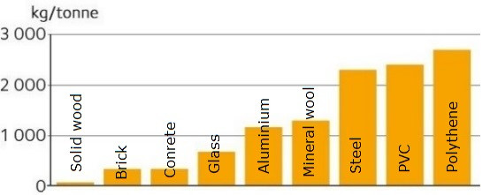

**Fig. 1.50. Carbon emission from manufacture of construction materials**15

New standards are currently being drawn up as a mean of assessing a building’s environmental impact. The standards for life cycle analyses ISO 14040, ISO 14044 and ISO 14025 describe how to transfer the results from the life cycle analysis to an Environmental Product Declaration.

Product Category Rules (PCR) setting out how to draw up an Environmental Product Declaration are governed by EN 15804 for building products. EN 15978 specifies the calculation method, based on a life cycle analysis that is used to assess the environmental performance of the whole building.

Green building is defined as the practice of increasing the efficiency with which buildings use resources while reducing building impacts on human health and the environment - through better siting, design, material selection, construction, operation, maintenance and removal - over the complete building life cycle.

## 2.5. Overview of glued wooden construction materials

Wood-based materials are divided into two main groups:

* solid wood materials
* wood-based panel (WBP).

Solid wood materials are made of round wood, divided into longitudinal or cross to grain directions. Wood based panels are made by peeling, chopping solid wood and joining chopped wood elements with adhesives. As bonding elements can be the wood's own bonding forces or additional adhesives. In order to improve various properties, fire protection products, protection products against the effects of high humidity, or products for improving special properties can be added (Fig.1.51.).

Content of

Wood Based Materials

Wood or other wooden - materials such as straw, reeds

Adhesives

* synthetic adhesives urea (formaldehyde resin); phenol formaldehyde resin; isocyanate adhesives
* mineral adhesives;
* glue derived from wood components (lignin, tannins etc.)

Additives

* wax
* wood protection products protectors against ignition
* other additives (paints etc.)

**Fig. 1.51. Content of components of the Wood Based Materials.**

Different wood-based panels have different requirements for wood quality (Fig.1.52.). The requirements for wood quality increase as the degree of shredding decreases. For glued solid wood and glued plywood, they are significantly higher than for particle and fiber panels.

Wood materials

Materials from

Solid wood

* Glued Laminated Timber (GLT)
* Cross Laminated Timber (CLT)
* Solid wood boards

Materials form

Veneers

* Plywood
* Laminated Veneer Lumber (LVL)
* Parallam

Materials from

Chips

* Wood Particle Board
* Orientated Strand board (OSB)
* Scrimber;  
  Laminated Strand Lumber (LSL)

Combined materials

* I-beams
* Wood construction board
* Lightweight stabilised block board panels

Materials from

Fibers

* Wood Fiber Boards for Insulation (LDF)
* Middle Density Fiber Boards (MDF)
* High Density Fiber Boards (HDF)

**Fig. 1.52. Classification of Wood materials and Wood Based Panels** (Kruse K. and Venschott D., 2001)

### 2.5.1. Lumber-Based Timber Products

In order to make glued timber construction materials, the wood is first divided into structural elements of different sizes.

Solid wood-based materials began to be widely used in the late 1980s. The driving force behind this development was the growing demand for wood as an ecological building material. Classification of solid wood base structural materials is given in figure 1.53.

Lumber based materials

Panel type

* Single layer
* Multi-layer

Lumber type

* Glued solid wood
* Glued wood lamellas

Jointed type

* Beams with holes
* Combine with sound or thermal insulation

**Fig. 1.53. Classification of solid wood base structural materials.**

Depending on the size of the structural elements, the properties of the manufactured materials are changed significantly (Fig.1.54.). The properties of glued timber construction materials can vary over a very wide range depending on the structure. Compared to solid wood, these materials have a longer length, higher shape stability (no cracks or deformations due to changes in humidity).

|  |  |  |
| --- | --- | --- |
| Property/ Characteristic | Solid Wood | Glued Structural Timber |
| strength |  | |
| thermal insulation |  | |
| surface quality |  | |
| homogeneous |  | |
| isotropy |  | |
| energy consumption |  | |
| environmental impact |  | |

**Fig. 1.54. Influence of the size of structural elements on the material properties of glued wood structures (from sawn timber to wood fiber board** (Feller 1999).

In this learning unit we will look at some examples of solid wood glued building elements included in this group, the use of which will be discussed in other learning units. Construction panels or Cross laminated timber (CLT) has been shown in LU2. Just to add these panels could be made without glue - by nailing or doweling, which are not considered classic CLT panels (Fig.1.55.A and B).

|  |  |  |
| --- | --- | --- |
|  |  | http://media.treehugger.com/assets/images/2011/11/iclt_section.jpg.650x0_q70_crop-smart.jpg |
| A (Gong M.) | B (Gong M.) | C**[16]** |

**Fig. 1.55. Glue-less laminated timber panels:** A- nailed; B- dowelled; self-stressed.

Another type of solid wood panels, which is not made of glue, the swelling force of wood, has been scientifically confirmed. No practical application has been found for this type of panel at present (Fig.1.55.C). In the formation of glued beams, all layers are oriented in one direction after the years, except for the last one, which is turned in the opposite direction. When creating single-layer solid wood panels, the direction of the annual orientation of each board must be observed in order (Fig.1.56.) to ensure the stability of the board shape.

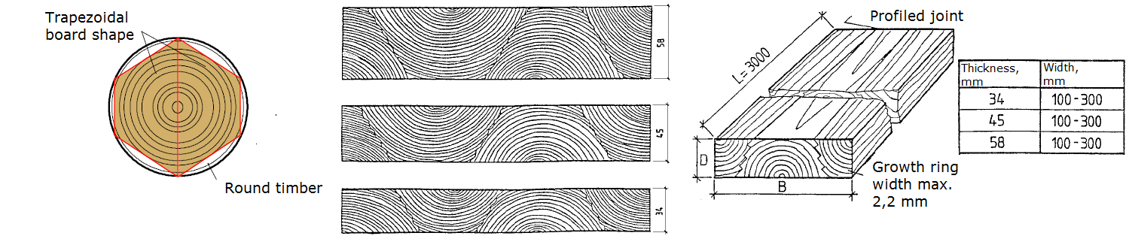

**Fig. 1.56. Use of trapezoidal boards in shaped solid wood panels[17]**

Beam elements so far have been used very widely in building constructions. These building elements, similar to the wooden building panels discussed above, can be glued, nailed and even screwed. Beams with holes in the middle of beam can be made of small diameter round wood (Fig.1.57.). Sometimes the holes are filled with sand to improve sound insulation or with insulation materials - wood fiber materials to improve thermal insulation.

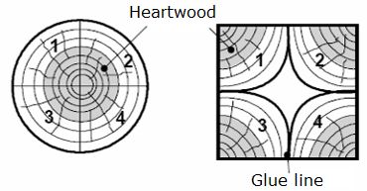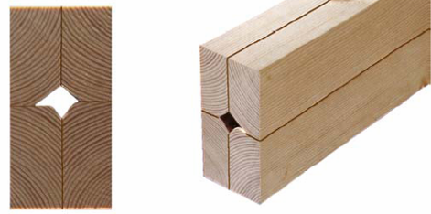

**Fig. 1.57. Small diameter roundwood for beam production[18]**

Technologically - round wood is divided into 4 segments and before joining with glue, prepares the contact surfaces.

A beam with an optimal rectangular cross-section is obtained. Requirements for the creation of these materials:

* wood of quality and strength of wood must be used in the outer layers,
* a finger joint is used to connect individual elements in length, stick joint in some places allowed,
* odd layers form symmetrical with respect to the central-neutral axis of the material,
* the location of the growth rings in sticking layers must be compensating.

### 2.5.2. Wood Based Panels

Advantages of wood-based panels (WBP) include:

* very large and variable sizes (especially in length) are possible;
* form stability, no deformation due to changes of relative humidity;
* greater strength than solid wood with wood defects;
* depending on the type of use, materials of appropriate density and specific gravity can be selected (Fig.1.58.).

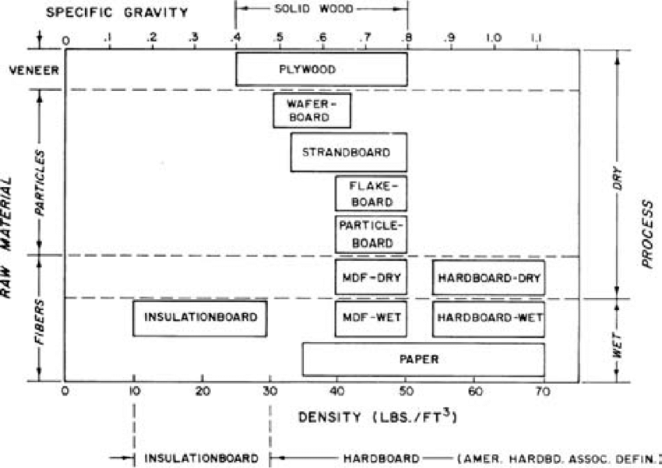

**Fig. 1.58. Classification of Wood Based Panels by density and specific gravity** (Wood Hanbook, 2010)

The following is a list of wood-based materials and a brief description of each material listed.

### 2.5.2.1. Veneer-based materials

Veneer-based materials are the oldest materials of glued constructions, such as plywood, in which the layers of adjacent veneers are oriented perpendicular to each other Fig.1.59.A) and it is very well known structural panel.

Plywood is made by gluing together thin sheets of peeled veneers. The thickness of an individual sheet is 0,2 to 3,2 mm an odd number of sheers (at least three). In gluing, weather-resistant phenolic resin adhesive is normally used. The thickness (nominal) of plywood starts with 4 and till 30, sometimes to 50 mm. Basic plywood can be divided into three main categories: **birch plywood** (density ~ 680 kg m-3), **mixed plywood** (density ~ 620 kg m-3) and **softwood plywood’s** (density 460 to 520 kg m-3). Bakelite plywood (Fig.1.59.C) is glued with veneers previously impregnated with phenolic (bakalite) resin. This plywood is used where board materials must provide increased surface abrasion resistance and hardness, as well as high resistance to various chemicals.

|  |  |  |  |
| --- | --- | --- | --- |
|  |  | Att&emacr;lu rezult&amacr;ti vaic&amacr;jumam “resin impregnated plywood” |  |
| A | B | C | D |

**Fig. 1.59. Types of veneer materials:** A– plywood[19]; B- Laminated veneer lumber[20]; C- bakelite plywood; D- Environment friendly plywood19.

**Mixed plywood** are multi-purpose general plywood. They are used, for example, as basic boards and concrete moulds for downstream products and special plywood. Because the surface of mixed plywood is always birch, they are in the same quality classes as birch plywood.

**Conifer plywood** are particularly used in construction, for example in roof structures and interior linings. They are mostly made of spruce.

The choice of quality class of birch veneer-surfaced plywood according to application (in brackets, the other generally used quality class):

* A (E) - flawless special quality (only available to a limited extent).
* B (I) - lacquered or waxed surface.
* S (II) - paintable surfaces.
* BB (III) - normal quality, for example under coverings, the most common quality in structures.
* WG (IV) - for less demanding applications, a quality that cannot be repaired

Special plywood are chiefly basic plywood made for a specific purpose in standard dimensions and coated in different ways, depending on the application. Film (dark brown, special colours) coated plywood are most used for outdoor conditions.

The properties of veneer-based materials are significantly affected by the thickness, density and adhesive consumption. And glue has been one of the most pressing issues lately and specifically about its impact on the environment. Therefore, the plywood manufacturer JSC *Latvijas Finieris* has together with *Stora Enso* taken the next steps towards replacing phenol - in resins used in plywood - with lignin. This new lignin-based glue significantly reduces the carbon footprint of plywood products all the way from production to final end-use applications without compromising on technical performance. New product is known by the trade mark Riga *ECOlogical*[21] (Fig.1.59.D.).

**As a construction material plywood can be used for:**

* roof substructures
* subfloor boarding
* stiffening boarding for wall and load-bearing structures
* interior lining
* balcony floors
* scaffolding platforms
* concrete moulds
* building site fences[22]

In recent years, laminated veneer lumber (LVL) (Fig.1.59.B), EN 14374, in which the adjacent layers of veneer are oriented in one direction) and *Paralams* (material from peeled veneer sheets) are increasingly used in construction. In figure 1.60. a classification of veneer-based materials is given.

Veneer based materials

Densified/ Undensified

* Plywood (U)
* Laminated Veneer Lumber (U)
* Bakelite plywood (D)

Veneer type

* Full veneer sheet (plywood, LVL)
* Veneer stripes (Parrallam)

Orientation of Veneers

* 90° each other (plywood)
* Parallel fibers (LVL)
* Different ways (special plywood)

**Fig. 1.60. Veneer based structural materials.**

LVL glued in the direction of fibers (most often from softwood peeled veneers with thickness up to~ 3 mm). In part, some layers are oriented perpendicularly to increase the strength perpendicular to the direction of the outer layer fibers. That kind panels produced very well-known company with trade mark KERTO[23]

The production of LVL is shown in this [video](https://www.youtube.com/watch?v=qNMCu4MMx_0&feature=emb_logo)

LVL production company *MetsäWood* use for panel production (chapter 2.5.5.2).

### 2.5.2.2. Particle-based materials

Particle-based materials (Fig.1.61.) are currently the world's dominant glued timber construction materials. Particle board is made by compressing wood chips with glue. In flat-pressed particle board, the chips are mainly parallel to the surface. The chips in the surface layer are thinner than those in the middle layer, so the surface of the particle board is denser and more compact than the middle. It has the following benefits, owing to its method of manufacture:

* no grain direction
* particle board is homogeneous and has the same degree of strength in different directions
* the dynamics of the board in the direction of the plane surface is slight

The density of particle board varies between 650 and 750 kg m-³, so it is considerably heavier than sawn softwoods.

Standard particle boards are uncoated particle boards meant for construction.

|  |  |  |  |
| --- | --- | --- | --- |
| Skaidu plātne P2 - Skaidu plātne P2 - Skaidu plātne - Kronobuild - Produkti  - Kronospan | Particleboard P5 - Particleboard P5 - Particleboard - Kronobuild - Products  - Kronospan - Leading manufacturer of wood-based panels | Fire Retardant Particleboard - Fire Retardant Particleboard - Particleboard  - Kronobuild - Products - Kronospan - Leading manufacturer of wood-based  panels | OSB - Kronobuild - Produkti - Kronospan |
| A | B | C | D |

**Fig. 1.61. Wood particle boards: A, B, C- particle board; B- OSB**[24]

Particleboards for use in construction are classified into the following groups (EN 312):

* P1 - Construction boards for interior use.
* P2 - Furniture boards for interior use (Fig.1.61.A).
* P3 - Non-load-bearing use, a board that withstands moisture better than standard particle board.
* P4 - Boards that can withstand stress, for interior use.
* P5 - For applications that need to withstand stress, a board that withstands moisture better than standard particle board (Fig.1.61.B).
* P6 - Floor boards that can withstand severe stress, for interior use.
* P7 - For applications that need to withstand severe stress, a board that withstands moisture better than standard particle board.

Oriented strand board (OSB) (Fig.1.62.) is an engineered wood-based panel material in which long strands of wood are bonded together with a synthetic resin adhesive. OSB is usually composed of three layers, with the strands of the outer two layers orientated in a particular direction, more commonly in the long direction of the panel. OSB’s strength mainly comes from its uninterrupted wood fibre, interweaving of long strands and the degree of strand orientation in the surface layers[25]

OSB (according to EN 300) is divided into:

* OSB 1 - general purpose boards, suitable for interior use, including furniture production.
* OSB 2 - construction boards for indoor use in dry operating conditions.
* OSB 3 - structural boards for use in wet operating conditions.
* OSB 4 - for use of heavy-duty structural boards in wet operating conditions.

Some other products such as fibrolite made up from long strands composing with cement suspension (Fig.1.62.).

|  |  |  |
| --- | --- | --- |
| https://media.voog.com/0000/0039/1555/photos/Biezumi.jpg | https://media.voog.com/0000/0039/1555/photos/galerija_konstruktivo_5977_large.jpg | https://media.voog.com/0000/0039/1555/photos/Virtuve_2_block.jpg |
| A | B | C |

**Fig. 1.62. Fibrolite:** A- fibrolite; B- isolation; C- design elements[26]

This material is very good for sound insulation and absorption of undesirable noise, suspended ceiling constructions, wall covering. As well, as for permanent formwork systems, timber frame construction solutions to reduce heat losses and to ensure optimal indoor climate - construction insulation, thermal inertia increase. Available as 2400x600 mm boards in either 25, 50, 75 or 100 mm thickness.

In market there can be found also a cement bonded particle board (Fig.1.63.) intended for both internal and external use which has very high levels of performance in the presence of moisture and has high resistance to fire.

|  |  |
| --- | --- |
| http://www.euroform.co.uk/wp-content/uploads/2019/04/versapanel-close-up-3.jpg A | http://www.euroform.co.uk/wp-content/uploads/2019/05/Trespa-Image-3.jpg B |

**Fig. 1.63. Cement bonded particle board:** A- material; B- application;[27]

This untreated state is weather resistant and will not degrade significantly with permanent exposure, even if subjected to freeze/thaw conditions. However, in general, a surface treatment, such as a breather membrane, is recommended for external applications. Available as 2400x1200 mm boards in either 10 or 12mm thickness.

### 2.5.2.3. Fiber based materials

Wood fiberboard is made of wood fibers which are connected to each other through the effect of heat pressure. Glue and other additives (less than 1%) can be used to improve the properties of the board and to even out differences in raw materials and manufacturing methods. Paraffin is normally used as a water-repellent adhesive. Starch, artificial resin and hardening oil are used as binding agents to improve the strength. By increasing the resin and wax in porous wood fiber board, it is possible to improve its weather-resistance properties. Board treated in this way is particularly suitable as a wind-shield material (thicknesses of 12 and 25 mm) for wood-framed external walls.

Standard wood fibre board can be divided into two main categories:

* porous (used for thermal insulation) (Fig.1.64.A)
* hard (MDF, HDF – for floors etc.) (Fig.1.64.B)

|  |  |
| --- | --- |
| https://www.steico.com/fileadmin/_processed_/csm_STEICOflex_pu_ae7380c136.jpg A | Vidēja blīvuma kokšķiedru plātne (MDF) B |

**Fig. 1.64. Wood fiber materials:** A- isolation[28]; B- MDF[29]

A wide variety of fiberboard is produced for special needs (roofs, walls) with a density of up to 350 kg m-3. Very low density (up to 150 kg m-3) insulation boards are available using wood fiber board production technology[30]

### 2.5.3. Wood based material properties (some of)

The physical-mechanical properties of WBP are bit different, e.g. MC at the same relative humidity is lower (table 1.20.).

Table 1.20.

Moisture content of glued wood construction materials (temp. 20°C, rel. humidity 65%)

|  |  |
| --- | --- |
| Wood based material | Moisture content, % |
| Plywood | 8 to 10 |
| Particle board (pressed by flat press) | 94 |
| Particle board (pressed by extrusion press) | 94 |
| HDF | 53 |
| MDF | 94 |

For wood-based materials, the swelling in the pressing direction (thickness) is significantly higher than for solid wood perpendicular to the direction of the fibers. It depends on the quality of the adhesive and the amount of moisture and water protection. This is the so-called compression of compacted particles. As the humidity changes, stresses and deformations occur when the glued wood construction materials are aged under differentiated conditions (when one side is wetter and the other drier), along with swelling in thickness and length. The reason for this is different equilibrium humidity and thus different layers at the time of production the panels. This problem especially occurs with asymmetrical slab construction, such as laminate flooring. As the density increases, the strength, speed of sound propagation and thermal conductivity increase. As the density of the outer layers increases, the surface quality increases. Density and some mechanical properties of above-mentioned materials are shown in table 1.21.

Table 1.21.

Properties of glued wood based construction materials

|  |  |  |  |  |  |  |  |  |
| --- | --- | --- | --- | --- | --- | --- | --- | --- |
| Property | Solid wood | Plywood | LVL | OSB | Particle board | MDF | LSL | PSL |
| Density,  kg m-3 | 450 | 500-600 | 660-700 | 660-700 | 680-700 | 760-790 | 650 | 660 |
| E-modulus,  N mm -2 | - | - | - | - | 2600-3200 | 4000-4500 | 12000 | 14000-15500 |
| parallel | 5000-7000 | 12000 | 13000-16000 | 7000 | - | - | - | - |
| perpendicular | 1000-3000 | 7000 | - | 1850 | - | - | - | - |
| Bending strength,  N mm -2 | - | - | - | - | 20-22 | 33-38 | - | - |
| parallel | 30-50 | 80 | - | 36 | - |  | - | 60-65 |
| perpendicular | 10-30 | 40 | - | 20-25 | - | - |  | - |
| Shear modulus  N mm -2 | - | - | - | - | - | - | - | - |
| flat | 200 | - | 500 | 300 | 100-180 | 100-200 | - | 700-800 |
| accros | 600-700 | - | 500 | 1100 | 1000-1500 | 600-1000 | 2300 | - |

### 2.5.4. Combined wood-based materials

Nowadays, special materials are becoming increasingly important: beams, moulds made of wood and glued wood construction materials as different combination (Fig.1.65.).

Connective wood materials

Middle layer form solid wood

Middle layer from particle board

Middle layer from wood cellular material

Middle layer from foam material

**Fig. 1.65. Classification of combined wood materials.**

### 2.5.4.1 I Beams

Beam and column building elements - type [I beams](https://www.youtube.com/watch?v=3rfCWK8GWMI) - have gained great popularity in the world (Fig.1.66.).



**Fig. 1.66. I joist with OSB web and solid wood flanges**[31]

The beams consist of shelves (upper and lower horizontal position), which are usually made of structural timber or long-fiber veneer boards or LVL (Laminated Veneer Lumber). Plywood or, most often, OSB is used to create the wall (vertical position). More about I joists is given in LU2.

### 2.5.4.2. Structural Insulated Panel

Considering the pace of construction development and technological possibilities, a construction panel solution has been developed (Fig.1.67.), the middle layer of which can be made of Expanded Polystyrene Foam (EPS), Extruded Polystyrene Foam (XPS), poly-isocyanate foam, polyurethane foam or wood cellular material or HSC (Composite Honeycomb). By mutually gluing the middle or thermal insulation layer with OSB, an insulated construction panel or SIP ([Structural Insulated Panel](https://www.youtube.com/watch?v=P4p_wDk-fcQ&feature=emb_logo)) is obtained.



**Fig. 1.67. Structural isolated panel SIP**[32]

### 2.5.4.3. Honeycomb

[Honeycomb](https://www.youtube.com/watch?v=pqI4PuDTxEw) filler is the most promising material for the manufacture of ultralight and durable structures for various purposes. Honeycomb core is a cellular structure. The shape of the placeholder cells follows the shape of bee honeycombs. One of the application forms - door constructions (Fig.1.68.).

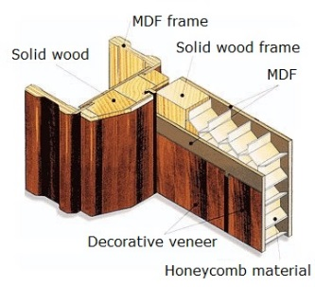

**Fig. 1.68. Honeycomb material as inner door filler[33]**

### 2.5.4.4. DendroLight

*DendrolLight* door blank represents a new concept in the door industry. It consists of the unique DendroLight core material sandwiched between two HDF deck layers and edged with thick MDF (HDF) blanks (Fig.1.69.). The core material provides a lighter weight and better quality – the most important qualities for door manufacturers.

|  |  |
| --- | --- |
| DendroLight Door Blank - MaterialDistrict A[34] | Dendrolight Latvija" saņem aizdevumu B[35] |

**Fig. 1.69. DendroLight® door panel:** A- door blank; B- application.

I had developed and certified 30-minute fire door blank concept that also reached 35 dB sound insulation performance. DendroLight building block (Fig.1.87.) is an improved and new construction material. It is light, strong and nature and man-friendly. It consists of DendroLight cellular material block, which is sandwiched between solid wood or plywood deck layers.

Find out more about *Dendrolight* building blocks in this [video](https://www.youtube.com/watch?v=DUe42gJ8gzU)

[DendroLight building blocks](https://www.youtube.com/watch?v=pxg2RTF7XJc&t=6s) (Fig.1.70.) are a good choice for those who want to reduce the building time and save up on labour costs, as it provides the main advantages of the material – light weight (~ 330 kg m-3), high strength, good thermal and sound insulation and it is easily portable.

Panel length could be up to 10 m, panel width up to 1300 mm; panel thickness is determined by required structural strength and desired thermal properties like thermal transmittance coefficient (U-value).

|  |  |
| --- | --- |
| WOO205-1 A[36] | Dendrolight Latvija - lightweight wood panels, door blanks and building  systems B[37] |

**Fig. 1.70. DendroLight® building block:** A- building block; B- application.

### 2.5.4.5. Wood plastic composites

[Wood plastic composites](https://www.youtube.com/watch?v=j5EE0s7zotE) (WPC) are composite materials made of wood fiber/wood flour and thermoplastics such as polyethylene (PE), polypropylene (PP), polyvinylchloride (PVC) or others. Wood-plastic composites are still new materials relative to the long history of natural lumber as a building material. Most of the physical and mechanical properties of WPC depend mainly on the interaction developed between wood and thermoplastic material. This product can be used as decking (Fig.1.71.) and siding boards and other shapes for other applications.

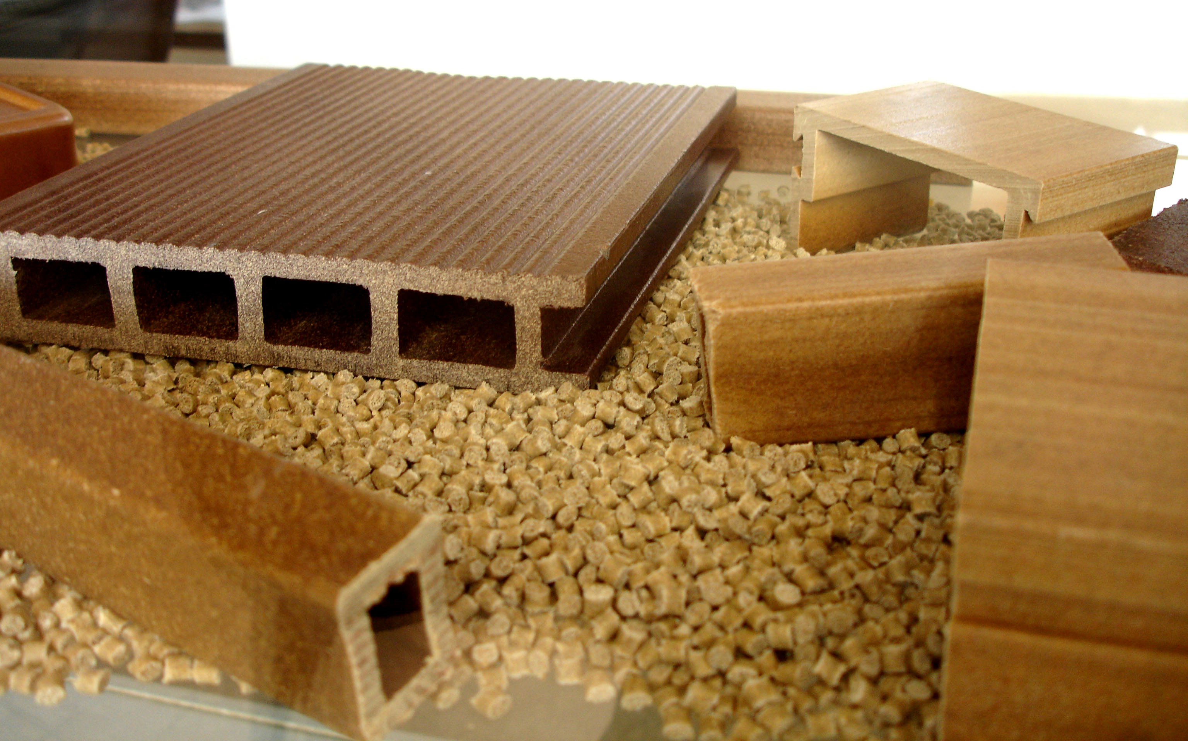

**Fig. 1.71. Wood plastic composites**[38]

### 2.5.4.6. Structural Composite Lumber (SCL)

Structural composite lumber (SCL), which includes laminated veneer lumber (LVL), parallel strand lumber (PSL), laminated strand lumber (LSL) and oriented strand lumber (OSL), is a family of engineered wood products created by layering dried and graded wood veneers, strands or flakes with moisture resistant adhesive into blocks of material known as billets, which are subsequently resawn into specified sizes. In SCL billets, the grain of each layer of veneer or flakes runs primarily in the same direction. The resulting products out- perform conventional lumber when either face- or edge-loaded. SCL is a solid, highly predictable, and uniform engineered wood product that is sawn to consistent sizes and is virtually free from warping and splitting.

### 2.5.4.7. Parallel Strand Lumber

[Parallel strand lumber](https://www.youtube.com/watch?v=NlXbBRKAX9E) (PSL) is manufactured from veneers clipped into long strands laid in parallel formation and bonded together with an adhesive to form the finished structural section. Like LVL and glulam, this product is used for beam and header applications where high bending strength is needed. PSL is also frequently used as load-bearing columns. Parallel strand lumber (PSL) well known as Parallam (Fig.1.72.A) is a product manufactured from strips of veneer measuring approximately 3 mm in thickness and 15 mm in width. The length-to-thickness ratio of the strands in PSL is around 300. Phenolic resin is used to bond the individual veneer strips. The strips can be up to 2,6 m long, before the strips are bundled together with their individual ends offset and with fibres oriented primarily parallel to the major axis of the beam. In a continuous press the veneer strips are pressed to form an endless beam. Parallel strand lumber is designed to be used in structures (Fig.1.72.B) with long free spans. In order to obtain components with large cross-sections, PSL members can be bonded together[39]

|  |  |
| --- | --- |
| A[40] | B[41] |

**Fig. 1.72. Parallel Strand Lumber** A- PSL material; B- application.

### 2.5.4.8. Laminated Strand Lumber (LSL)

Laminated strand lumber well known as [TimberStrand](https://www.youtube.com/watch?v=Dt9owR_CY4I&t=291s)® (Fig.1.73.A) is made from flaked wood strands that have a length-to-thickness ratio of approximately 150. Combined with an adhesive, the strands are oriented and formed into a large mat or billet and pressed. LSL Beam is designed to reduce installation time and provide a one-piece solution for a variety of residential applications (Fig.1.73.B) in floors and roofs[42]

|  |  |
| --- | --- |
| A[43] | B[44] |

**Fig. 1.73. Laminated Strand Lumber** A- LSL material; B- application.

### 2.5.5. Building panels systems

### 2.5.5.1. LIGNATUR

[Lignatur](https://www.youtube.com/watch?v=Xpz5z0A0b4Q) - an element that combines most functions of a ceiling, a roof, in one (Fig.1.74.). An element that needs no supports, even with a larger span, that effectively ­insulates sound, improves the room acoustics and satisfies strict fire protection regulations. Their covering width is 1000 mm, the maximum length is 16 m. Surface elements for spans up to 12 m can be modified to protect from the direct fire or increasing the sound insulation, sound absorption and heat insulation properties. Standard height of the panels are: 90, 120, 140, 160, 180, 200, 220, 240, 280, 320, 360 mm.

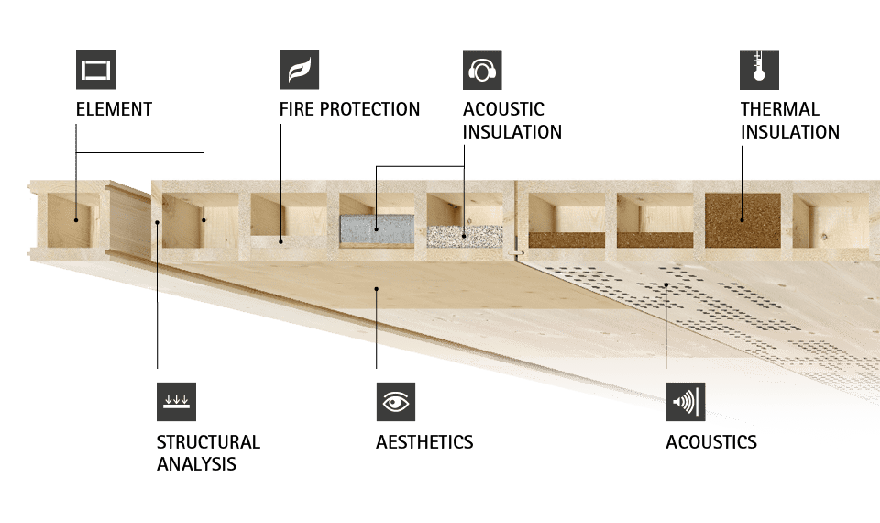

**Fig. 1.74. Lignatur panel system**[45]

### 2.5.5.2. Kerto-Ripa®

This system (Fig.1.75.) is an enhanced design pre-fabricated system for roof- and floor elements, developed by Metsä Wood. Based on Kerto® LVL S-beam & Kerto® LVL Q-panel loadbearing components and structural gluing it enables the elements very long spans, up to 25 meters, making it possible for structural designers to remove columns and increase design flexibility. Short assembly time - up to 1500m2 of weather protection in one day. [Kerto-Ripa](https://www.youtube.com/watch?v=5rqA-UjmpMw) box slab is five times lighter in weight than the TT concrete slab. Kerto-Ripa designed elements can be of both open and closed structure and insulated to match every unique buildings exact requirements.

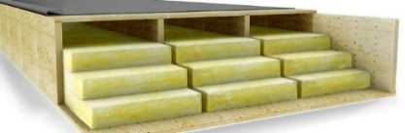

**Fig. 1.75. Kerto-Ripa panel system**[46]

### 2.5.5.3. LIGNO

Wall, ceiling and roof - [Lignotrend](https://www.youtube.com/watch?v=Mk4q2idOFko) is the first manufacturer of cross laminated timber elements to have developed a complete product range for all load-bearing and insulating components (Fig.1.76.). Certified and technically approved products ensure the necessary safety of a modern wooden house.

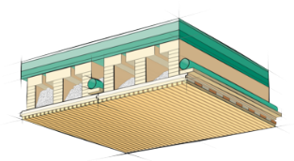

**Fig. 1.76. LIGNO box element**[47]

This is a cross laminated timber with webs or as box elements load-bearing or for wide range interior completion.

### 2.5.5.4. KIELSTEG

[Kielsteg](https://www.youtube.com/watch?v=Xe1L5M8mI9M) (Fig.1.77.) consists of top and bottom flanges of finger jointed structural timber connected by webs of V-shaped shear members made from plywood or OSB. A Kielsteg element can deliver a clear span of 27 meters with no down stand beams. Impressive from an engineering perspective and visually stunning from an aesthetic perspective.

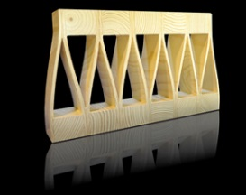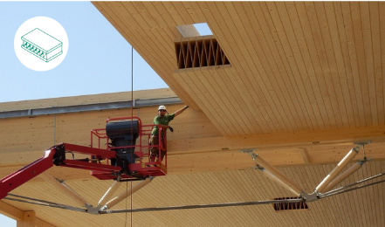

**Fig. 1.77. KEILSTEG panel element[48]**

# LIST OF REFERENCES

1. EN 300:2006 Oriented Strand Boards (OSB) – Definitions, classification and specifications.
2. **EN 312:2010 Particleboards. Specifications.**
3. EN 316:2009 Wood fibre boards. Definition, classification and symbols.
4. EN 15804:2012+A1:2013 Sustainability of construction works. Environmental product declarations. Core rules for the product category of construction products.
5. EN 15978:2011 Sustainability of construction works. Assessment of environmental performance of buildings. Calculation method.
6. Gong M. Lumber-Based Mass Timber Products in Construction. Timber Buildings and Sustainability. DOI: 10.5772/intechopen.85808
7. ISO 14025:2006 Environmental labels and declarations — Type III environmental declarations — Principles and procedures.
8. ISO 14040:2006 Environmental management — Life cycle assessment — Principles and framework.
9. ISO 14044:2006 Environmental management — Life cycle assessment — Requirements and guidelines.
10. Kruse K., Venschott D. Eigenschaften und Einsatzpotentiale neuer Holzwerkstoffe im bauwessen, Institut für Holzphysik und mechanische Technologie des Holzes, 2001
11. Wood Handbook, Wood as an Engineering Material. Forest Products Laboratory. General Technical Report FPL-GTR-190. Forest Products Laboratory, USA, 2010., 508 p.

1. <https://www.swedishwood.com/wood-facts/about-wood/wood-and-the-environment/the-forest-and-sustainable-forestry/>
2. <https://www.swedishwood.com/sustainability/the-forest-and-the-climate/>
3. <http://www.fao.org/3/w3722E/w3722e05.htm>
4. <https://www.forestindustries.fi/statistics/forest-resources-and-wood-raw-material/>
5. <https://www.climatechangepost.com/greece/forestry-and-peatlands/>
6. <https://www.zm.gov.lv/public/ck/files/ZM/mezhi/skaitlifakti_ENG20.pdf>
7. <http://www.fao.org/forestry/country/57478/en/esp/>
8. [www.fsc.org](http://www.fsc.org)
9. <https://www.pefc.org/>
10. [www.unece.org](http://www.unece.org)
11. (<https://ec.europa.eu/environment/forests/timber_regulation.htm>)
12. <https://civildigital.com/fiber-reinforced-concrete/>
13. [www.upb.lv](http://www.upb.lv)
14. [www.iktk.lv](http://www.iktk.lv)
15. <https://www.swedishwood.com/wood-facts/about-wood/wood-and-the-environment/wood-is-a-sustainable-construction-material/>
16. <http://www.treehugger.com/sustainable-product-design/interlocking-cross-laminated-timber-could-use-square-miles-beetle-killed-lumber.html>
17. 7.%20 Neue%20 Holzwerkstoffe%20S.7.1_ 7.12.pdf
18. 7.%20 Neue%20 Holzwerkstoffe%20S.7.1_ 7.12.pdf
19. <https://www.finieris.com/en/products/plywood/raw-plywood/riga-ply>
20. <https://www.woodproducts.fi/metsa-wood-kertor-lvl-qp-beam>
21. <https://www.storaenso.com/en/newsroom/news/2020/6/developing-a-lignin-based-resin-for-plywood>
22. <https://www.woodproducts.fi/content/plywood>
23. <https://www.metsawood.com/global/Products/kerto/Pages/Kerto.aspx>
24. <https://lv.kronospan-express.com/lv>
25. <https://europanels.org/the-wood-based-panel-industry/types-of-wood-based-panels-economic-impact/oriented-strand-board/>
26. <https://www.cewood.com/>
27. <http://www.euroform.co.uk/>
28. <http://steico.eu/>
29. <https://lv.kronospan-express.com/lv>
30. <https://www.woodproducts.fi/content/wood-fibre-board>
31. <https://www.metsawood.com/global/Products/finnjoist/applications/Pages/default.aspx>
32. <https://www.sipsdirect.co.uk/>.
33. <http://www.honeycomb.lv/>
34. <https://materialdistrict.com/material/dendrolight-door-blank/>
35. <https://www.ventasbalss.lv/zinas/ekonomika/271-dendrolight-latvija-sanem-aizdevumu>
36. <https://materialdistrict.com/material/dendrolight-building-block-bb/>
37. <http://dendrolight.lv/en/products/building-systems/>
38. <https://www.aimplas.net/processing-and-prototyping/compounding/wood-plastic-composites/>
39. <https://www.dataholz.eu/en/building-materials/beams-columns/parallel-strand-lumber-psl.htm>
40. <https://www.weyerhaeuser.com/woodproducts/engineered-lumber/parallam-psl/>
41. <https://www.naturallywood.com/products/parallel-strand-lumber/>
42. <https://www.apawood.org/structural-composite-lumber>
43. <https://www.weyerhaeuser.com/woodproducts/engineered-lumber/timberstrand-lsl/timberstrand-lsl-beams/>
44. <https://www.weyerhaeuser.com/woodproducts/engineered-lumber/timberstrand-lsl/>
45. <https://www.lignatur.ch/en/product>
46. <https://www.metsawood.com/global/Products/kerto/applications/Pages/Wood-elements.aspx>
47. <https://www.lignotrend.de/home/>
48. http://www.kielsteg.at/was-ist-kielsteg/