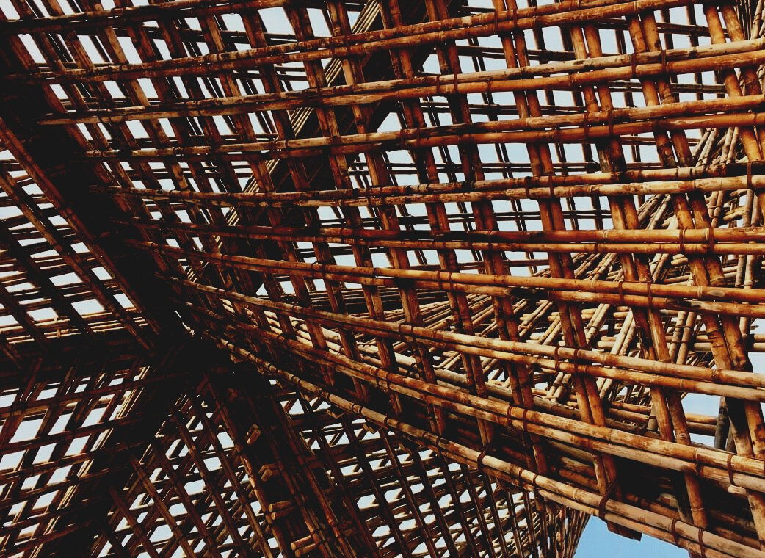

UPWOOD
Up-skilling construction workers in wood construction methods for energy-efficient buildings

UPWOOD
Up-skilling construction workers in wood construction methods for energy-efficient buildings

methods for energy-efficient buildings

UPWOOD
Up-skilling construction workers in wood construction methods for energy-efficient buildings

methods for energy-efficient buildings

UPWOOD
Up-skilling construction workers in wood construction methods for energy-efficient buildings

methods for energy-efficient buildings

UPWOOD
Up-skilling construction workers in wood construction methods for energy-efficient buildings

truction methods for energy-efficient buildings

UPWOOD
Up-skilling construction workers in wood construction methods for energy-efficient buildings

methods for energy-efficient buildings

UPWOOD
Up-skilling construction workers in wood construction methods for energy-efficient buildings

methods for energy-efficient buildings

UPWOOD
Up-skilling construction workers in wood construction methods for energy-efficient buildings

methods for energy-efficient buildings

UPWOOD
Up-skilling construction workers in wood construction methods for energy-efficient buildings

TRAINING & ASSESSMENT
MATERIAL

Learning Unit 1

TRAINING & ASSESSMENT
MATERIAL

Learning Unit 4
- Lesson 1: Energy-efficiency value of wood as a building material and wooden constructions.

TRAINING & ASSESSMENT
MATERIAL

Learning Unit 4
- Lesson 1: Energy-efficiency value of wood as a building material and wooden constructions.

TRAINING & ASSESSMENT
MATERIAL

Learning Unit 4
- Lesson 1: Energy-efficiency value of wood as a building material and wooden constructions.

TRAINING & ASSESSMENT
MATERIAL

Learning Unit 4
- Lesson 1: Energy-efficiency value of wood as a building material and wooden constructions.

TRAINING & ASSESSMENT
MATERIAL

Learning Unit 4
- Lesson 1: Energy-efficiency value of wood as a building material and wooden constructions.

TRAINING & ASSESSMENT
MATERIAL

Learning Unit 4
- Lesson 1: Energy-efficiency value of wood as a building material and wooden constructions.

TRAINING & ASSESSMENT
MATERIAL

Learning Unit 4
- Lesson 1: Energy-efficiency value of wood as a building material and wooden constructions.

1. CASE STUDIES 3
CASE STUDY 1 3
CASE STUDY 2 3
CASE STUDY 3 3
CASE STUDY 4 3
CASE STUDY 5 4
CASE STUDY 6 4
CASE STUDY 7 4
CASE STUDY 8 5
CASE STUDY 9 5
CASE STUDY 10 5
CASE STUDY 11 6
CASE STUDY 12 6
CASE STUDY 13 7
CASE STUDY 14 7
CASE STUDY 15 7
2. QUESTIONS AND ANSWERS (FAQS) 8
3. MULTIPLE CHOICE QUESTIONS 13
4. CASE STUDIES AND APPLICATION SCENARIO ANALYSIS 18

CASE STUDIES
WOOD PROPERTIES, ITS LIMITATIONS AND WOOD CONSTRUCTION PHYSICS

CASE STUDY 1
Read from graph. Make calculation of coefficient decreasing of Bending Strength, if Moisture Content increase from 12 to 20 %.
$$CO=\frac{f_{b12}}{f_{b20}}$$  where: f_{b12} – bending strength at moisture content 12%;  f_{b20} - bending strength at moisture content 20%;  Read from graph:  Bending strength at 12% (blue arrow)  – 92 N mm⁻²  Bending strength at 20% (red arrow)  – 68 N mm⁻²  Put numbers into formula  $$CO=\frac{68}{92}=0,739$$ | 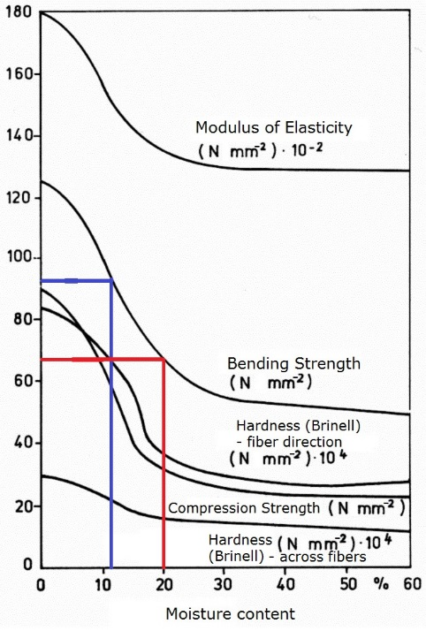

CASE STUDY 2
Draw briefly the load diagrams of the wood for tensile, compressive and bending depending of moisture content.

CASE STUDY 3
Draw briefly what is going to happen with these kind of shapes of cross section of the board after the drying.
¹

CASE STUDY 4
Find the correct wood moisture content (MC) for boards used for floors on the 1st floor heated air more than 21 °C?

CASE STUDY 5
Find the correct wood moisture content (MC) for boards used for decking (garden floor)?

CASE STUDY 6
Please, mention what is the best way for use of wood species below and why?
Pine | Spruce | Oak
 |  | High hardness - can be used for floor boards

CASE STUDY 7
Here is an example of the board. If You use it as a beam for second stage floor, how do You place that board on support, e.g. wall- such way (as shown in figure – this edge wise) or opposite edge wise? If opposite then, please, make characterization of that.
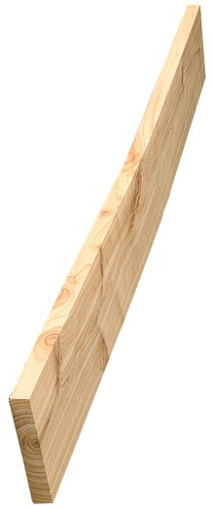

POSSIBILITIES OF IMPROVING THE PROPERTIES OF THE WOOD AND WOOD PROTECTION, DURABILITY

CASE STUDY 8
From the table below choose wooden species for decking (garden floor) under construction and justify the choice. Please, describe Your choice.

Durability by wood species
Wood type | Heartwood | Sapwood
Fir | 4 | 5
Larch | 3-4 | 5
Spruce | 4 | 5
Pine | 3-4 | 5
European oak | 2-4 | 4
Teak | 1-3 | -

CASE STUDY 9
Choose one example from the table below regarding standard EN 1611 – 1 and describe this timber grade. Put down the grade – quality class regarding old grading rules.

Timber grade classes
Grading rules | Grades – quality classes
EN 1611 – 1
4-sided grading | - | - | G4-0 | G4-1 | G4-2** | G4-3 | G4-4
2-sided grading* | - | - | G2-0 | G2-1 | G2-2 | G2-3 | G2-4
Old grading rules | Grades – quality classes
Nordiskt trä - Nordic Timber Grading Rules (The Blue Book) 1994 | A |  |  |  | B | C | D
 | A1 | A2 | A3 | A4
Guiding principles for grading of Swedish sawn timber  (The Green Book) 1960 | US |  |  |  | 5th | 6th | 7th
 | I | II | III | IV | V | VI | VII
* 2-sided grading G2, seldom used in Sweden. ** Most common for construction timber.

CASE STUDY 10
Describe typical steps in pressure treating process. What happens with wood? Generally, description is given in following steps and figure below: A – untreated wood is placed in cylinder; B - a vacuum is applied; C - the wood is immersed in solution (still under vacuum); D - pressure is applied; E - preservative is pumped out, and a final vacuum; F - the wood is removed from the cylinder.
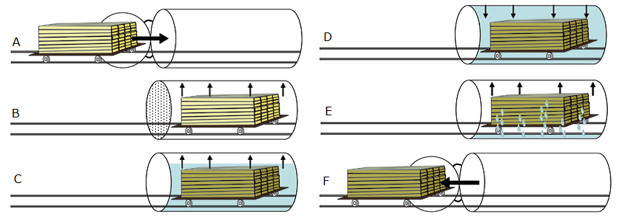

AVAILABILITY AND ENVIRONMENTAL FRIENDLINESS OF WOOD AS BUILDING MATERIAL

CASE STUDY 11
Describe all wood species as much as You can. In green - example is given.

 | 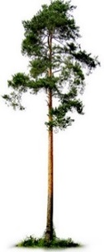 | 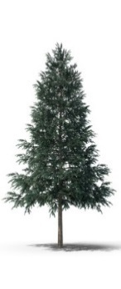 |  | 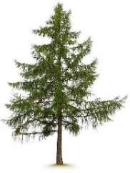 | 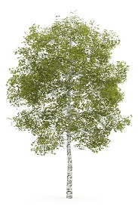
Name | Pine
Properties | Have sapwood and heartwood. First trunk from ground without knots
Application | Can be used as structural timber for frame houses or logs for cabin houses
Other | Good for industrial – chemical treatment

CASE STUDY 12
Choose one of the lumber-based wood products and give it characterization – production, properties, application for constructions etc.

CASE STUDY 13
Choose one of the veneer-based wood panels and give it characterization – production, properties, application for constructions etc.
In green - example is given.

Plywood | Have odd number of veneers (starts from 3). Usually every next veneer direction of wood fibers are perpendicular to previous. 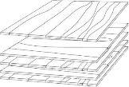  Mechanical properties in wood fibers direction are higher than opposite. Can be used for internal and external (in laminated with films) panelling, concrete shuttering etc.

CASE STUDY 14
Choose one of the particle-based wood panels and give it characterization – production, properties, application for constructions etc.

CASE STUDY 15
Choose one of the fiber-based wood panels and give it characterization – production, properties, application for constructions etc.

QUESTIONS AND ANSWERS (FAQS)
WOOD PROPERTIES, ITS LIMITATIONS AND WOOD CONSTRUCTION PHYSICS
What are the main sections of the pine trunk?
A: lower trunk part without knots; middle trunk part with dead knots; upper trunk part with live knots
What are the main sections of the spruce trunk?
A: lower trunk part with dead and live knots; middle trunk part with live and dead knots; upper trunk part with live knots
Why do we care about changes in MC?
A: It makes general influence on physical and especially on mechanical properties of wood, which is the most significant thing for use it in structures
What components of the trunk are visible in its cross section (mention at least 3 of them?
A: bark; pith; sapwood; heartwood; growth-annual rings; early wood; late wood
Which tree species have resin pockets?
A: softwoods (pine, spruce, larch)
What chemical elements are in wood?
A: carbon (C), hydrogen (H), oxygen (O) and nitrogen (N)
Does the chemical composition of wood depend on the tree species?
A: Yes
What is wood moisture content (MC)?
A: It is water content in the wood, calculated in percentage
What methods of determination of the wood moisture content (MC) do You know?
A: Electric moisture method; oven dry method; hygrometric method and distillation method
What is wood shrinkage and swelling in which direction is the greatest one?
A: Changes of dimensions, in tangential
What is the density of wood, units? Why determine the standard density at ρ12?
A: It is mass of wood peace divided by its volume, kg m-3. Just to compare the density between wood species
What is the strength of the wood?
A: Maximum force which can be applied to the exact material
What is the hardness of the wood?
A: It is wood surface operational property, especially vital for floor products
In which direction is the strength greater?
A: In direction of wood fiber (parallel to fiber direction)
How to determine the weariness resistance of the wood?
A: It can be done visually and by weighting of material before and after grinding
What types of branches can be found on sawn timber surface?
A: live knot; dead knot; knot with bark; rotten knot; edge knot; wedge knot; leafy knot; group of knots
How do the knots affect the strength and quality of wood?
A: Group of knots decrease strength of wood

What are the timber defects for standing tree?
A: juvenile wood, reaction wood and slope of grain

POSSIBILITIES OF IMPROVING THE PROPERTIES OF THE WOOD AND WOOD PROTECTION, DURABILITY
Which tree species are biologically resistant?
A: Larch, Oak, Teak e.g.
What substances are used to protect wood industrially?
A: preservatives, oils, surface burning
What substances are used to protect wood manually?
A: paints, varnishes, oil, waxes, surface burning etc.
What are the main 2 methods of chemical protection of wood?
A: preventive and corrective
What does wood modification improve?
A: The stability of the wood dimensions and biological stability
What does wood modification reduce?
A: It reduces moisture uptake and renders it unusable for bio-degraders
Please, name at least 3 improving methods of wood properties.
A: chemical, thermal, operational, technological, by appearance
What substance forms brown color in wood at the time of thermal modification?
A: Lignin
The wood-destroying agents considered to standard are?
A: wood-decaying fungi; beetles capable of attacking dry wood; termites; marine organisms capable of attacking wood in service

Please, name planed sawn material surface:
A: smooth planed and rough planed
What can be end sizes of cross section of the planned wood materials if the sizes before planning was: thickness 100 mm and width 200 mm?
A: Thickness 95 mm and width 195 mm.

AVAILABILITY AND ENVIRONMENTAL FRIENDLINESS OF WOOD AS BUILDING MATERIAL
What amount of carbon dioxide is absorbed and what amount of oxygen released by one cubic meter of wood in its growing period?
A: It absorbs a ton of carbon dioxide and releases 0,7 tons of oxygen
What is the most vital formula:
A: 6H2O + 6CO2 + solar energy  C6H12O6 +n 6O2
Which of these five countries: Austria, Finland, Greece, Latvia or Spain is the most wooden (from forest covering point of view)?
A: Finland
Name the most well-known Forest certification schemes.
A: Forest Stewardship Council of FSC and Programme for the Endorsement of Forest Certification of PEFC
Which wood species are mostly used for structures?
A: Spruce, pine, larch, oak birch (as plywood material)
Name some advantages of structural steel?
A: compression and tensile strength; fire resistance; durability; in structure like footings, dams, piers etc. reinforced concrete is the most economical construction material
Name some advantages of reinforced concrete?
A: steel has a high strength/weight ratio; ductility; speed of erection; ease of repair; repetitive use; expanding existing structures
Name some advantages of structural wood?
A: tensile strength in fiber direction; electrical and heat resistance; sound absorption; locally sourced; environmentally friendly
How does Cross laminated timber (CLT) can be made without glue?
A: by nailing, doweling or swelling force of wood
What are the advantages of wood-based panels (WBP)?
A: very large and variable sizes; form stability, no deformation due to changes of relative humidity
Where the plywood can be used?
A: roof substructures; subfloor material; stiffening boarding for wall and load-bearing structures; interior lining; shuttering
What types of particle boards are known?
A: particle board, oriented strand board, Cement bonded particle board, fibrolite
Name two main categories wood fiber board can be divided into:
A: porous (used for thermal insulation); hard (MDF, HDF – for floors etc.)
Name the content of wood plastic composites.
A: wood fiber/wood flour and thermoplastics such as polyethylene (PE), polypropylene (PP), polyvinylchloride (PVC) or others.

MULTIPLE CHOICE QUESTIONS
WOOD PROPERTIES, ITS LIMITATIONS AND WOOD CONSTRUCTION PHYSICS
Which European wood species usually used for structures in Europe?

- Spruce, aspen, pine
- Pine, oak, spruce
- Oak, aspen, beech

If the moisture content of the wood increase above 30%:

- Mechanical properties decrease
- Mechanical properties does not change at all
- Mechanical properties increase

If the moisture content of the wood decreases below 30%:

- Mechanical properties decrease
- Mechanical properties does not change
- Mechanical properties increase

Which type of board could be used for windows production (multiple choice could be used)?

- Tangential
- Radial
- Semi radial

In which board direction is the greatest shrinking/swelling?

- Radial
- Tangential
- Longitudinal

Which part of green pine wood cross section is with higher moisture content?

- Sapwood
- Heartwood
- Both equal

Which cut of three below mentioned is with nicest structure?

- Axial (cross cut)
- Radial
- Tangential

Which is the most precise method of determination of the wood moisture content (MC)?
- Electric moisture method
- Oven dry method
- Both above mentioned
Which is the level of wood moisture content for wood materials starting to shrink?
- 50%?
- 40%?
- 30%?
If the density of wood is higher:
- Strength is higher
- Strength is lower

POSSIBILITIES OF IMPROVING THE PROPERTIES OF THE WOOD AND WOOD PROTECTION, DURABILITY
Which one of these materials will be with greater strength?
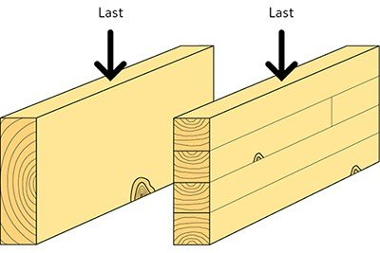
- Material on the left hand side
- Material on the right hand side
- Both are equal

What does wood modification improve?
- the stability of the wood dimensions
- mechanical properties
- both above mentioned
What does wood modification reduce? (multiple choice)
- moisture uptake
- mechanical properties
- both above mentioned
What substance forms brown color in wood at the time of thermal modification?
- cellulose
- lignin
- hydrogen
What changes occur in wood during heat treatment? (multiple choice)
- the color changes
- density changes
- texture changes

The wood-destroying agents considered to standard are (write down if something is missing)

- wood-decaying fungi
- beetles capable of attacking dry wood
- _____________ (correct answer is termites)
- marine organisms capable of attacking wood in service

AVAILABILITY AND ENVIRONMENTAL FRIENDLINESS OF WOOD AS BUILDING MATERIAL

Does the growth rings oriented correctly?

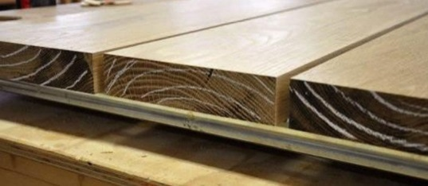
- Yes
- No
- __________
Name the most well-known Forest certification schemes
- FSC and PEFC
- FGH and PRST
- ____________

Which of these five countries: Austria, Finland, Greece, Latvia or Spain is the most wooden
- Spain
- Latvia
- ______________ (correct answer is Finland)
Which three wood species are mostly used for structures?
- Spruce, pine and oak
- Spruce, birch and aspen
- Birch aspen and oak

What amount of carbon dioxide is absorbed by one cubic meter of wood in its growing period?
- 0,5 tons
- 1 ton
- 2 tons
Does the bending strength and modulus of elasticity for wood particle board are equal?
- In length of the board and width are equal
- In length of the board higher than in width

Does the bending strength and modulus of elasticity for OSB are equal?
- In length of the board and width are equal
- In length of the board are higher than in width
Name the main veneer based products
- Laminated veneer lumber and wood particle board
- Laminated veneer lumber and glued laminated timber
- ______________ (correct answer: Laminated veneer lumber and plywood)
What can be used for gluing of veneers instead of synthetic adhesives?
- Lignin
- Cellulose
- Hemicellulose

With the size of structural elements the material properties of glued wood structures are increasing
- Strength, homogeneous, energy consumption
- Environmental impact, homogeneous, energy consumption
- Strength, homogeneous, energy consumption

CASE STUDIES AND APPLICATION SCENARIO ANALYSIS
1. Choose one of the wood species (Pine, Oak or Spruce) and characterize as much as You can. Make characterization - draw pictures, show data, create sketches etc.

2. Sketch your imaginary family house or multistory building and choose wood materials for the main construction of the building, roof construction building elements, depending on the grading class and quality class of the construction timber, as well as choose timber for interior cladding (siding), exterior cladding (siding). If you plan to create elements for the garden structures, choose the basic building elements of structures and wood materials (tree species, approximately sizes, type of treatment, etc.) that perform the general function.

3. Sketch your imaginary family house or multistory building and choose wood based materials for the main construction of the building, roof construction building elements, depending on the reviewed wood products characteristics. Justify your choice.

https://www.swedishwood.com/building-with-wood/about-glulam/choosing_glulam/
https://www.swedishwood.com/building-with-wood/about-glulam/choosing_glulam/
https://www.masterdoor.ca/resources/doors-cross-sections/

