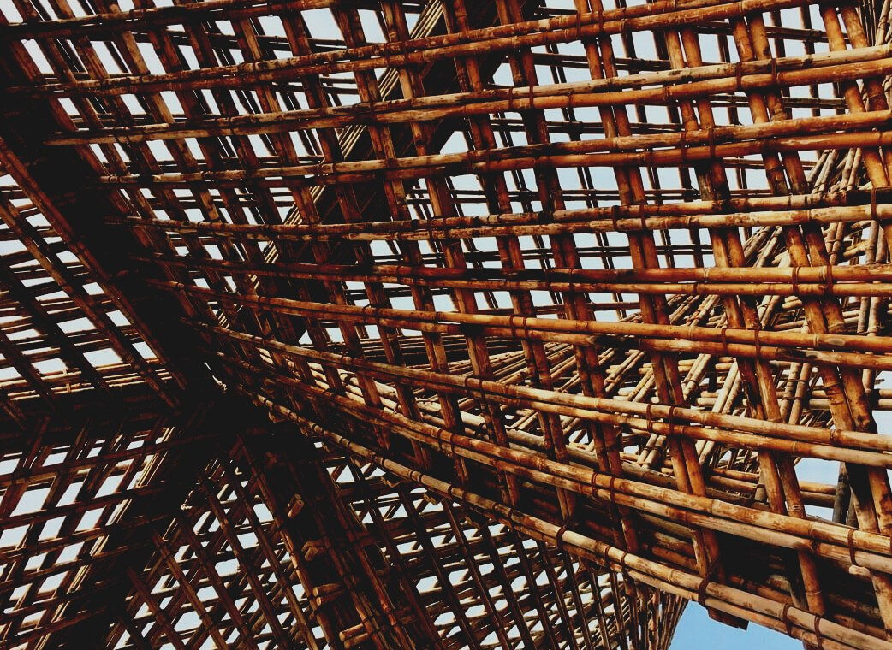

TRAINING & ASSESSMENT
MATERIAL
Learning Unit 3

Lesson 7: Thermal insulation materials
UPWOOD
Up-skilling construction workers in wood construction methods for energy-efficient buildings

UPWOOD
Up-skilling construction workers in wood construction methods for energy-efficient buildings
construction workers in wood construction methods for energy-efficient buildings

methods for energy-efficient buildings

UPWOOD
Up-skilling construction workers in wood construction methods for energy-efficient buildings

methods for energy-efficient buildings

UPWOOD
Up-skilling construction workers in wood construction methods for energy-efficient buildings

truction methods for energy-efficient buildings

UPWOOD
Up-skilling construction workers in wood construction methods for energy-efficient buildings

methods for energy-efficient buildings

UPWOOD
Up-skilling construction workers in wood construction methods for energy-efficient buildings

methods for energy-efficient buildings

UPWOOD
Up-skilling construction workers in wood construction methods for energy-efficient buildings

methods for energy-efficient buildings

UPWOOD
Up-skilling construction workers in wood construction methods for energy-efficient buildings

CONTENT
1. INTRODUCTORY PARAGRAPH 2
2. Definitions 3
3. Benefits of heat insulation in buildings 5
4. Materials accessible in the insulation market 7
4.1. Glasswool Insulation 9
4.2. Earthwool Insulation 10
4.3. Polyester Insulation 10
4.4. Rockwool Insulation 11
4.5. Reflective Foil Insulation 11
4.6. Insulation Rigid Boards (EPS & XPS) 12
4.7. Spray Foam Insulation 13
4.8. Wood Fibres 13
4.9. Cellulose/ Paper Fibres 14
4.10. Common insulating materials, “R” values, advantages and disadvantages 14
5. Application of materials 16
6. Faults in heat insulation systems – heat losses 21
7. LIST OF REFERENCES 24

- INTRODUCTORY PARAGRAPH
Thermal insulation is defined as the reduction of heat transfer (the transfer of thermal energy between objects of differing temperature) between objects in thermal contact.
Key issues:
- Reducing the amount of energy used from fossil fuels is the most important factor in promoting sustainability.
- Insulation has the greatest potential for reducing CO² emissions.
- Energy conserved through insulation use far outweighs the energy used in its manufacture. Only when a building achieves a ‘Low-Heat’ standard does insulation’s embodied carbon become significant.
- To reduce sound from outside and opposite.
- To improve fire safety of building.

- Definitions
The thermal properties of insulating materials and construction materials are known or can be accurately measured. The amount of heat transmission (flow) through any combination of materials can be calculated. However, it is necessary to know and understand certain technical terms to be able to calculate heat losses and understand the factors that are involved.
By convention, the ending “-ity” means the property of a material, regardless of its thickness and the ending “-ance” refers to the property of a specific body of given thickness.
Heat energy
One kilocalorie (1 kcal or 1 000 calories) is the amount of heat (energy) needed to raise the temperature of one kg of water by one degree Celsius [°C]. The SI standard unit for energy is Joule [J]. One kcal is approximately 4.18 kJ (this varies slightly with temperature). Another unit is the Btu (British thermal unit). One Btu roughly corresponds to 1 kJ.
Conversion table for units of work, energy and heat
 | J | kJ | kWh | kcal | kpm
1J = 1Nm=1Ws | 1 | 10⁻³ | 2,78*10⁻⁷ | 2,39*10⁻⁴ | 0,102
1kJ | 1000 | 1 | 2,78*10⁻⁴ | 0,239 | 102
1kWh | 3,6*10⁶ | 3,6*10³ | 1 | 860 | 3,67*10⁵
1 kcal | 4,19*10³ | 4,19 | 1,16*10⁻³ | 1 | 427
kpm | 9,81 | 9,81*10⁻³ | 2,72*10⁻⁶ | 2,34*10⁻³ | 1

Sorce:https://www.bossard.com/global-en/assembly-technology-expert/technical-information-and-tools/technical-resources/conversion-tables/conversion-table-for-units-of-work-energy-and-heat/

Thermal conductivity (k-value)
In simple terms this is a measure of the capacity of a material to conduct heat through its mass. Different insulating materials and other types of material have specific thermal conductivity values that can be used to measure their insulating effectiveness. It can be defined as the amount of heat/energy (expressed in kcal, Btu or J) that can be conducted in unit time through unit area of unit thickness of material, when there is a unit temperature difference. Thermal conductivity can be expressed in [kcal/m°C], [Btu/ft°F] and in the SI system in watt [W/m°C]. Thermal conductivity is also known as the k-value.
Coefficient of thermal conductance “λ” (kcal /m²h°C)
This is designated as λ (the Greek letter lambda) and defined as the amount of heat (in kcal) conducted in one hour through 1 m² of material, with a thickness of 1 m, when the temperature drop through the material under conditions of steady heat flow is 1 °C. The thermal conductance is established by tests and is the basic rating for any material. l can also be expressed in [Btu/ft²h°F] (British thermal unit per square foot, hour, and degree Fahrenheit) or in SI units in [W/m²K] Kelvin.
Thermal resistivity
The thermal resistivity is the reciprocal of the k-value (1/k).
Thermal resistance (R-value)
The thermal resistance (R-value) is the reciprocal of l (1/l) and is used for calculating the thermal resistance of any material or composite material. The R-value can be defined in simple terms as the resistance that any specific material offers to the heat flow. A good insulation material will have a high R-value. For thicknesses other than 1 m, the R-value increases in direct proportion to the increase in thickness of the insulation material. This is x/l, where x stands for the thickness of the material in meters.

Coefficient of heat transmission (U) (kcal/m²h°C)
The symbol U designates the overall coefficient of heat transmission for any section of a material or a composite of materials. The SI units for U are kcal per square metre of section per hour per degree Celsius, the difference between inside air temperature and outside air temperature. It can also be expressed in other unit systems. The U coefficient includes the thermal resistances of both surfaces of walls or flooring, as well as the thermal resistance of individual layers and air spaces that may be contained within the wall or flooring itself.
- Benefits of heat insulation in buildings
1. The primary function of thermal insulation materials used in buildings to reduce the transmission of heat through building walls. Insulation in the walls of the building can reduce the amount of heat or cold that enters the building and so reduce the amount of heat of cooling keep the comfortable climate inside building (~20-24⁰ Celsius).
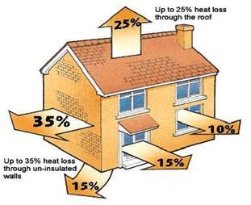
Figure 1. Heat losses in buildings

2. Thermal insulation of building walls has a significant effect on the reduction of thermal energy consumption in buildings that leads to the reduction of CO² emissions.

3. Energy Efficiency with Thermal Insulation
Meeting a significant portion of the world’s energy requirement and having limited resources, fossil fuels such as petroleum and natural gas are rapidly consumed away today. In the world where the resources are gradually diminishing although the energy requirement is continuously increasing, a wide range of programs are applied to ensure efficient use of energy. Thermal insulation comes to the forefront as one of the most successful tools for energy saving.
4. Stronger and Longer - Lasting Buildings
Thermal insulation reduces heat movements and vapor condensation. Therefore, it prevents humidity, mold, freezing, deformation that may occur in the building and weakening of iron parts due to corrosion; and helps preservation of the building. Building has an extended life and increased durability thanks to thermal insulation, which also contributes to earthquake safety.
5. Positive Effect on Human Health
Homogeneous heat distribution between interior areas with correct application of thermal insulation enhances the comfort in your living spaces.
Moreover, thermal insulation outside the building contributes positively to human health by preventing factors such as humidity, mold, fungus, moisture, dust, noise and air pollution that may have negative effects on human health.
6. Environment and Ecological Balance
Thermal insulation applications help to protect the ecological balance. Minimum energy is used for heating, cooling and climatization of thermal-insulated buildings; reducing the consumption of fossil fuels such as coal and natural gas. In consequence, emission of carbon dioxide (CO²), sulfur dioxide (SO²) and other harmful greenhouse gases spreading into the atmosphere is minimized, and the negative effect on the ecological balance is reduced.
When apply thermal insulation in building correctly selected fuel type with an appropriate technique, you utilize the whole energy consumption for heating or cooling purposes. Therefore, you can minimize the effect of the fuel on environmental pollution without wasting energy.
7. Helping Sound Insulation
Thermal insulation reduces noise as well as weather effects from outside; therefore, it helps prevention of harmful effects of noise on humans. Moreover, thermal insulation applications in building gaps such as elevators, stairs and installations prevent occurrence of sound escape funnel.
8. Contribution to National and Family Economy
Maintenance and repair expenses are reduced with thermal insulation, which protects your building from external factors. It reduces fossil fuel import and foreign dependence of our country as it ensures optimum use of energy resources. Moreover, it also contributes to the economy by reducing building energy and family health expenses.
To choose the best type of insulation, you should first determine the following:
- Where you want or need to install/add insulation
- The recommended R-values for areas you want to insulate.

- Materials accessible in the insulation market
Industrial insulation products are largely classified into three groups – inorganic or mineral fibre, cellular plastic and plant/animal derived.
Inorganic or mineral fibre products include rock wool, slag wool and glass wool, which can be sourced from recycled waste. These materials are melted at high temperatures, spun into fibre and then have a binding agent added to form rigid sheets and insulation batts. If removed in appropriate conditions, mineral fibre can be reused and recycled at the end of its life.
Perochemical or cellular plastic products are oil-derived and include rigid polyurethane, phenlic, expanded polystyrene, and extruded polystyrene. The products are available as loose fill, rigid sheets and foam. In the past, the production process involved ozone depleting agents, such as HCFCs. However, the production process has switched to using neutral hydrocarbons. As such, when sourcing cellular plastic insulation products, it is important to ensure the specified products have production processes that do not use ozone depleting agents. Cellular plastic products can be recycled but it is a cumbersome process. It is more suitable for cellular plastic products to be incinerated for energy recovery at their end of life.
Natural or renewable fibre derived products include cellulose fibre, sheep wool, cotton, and flax. These products have low embodied energy, as the materials can be sourced from renewable raw materials. The products are in the form of fibre, batts or compressed board. Their production involves chemical treatment to ensure appropriate properties, such as fire resistance and no vermin infestation. As such, at the end of life, it is difficult to use it for energy recovery through incineration.

Insulation Materials
Organic Materials
Inorganic Materials
Natural (renewable)
Petrochemical
Glass Wool
Rock Wool
Expanded Polystyrene (EPS)
Extruded Polystyrene (XPS)
Phenol Formaldehyde (PF)
Polyurethane (PUR)
Polyisocyanurate (PIR)
Urea-formaldehyde (UF)
Cellulose
Coconut
Flax Wool
Hemp
Recycled Cotton
Sheep Wool
Wood Wool
Expanded Cork
Calcium silicate
Foam Glass
Perlite
Vermiculite
Expanded Clay Aggregate
Expanded polylactic acid (PLA) (new materials)
Vacuum Insulation Panels (VIPs)
(new materials)

Thermosheets (new material)
Greensulate (Fungus) (new material)

Aerogel
(new material)

Figure 2. Thermal insulation materials in market Note: more often used thermqal insulation materials are marked in bold.

4.1. Glasswool Insulation
This is the most common type of insulation material used in residential, commercial or industrial applications. Glasswool is also referred to as fibreglass insulation and is made from up to 80% recycled glass material. The glass is melted in a furnace then sent through a spinner to create fibres. The glass fibres in glasswool insulation creates millions of tiny air pockets which trap air. The R-value of glasswool insulation ranges from an R1.5 for walls up to an R6.0 for ceiling applications. Glasswool insulation is relatively inexpensive in comparison to other insulation products. Glasswool thermal insulation products include; Knauf Earthwool Insulation, Fletcher Pink Batts, and Bradford thermal insulation.
Glasswool features and benefits: high thermal performance – year round comfort, non-combustible, saves energy – lower energy bills, soft to handle and install, lightweight, flexible and resilient.

4.2. Earthwool Insulation
Glasswool insulation is a general category of insulation, while Earthwool insulation is a specific product that is manufactured by Knauf Insulation. However, what makes Earthwool insulation different to regular glasswool products? Earthwool insulation is manufactured using ECOSE technology which is a sustainable, renewable bio-based binder that contains no added formaldehyde. No traditional petrol-based chemicals are used. Earthwool is one of the most common thermal insulation materials used in residential, commercial and industrial applications. It is available in wall, ceiling, floor and acoustic product types.
Earthwool features and benefits: low irritant product which means it is virtually itch free, environmentally-friendly natural binder, high thermal performance – year round comfort, acoustic products available, non-combustible, 50 year warranty, compression packed – more product per pack, odourless.

4.3. Polyester Insulation
Polyester is manufactured from a minimum of 50% recycled PET plastics such as drink bottles which would otherwise end up in land fill. Polyester fibres are bonded together by heat and no binder chemicals are used. This gives polyester its rigid, yet flexible structure. Polyester is a popular thermal insulation material as it contains no breathable particles and is a popular choice for asthma or severe dust allergy home occupants. Polyester material is soft to touch and itch-free, making it a great DIY material for your renovation or retrofit project, as no protective clothing is required while handling it. In comparison to glasswool, polyester thermal insulation material can more expensive. However, it can be used for the same applications as glasswool material. This includes; commercial and residential buildings. The material is pre-cut to fit timer-frames studs in walls, ceilings, underfloor and mid-floor joist spacings. Examples of polyester insulation products include; Bradford Polymax, Autex Greenstuf Polyester, and Autex acoustic range (Quietspace, Etch, Workstation).
Polyester features and benefits: made from recycled materials, the product itself can be recycled, non-allergenic particles, breathe easier, non-toxic and non-irritant, safe to touch, non-flammable, 50 year durability warranty.

4.4. Rockwool Insulation
Rockwool insulation is made from rock such as basalt. Rockwool is manufactured by first melting the rock and then spinning it at high temperatures to create fibres which make up insulation batts or rolls. No binder resin is used during this process. Rockwool insulation has exceptional fire ratings as it is non-combustible, does not conduct heat and can withstand temperatures of above 1000°C. Rockwool’s ability to insulate works by trapping air in between the fibres, which restricts heat transfer. Generally, Rockwool is three times more expensive than glasswool insulation. Rockwool offers high R-values, acoustic and fire ratings. Rockwool can be used in both residential and commercial settings, although Rockwool is most commonly used in wall constructions between adjacent tenancies. Some examples of Rockwool insulation products include; James HardieFire and Bradford Fireseal.
Rockwool features and benefits: highly durable, performance not adversely affected by water contact, fire resistance, non-combustible, high acoustic ratings, high thermal performance, 10 year warranty.

4.5. Reflective Foil Insulation
This insulation type has a reflective surface of aluminum (or similar material). Foil insulation can allow some internal trades to commence work before the tile and cladding are applied, improving on-site work flow efficiency. Reflective foil insulation by itself only has a small R-value of around an R1.0. However, when installed correctly with a dead air space (sealed cavity with no air movement) much higher R-values can be achieved. It is dead air space that provides additional R-value, so essentially the greater the dead air space, the greater the overall R-value. Reflective foil increases the thermal insulation value of your home by reflecting heat from entering the building and can be used in commercial and residential applications. Examples of reflective foil insulation include; Kingspan air-cell range and Fletcher insulation range.
Reflective foil features and benefits: cost-effective, thin and lightweight, making it easy to work with and fit, can be used as a vapour barrier as it is unaffected by moisture, non-degradable and non-combustible, it is non-toxic and non-carcinogenic, making it safer and easy to install with the use of less safety equipment, it is very effective in warm climates where it is useful in keeping buildings cool

4.6. Insulation Rigid Boards (EPS & XPS)
Many insulation boards are designed to achieve high R-values in a narrow thickness, such as Kingspan Kooltherm, and others are designed to reflect heat like Foilboard insulation. Thermal insulation boards can create stable indoor temperatures and they minimize heat loss in winter and heat gains in summer. Insulation boards can be either a closed cell or open cell structure. Closed cell structures are harder and firmer, acting as an effective vapour barrier reducing the risk of moisture entering your home. An example of a closed cell insulation board is extruded polystyrene insulation or XPS Insulation. Open cell structure on the other hand is softer and springier, and there are air-gaps present within the thermal insulation material. An example of an open-cell insulation boards is Expanded polystyrene insulation or EPS insulation.
Insulation boards are an effective thermal insulation product for both commercial and residential developments and are suitable for a wide range of applications including:roofs, walls, ceilings including cathedral ceilings, residential underfloor construction, industrial factory lining.

4.7. Spray Foam Insulation
Spray foam is usually more expensive than most other insulation materials. It requires a blowing machine to install and usually requires a trained professional installer to use it. This means that the overall cost may be higher. Spray foam is better at sealing air leaks, preventing water leaks and minimizing mould growth. This means that the insulation is less likely to be damaged, so check-ups aren’t required as often. Foam spray has a lifespan of around 50 years, if it is kept dry. Similar to rigid boards, there are two main categories of spray foams called open-cell foams and closed-cell foams. Open cell spray foams are denser and spongier due to the air that gets inside the cells, giving it greater sound dampening effects. Open cell foam is less expensive than closed cell insulation. However, closed cell is more rigid and solid in structure making it better at keeping air and water from leaking into your home. Foam spray is an effective thermal insulation material in residential homes and is suitable for retrofit applications.
Spray foam insulation features and benefits: reduce energy bills, airtight seal, reducing air draughts in your home, deters mould growth, long lifespan up to 50 years approx., eco-friendly product

4.8. Wood Fibres
The raw material for wood fibres insulating materials originates from sustainable forestry, which complies with the strict requirements of the FSC (Forest Stewardship Council). The goal of the FSC® is the promotion of environmentally-friendly, socially responsible and economically sustainable forest management. Consequently, those using wood fibres insulation materials make a significant contribution to climate protection. An average tree stores approximately 1 tonne of CO² during its growth and at the same time produces 0.7 tonnes of oxygen. The CO² stored in the trees in the form of carbon remains in the finished product – while the replanted trees continue to absorb the greenhouse gas CO² from the atmosphere.
Wood fibres insulating materials is characterised by good compression resistance as well as dimensional stability. Cut sizes maintain their form and are safe to install even when done so overhead. Thanks to the flexible structure of the insulation material, smaller unevenness can easily be levelled. Material is used as boards or bowed between wood studs.

4.9. Cellulose/ Paper Fibres
Cellulose /paper fibres insulation material properties are similar to wood fibres insulation materials. Material is made from recycled newspapers, where antifungicide and antipyrine chemicals are added. Ecological insulation made from recycled paper and chemicals without boron.
Areas of application - air injected insulation for timber frame applications in roofs, walls and ceiling. Open blown insulation in attic floors. Prefabricated wall and roof constructions. Ideal insulation for renovation of roofs and floors. Joint free, no cutting, insulates all sizes of cassettes, high quality cellulose thanks to modern production facilities, excellent insulation in winter, excellent summer heat protection, water vapor open for a healthy internal climate, long term slump resistance with minimum material, suitable for use with machines of all sizes, trained installer network ensures high quality installation

4.10. Common insulating materials, “R” values, advantages and disadvantages
Some of the more common materials used for insulation are compared in Table below with their relative insulating values and the advantages and disadvantages of particular types. In general, the more expensive materials, such as the polyurethane foams are more efficient insulators for given thicknesses. Using the “R value” system of grading (see definitions in paragraph 2.), it is possible to arrive at equivalent “R values” for a variety of insulating material types.

Table 1. Common insulating materials, “R values”, advantages and disadvantages
Insulating material | R value, 25mm | Advantages | Disadvantages
Polyurethane, board | 6.25 | Very good R-value, can be used with fibreglass resins | Not always easily available, relatively expensive
Polyurethane, spray on | 7.0 | Very good R-value, can be used with fibreglass resins, easy application with spray equipment | Not always easily available, expensive, requires special spray equipment
Polyurethane, poured (two-part chemical) | 6.6 | Very good R-value, can be used with fibreglass resins, relative ease of application | Not always easily available, expensive, requires very careful volume calculations
Polystyrene, sheets (smooth)  Trade name “Styrofoam” | 5.0 | Readily available, low cost, reasonable R-value | Cannot be used with fibreglass resins unless protected, easily damaged
Polystyrene, foamed in place and expanded moulded beads. Known as Isopor, Polypor, etc. | 3.5 to 4.0 | Reasonable R-values, lower cost than smooth surfaced sheets | Cannot be used with fibreglass resins unless protected, easily damaged
Cork board | 3.33 | Availability in many markets, reasonable cost, can be covered with fibreglass | Lower R-values than polyurethane for styrene foams
Fibreglass wool batts | 3.3 | Low cost, ease of installation | Readily absorbs water or other fluids, loses insulating value when wet
Rock wool batts | 3.7 | As above | As above
Wood shavings | 2.2 | Readily available, low cost, non-allergenic | Absorbs moisture and loses R-values when wet, decays
Wood fibres | 3.33 | Readily available, low cost, non-allergenic | Absorbs moisture and loses R-values when wet, decays
Cellulose/ paper fibres | 4.16 | Readily available, low cost, non-allergenic | Absorbs moisture and loses R-values when wet, decays
Sawdust | 2.44 | Readily available, low cost | Absorbs moisture and loses R-value when wet, packs down under vibration
Straw | 4.75 | Readily available, low cost | Absorbs moisture and loses R-value when wet, host to insects, etc.
Air space | ~1.0 | No cost | Has to be completely sealed to prevent air circulation causing heat infiltration

- Application of materials
Type | Material | Where applicable | Installation methods | Advantages
Blanket: batts and rolls | Fiberglass  Mineral (rock or slag) wool  Plastic fibers  Natural fibers | Unfinished walls, including foundation walls  Floors and ceilings | Fitted between studs, joists, and beams. | Do-it-yourself.  Suited for standard stud and joist spacing that is relatively free from obstructions. Relatively inexpensive.
Concrete block insulation  and insulating concrete blocks | Foam board, to be placed on outside of wall (usually new construction) or inside of wall (existing homes):  Some manufacturers incorporate foam beads or air into the concrete mix to increase R-values | Unfinished walls, including foundation walls  New construction or major renovations  Walls (insulating concrete blocks) | Require specialized skills  Insulating concrete blocks are sometimes stacked without mortar (dry-stacked) and surface bonded. | Insulating cores increases wall R-value.  Insulating outside of concrete block wall places mass inside conditioned space, which can moderate indoor temperatures.  Autoclaved aerated concrete and autoclaved cellular concrete masonry units have 10 times the insulating value of conventional concrete.
Foam board or rigid foam | Polystyrene  Polyisocyanurate  Polyurethane | Unfinished walls, including foundation walls  Floors and ceilings  Unvented low-slope roofs | Interior applications: must be covered with 1/2-inch gypsum board or other building-code approved material for fire safety.  Exterior applications: must be covered with weatherproof facing. | High insulating value for relatively little thickness.  Can block thermal short circuits when installed continuously over frames or joists.
Insulating concrete forms (ICFs) | Foam boards or foam blocks | Unfinished walls, including foundation walls for new construction | Installed as part of the building structure. | Insulation is literally built into the home's walls, creating high thermal resistance.
Loose-fill and blown-in | Cellulose  Fiberglass  Mineral (rock or slag) wool | Enclosed existing wall or open new wall cavities  Unfinished attic floors  Other hard-to-reach places | Blown into place using special equipment, sometimes poured in. | Good for adding insulation to existing finished areas, irregularly shaped areas, and around obstructions.
Reflective system | Foil-faced kraft paper, plastic film, polyethylene bubbles, or cardboard | Unfinished walls, ceilings, and floors | Foils, films, or papers fitted between wood-frame studs, joists, rafters, and beams. | Do-it-yourself.  Suitable for framing at standard spacing.  Bubble-form suitable if framing is irregular or if obstructions are present.  Most effective at preventing downward heat flow, effectiveness depends on spacing.
Rigid fibrous or fiber insulation | Fiberglass  Mineral (rock or slag) wool | Ducts in unconditioned spaces  Other places requiring insulation that can withstand high temperatures | HVAC contractors fabricate the insulation into ducts either at their shops or at the job sites. | Can withstand high temperatures.
Sprayed foam and foamed-in-place | Cementitious  Phenolic  Polyisocyanurate  Polyurethane | Enclosed existing wall  Open new wall cavities  Unfinished attic floors | Applied using small spray containers or in larger quantities as a pressure sprayed (foamed-in-place) product. | Good for adding insulation to existing finished areas, irregularly shaped areas, and around obstructions.
Structural insulated panels (SIPs) | Foam board or liquid foam insulation core  Straw core insulation | Unfinished walls, ceilings, floors, and roofs for new construction | Construction workers fit SIPs together to form walls and roof of a house. | SIP-built houses provide superior and uniform insulation compared to more traditional construction methods; they also take less time to build.

Economic Thickness of heat insulation material is selecting the thickness of insulation that yields the minimum total life-cycle cost. Economics can be used to:
- select the optimum insulation thickness for a specific insulation,
- evaluate two or more insulation materials for least cost for a given level of thermal performance.
In either case, economic considerations determine the most cost-effective solution for insulating over a specific period. Life-cycle costing considers the initial cost of the insulation system plus the ongoing value of energy savings over the expected service lifetime. The economic thickness is defined as the thickness that minimizes the total life-cycle cost.
Figure 2 shows installed costs for a multilayer application. The slope of the curves is discontinuous and increases with the number of layers because labor and material costs increase more rapidly as thickness increases. Labor and material costs of installed insulation increase with thickness. Insulation is often applied in multiple layers:
- because materials are not manufactured in single layers of sufficient thickness
- in many cases, to accommodate expansion and contraction of insulation and system components.
Figure 2 shows curves of total cost of operation, insulation costs, and lost energy costs. Point A on the total cost curve corresponds to the economic insulation thickness, which, in this example, is in the double-layer range. Viewing the calculated economic thickness as a minimum thickness provides a hedge against unforeseen fuel price increases and conserves energy.
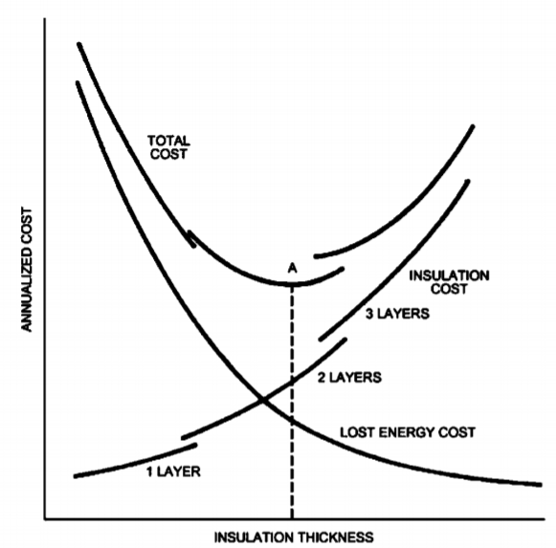
Figure 2. Determination of Economic Thickness of heat insulation materials – point A.

Initially, as insulation is applied, the total life-cycle cost decreases because the value of incremental energy savings is greater than the incremental cost of insulation. Additional insulation reduces total cost up to a thickness where the change in total cost is equal to zero. At this point, no further reduction can be obtained; beyond it, incremental insulation costs exceed the additional energy savings derived by adding another increment of insulation.
- Faults in heat insulation systems – heat losses
Conductive losses through the building fabric can be split into two categories:
1. Plane heat losses: through the main elements of the building fabric (roof, walls, windows and floor). The U-value (W/m²K) of a construction multiplied by the area of that construction gives the heat loss in (W/K).
2. Thermal bridge heat losses: through corners, junctions, and structural elements penetrating the insulation layer.
Plane heat losses is relatively easy to prevent, by adding extra layer of heat insulation material.
A thermal bridge occurs when there is a gap between materials and structural surfaces. The main thermal bridges in a building are found at the junctions of facings and floors, facings and cross walls; facings and roofs, facings and low floors. They also occur each time there is a hole (doors, windows, loggias etc.) These are structural thermal bridges. These thermal bridges vary in importance according to the type of wall or roof (insulated or not).
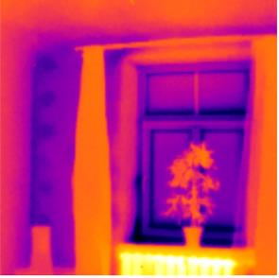 |  | 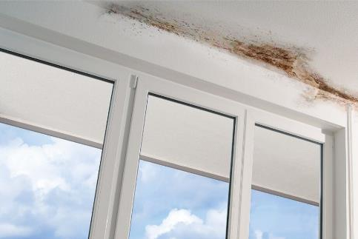
A. |  | B.
Figure 3. Thermal bridges in construction. A. in thermal camera view its marked in blue color (in inside of room view); B. Photograph showing mould growth on the ceiling of a concrete slab adjacent to an exposed slab edge thermal bridge. Condensation forms here frequently as a result of colder interior surface temperatures.

In a building that is not properly insulated, thermal bridges represent low comparative losses (usually below 20%) as total losses via the walls and roof are very high (about >1W/m²K).
However, when the walls and roof are very well insulated, the percentage of loss due to thermal bridges becomes high (more than 30%) but general losses are very low (less than 0.3 W/m²K). That is why in low energy consuming buildings, it is important to have very high thermal resistances for walls and roofs to have low heat losses via the junctions.
Integrated thermal bridges - heat insulation errors are made in design stage
A wall or floor almost always consists of several components pasted, screwed or mechanically assembled together. If they are not well designed, these assembly systems can produced thermal bridges within the system, hence their name of integrated thermal bridges.
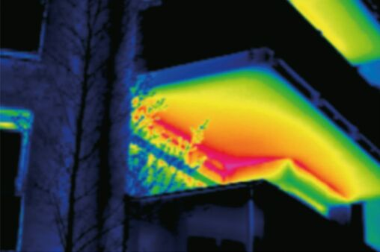
Figure 4. Infrared scan of a balcony thermal bridge with higher temperatures at the exterior slab.

How to act on thermal bridges?
At the design level, it is imperative to choose construction processes and components that reduce surface losses as much as possible and integrate the smallest possible losses in the junctions of these surfaces.
- LIST OF REFERENCES

- Steico Steico.com
- Benjamin Durakovic, Gökhan Yildiz, Mohamed E Yahia (2020) Comparative Performance Evaluation of Conventional and Renewable Thermal Insulation Materials Used in Building Envelope. ISSN 1330-3651 (Print), ISSN 1848-6339 (Online). Accs: https://hrcak.srce.hr/file/340548 DOI: https://doi.org/10.17559/TV-20171228212943
- Climat technology centre & network (2021) Building envelope thermal insulation. Accs. https://www.ctc-n.org/technologies/building-envelope-thermal-insulation
- Energy gov (2020) Types of Insulation. Accs. https://www.energy.gov/energysaver/weatherize/insulation/types-insulation
- Ing dep (2017) Termiskie tilti (Thermal bridges). In Latvian. Accs. http://www.ingdep.lv/lv/termiskie-tilti
- Saint Gobain Isover (2020) What is a termal bridge? Accs. https://www.isover.com/what-thermal-bridge
- ASHRAE (2013) Handbook: Fundamentals, I-P Edition ISBN 978-1-936504-46-6 or ISSN 1523-7230
- Engineering tool box. Thermal Conductivity of some selected Materials and Gases. Accs. https://www.engineeringtoolbox.com/thermal-conductivity-d_429.html
- Passipedia (2019) Heating load in Passive Houses. Accs. https://www.passipedia.org/basics/building_physics_-_basics/heating_load
- Dylewski R. and Adamczyk J. (2011) Economic and environmental benefits of thermal insulation of building external walls. Building and Environment, Vol.46, Issue 12, December 2011, Pages 2615-2623
- Building energy rating Ireland (2011) BER Certs. Accs. http://www.buildingenergyireland.ie/BERCerts.htm

