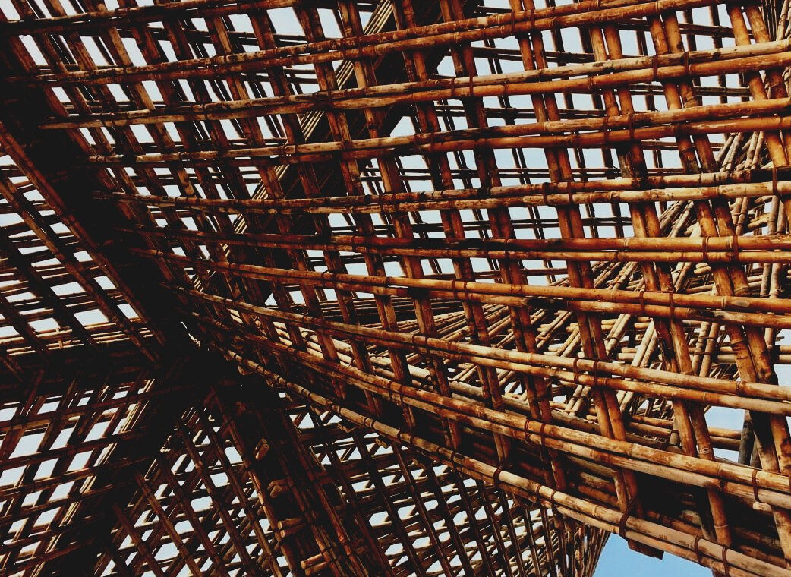

UPWOOD
Up-skilling construction workers in wood construction methods for energy-efficient buildings

UPWOOD
Up-skilling construction workers in wood construction methods for energy-efficient buildings

methods for energy-efficient buildings

UPWOOD
Up-skilling construction workers in wood construction methods for energy-efficient buildings

methods for energy-efficient buildings

UPWOOD
Up-skilling construction workers in wood construction methods for energy-efficient buildings

methods for energy-efficient buildings

UPWOOD
Up-skilling construction workers in wood construction methods for energy-efficient buildings

truction methods for energy-efficient buildings

UPWOOD
Up-skilling construction workers in wood construction methods for energy-efficient buildings

methods for energy-efficient buildings

UPWOOD
Up-skilling construction workers in wood construction methods for energy-efficient buildings

methods for energy-efficient buildings

UPWOOD
Up-skilling construction workers in wood construction methods for energy-efficient buildings

methods for energy-efficient buildings

UPWOOD
Up-skilling construction workers in wood construction methods for energy-efficient buildings

TRAINING & ASSESSMENT
MATERIAL

Learning Unit 4

TRAINING & ASSESSMENT
MATERIAL

Learning Unit 4
- Lesson 1: Energy-efficiency value of wood as a building material and wooden constructions.

TRAINING & ASSESSMENT
MATERIAL

Learning Unit 4
- Lesson 1: Energy-efficiency value of wood as a building material and wooden constructions.

TRAINING & ASSESSMENT
MATERIAL

Learning Unit 4
- Lesson 1: Energy-efficiency value of wood as a building material and wooden constructions.

TRAINING & ASSESSMENT
MATERIAL

Learning Unit 4
- Lesson 1: Energy-efficiency value of wood as a building material and wooden constructions.

TRAINING & ASSESSMENT
MATERIAL

Learning Unit 4
- Lesson 1: Energy-efficiency value of wood as a building material and wooden constructions.

TRAINING & ASSESSMENT
MATERIAL

Learning Unit 4
- Lesson 1: Energy-efficiency value of wood as a building material and wooden constructions.

TRAINING & ASSESSMENT
MATERIAL

Learning Unit 4
- Lesson 1: Energy-efficiency value of wood as a building material and wooden constructions.

CONTENT
1. CONTENT 1
2. CASE STUDIES 3
CASE STUDY 1 3
CASE STUDY 2 6
CASE STUDY 3 7
CASE STUDY 4 8
CASE STUDY 5 12
CASE STUDY 6 15
CASE STUDY 7 17
CASE STUDY 8 20
CASE STUDY 9 23
CASE STUDY 10 25
CASE STUDY 10 27
CASE STUDY 11 29
3. QUESTIONS AND ANSWERS (FAQS) 31
4. MULTIPLE CHOICE QUESTIONS 37
5. CASE STUDIES AND APPLICATION SCENARIO ANALYSIS 44

CASE STUDIES

CASE STUDY 1
Calculation of the heat transmitted through a timber wall. Different cases.
4.1.1. Case of Spain & Greece
It is required to calculate the heat loss of a familiar house made out of wood. For that, one of the perimeter walls will be taken as reference.
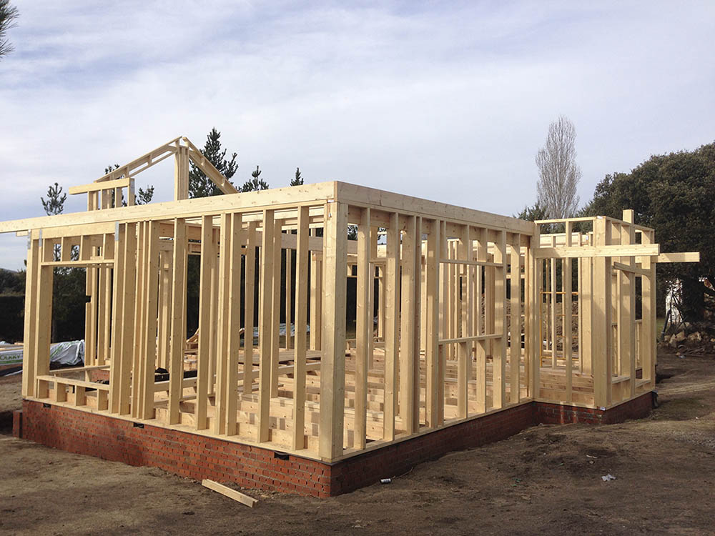
Fig. 1. Timber frame structure
Source 1. 100x100 Madera
For this case it is important to notice that the building is set in a warm environment like Spain or Greece, which means that the outer temperatures are soft in winter and can be hard in summer.
This wall of the house is part of the timber frame of the building, where the structure and the timber panels are made out of wood conformed of Nordic pine, which comes from Finland, and the insulation parts are conformed of organic insulation, particularly wood fiber. The wood has a thermal conductivity of 0,20 W/m*Cº, and the organic insulation has a thermal conductivity of 0,048 W/m*Cº.
Some other important features of these elements is the thickness of each layer composing the outer wall.
In this case, the perimeter wall is composed of the following layers:
- The outer surface is made of a 5 cm thick timber panels.
- The inner surface is also made of a 5 cm thick timber panels.
- Between the timber panels, there is a 30 cm layer of organic insulation, which in this case is wood fiber.
Given this previous information:
- What is the rate of heat loss per unit area of wall?

Solution:
In order to calculate the heat transfer through the wall, it can be expressed with "Fourier's Law“:
$U=\frac{1}{R}$ = $\frac{1}{\frac{s1}{λ1}+\frac{s2}{λ2}+\frac{s3}{λ3}…}$
Q $=U·A·dT=\left(\frac{1}{R}\right)·A·dT$

Where:
q= $\left(\frac{Q}{A}\right)$ Heat transfer per unit area ($\left(\frac{W}{A}\right)$, $\left(\frac{J}{A·s}\right)$)
$λ$ = Total thermal conductivity of the material $\left(\frac{W}{m·K}\right)$
s = material thickness (m)
A = heat transfer area ($m^{2}$)
R = $\frac{s}{λ}$ = Thermal resistance ($\frac{m^{2}·K}{W})$
U = Coefficient of Heat Transfer or Thermal transmittance $\left(\frac{W}{m^{2}·K}\right)$
dT = $T_{1}-T_{2}$= temperature gradient - difference over the material (°C, °F)

Aside of the data provided by the exercise, checking the different technic documents, the following features should be considered:
- Inner panel, considering the Wood as heavy conifer: $λ$1 = 0.18 W/m·°C, s1=5 cm.
- Wood fiber: $λ$2= 0.040 W/m·°C, s2=25 cm.
- Outer panel: $λ$3 = 0.18 W/m·°C, s3=5 cm.
- Inner temperature: Tin=20 °C.
- Outer temperature: Tout=5 °C.

Then, in order to calculate the heat loss per unit area, using the Fourier’s equation and the data provided:
q = $\frac{Q}{A}$ $=\left(\frac{1}{R}\right)·dT=(\frac{1}{\frac{s}{λ}})·{(T}_{1}-T_{2})$
Q $=U·A·dT=\left(\frac{1}{R}\right)·A·dT$

q = $\frac{Q}{A}$ $=\left(\frac{\text{1}}{\frac{0.05}{0.18}+\frac{0.25}{0.040}+\frac{0.05}{0.18}}\right)(\frac{W}{m^{2}·\text{°}\text{C}})·\left(20-5\right)(\text{°}\text{C})=0.1469·15=$ 2.21 $\left(\frac{W}{m^{2}} \right)$
The rate of heat loss per unit area obtained is 2,21 $\left(\frac{W}{m^{2}} \right)$.

CASE STUDY 2
Following the same typology than in the Case study 1, in this case the development of the case study will consider different locations and their adverse climates. These would be the case of locations like Austria or Latvia.
In this case, using the same procedure than in the previous case study, the following data will be used, in order to obtain the rate of heat loss per unit area of wall.
- Inner panel, considering the Wood as heavy conifer: $λ$1 = 0.18 W/m·°C, s1=5 cm.
- Wood fiber: $λ$2= 0.040 W/m·°C, s2=25 cm.
- Outer panel: $λ$3 = 0.18 W/m·°C, s3=5 cm.
- Inner temperature: Tin=20 °C.
- Outer temperature: Tout=0 °C.
For this reason, in order to calculate the heat loss per unit area, using the Fourier’s equation and the data provided the following result is obtained:
q = $\frac{Q}{A}$ $=\left(\frac{1}{R}\right)·dT=(\frac{1}{\frac{s}{λ}})·{(T}_{1}-T_{2})$
Q $=U·A·dT=\left(\frac{1}{R}\right)·A·dT$

q = $\frac{Q}{A}$ $=\left(\frac{\text{1}}{\frac{0.05}{0.18}+\frac{0.25}{0.040}+\frac{0.05}{0.18}}\right)(\frac{W}{m^{2}·\text{°}\text{C}})·\left(20-0\right)(\text{°}\text{C})=0.1469·20=$ 2.94 $\left(\frac{W}{m^{2}} \right)$
The rate of heat loss per unit area obtained is 2,94 $\left(\frac{W}{m^{2}} \right)$.

CASE STUDY 3
Following the same typology than in the Case studies 1 and 2, in this case the development of the case study will consider different locations and their adverse climates. These would be the case of locations like Finland, where the temperatures in winter use to get really low.
In this case, using the same procedure than in the previous case study, the following data will be used, in order to obtain the rate of heat loss per unit area of wall.
- Inner panel, considering the Wood as heavy conifer: $λ$1 = 0.18 W/m·°C, s1=5 cm.
- Wood fiber: $λ$2= 0.040 W/m·°C, s2=25 cm.
- Outer panel: $λ$3 = 0.18 W/m·°C, s3=5 cm.
- Inner temperature: Tin=20 °C.
- Outer temperature: Tout=-10 °C.

For this reason, in order to calculate the heat loss per unit area, using the Fourier’s equation and the data provided the following result is obtained:
q = $\frac{Q}{A}$ $=\left(\frac{1}{R}\right)·dT=(\frac{1}{\frac{s}{λ}})·{(T}_{1}-T_{2})$
Q $=U·A·dT=\left(\frac{1}{R}\right)·A·dT$

q = $\frac{Q}{A}$ $=\left(\frac{\text{1}}{\frac{0.05}{0.18}+\frac{0.25}{0.040}+\frac{0.05}{0.18}}\right)(\frac{W}{m^{2}·\text{°}\text{C}})·\left(20-(-10)\right)(\text{°}\text{C})=0.1469·30=$ 3.6$\left(\frac{W}{m^{2}} \right)$
The rate of heat loss per unit area obtained is 3.6 $\left(\frac{W}{m^{2}} \right)$.

CASE STUDY 4
Energy saving comparative between different Wood materials.
To make a proper design of a building, it is necessary to know the properties of the chosen materials.
In case of wood, we can find several types, although they have not the same properties. That is why it is so important to know de different features of each specific wood materials.
For that reason, we need to calculate the heat transmission of the walls, depending on the type of wood which composes It. To make it easier, we will make a differentiation between conifer and leafy types of wood.
The conifer wood has a lower thermal transmittance than the leafy wood. That is why the conifer woods expose a better behaviour against heat loss and therefore a better results in sustainability, since they act as better insulation systems.

In this case we will study and make a comparison between some of the most common timber materials for construction:
- Nordic pine
- Oak
- Fir

Depending on the type of wood, the inner composition has a different behaviour in terms of thermal isolation. That is why it is important to know the properties of the chosen material for construction.

The three materials we are going to analyse are the following ones:
Fir
Oak
Nordic pine
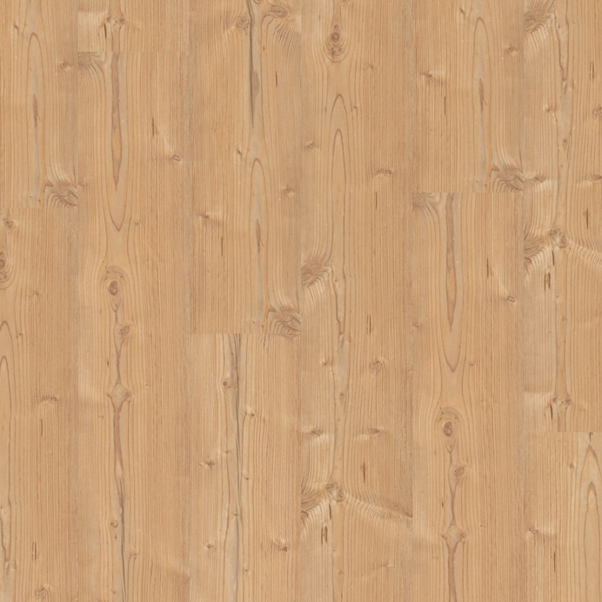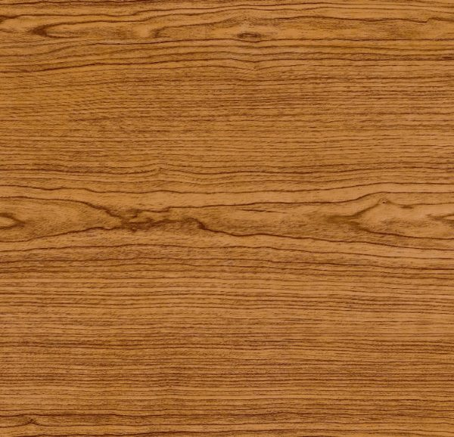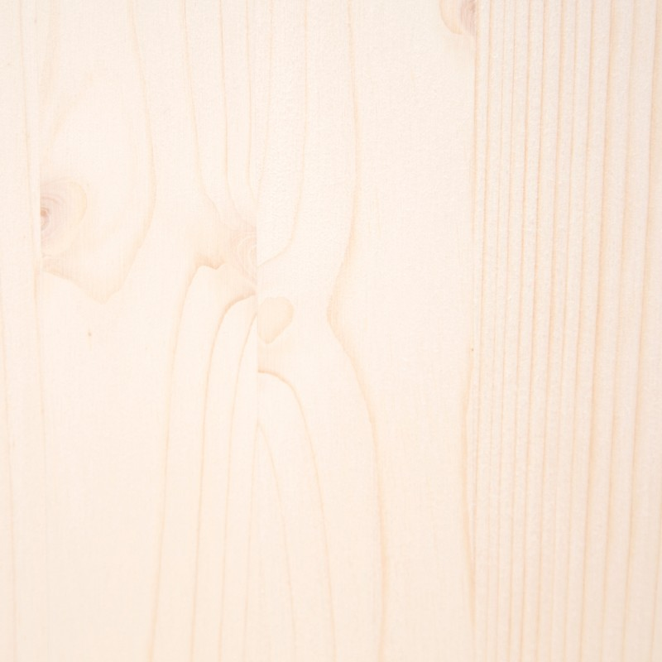
As seen in the previous case study, the U value is the most characteristic one to check the behaviour of the material in the wall. It defines the thermal transmittance of the wall.
For both cases, we will consider a wood board of 10 cm thickness as a wall.
The Nordic Pine, as a heavy conifer wood, has a thermal transmittance value of 0,18 W/m·K.
The Oak, as a half-weight leafy wood, has a thermal transmittance value of 0,18 W/m·K.
The Fir, as a half-weight conifer wood, has a thermal transmittance value of 0,15 W/m·K.
Given this information,
which is the U-value of the different wood materials we are aiming to study?
And,
which one has a better behaviour in terms of energy saving?

Solution:
With the aim of calculating the heat transfer through the material board, it can be expressed with the following expression:
U = $\frac{1}{R}=\frac{1}{s/λ}=\frac{λ}{s}$

Where:
U = Coefficient of Heat Transfer or Thermal transmittance $\left(\frac{W}{m^{2}·K}\right)$
$λ$ = Total thermal conductivity of the material $\left(\frac{W}{m·K}\right)$
s = material thickness (m)
R = $\frac{s}{λ}$ = Thermal resistance ($\frac{m^{2}·K}{W})$
With the data provided by the exercice, checking the CTE, there can be identified:
- Nordic pine, considering it as heavy conifer: $λ$1 = 0.18 W/m·°C, s1=10 cm.
- Oak: considering it as half-weight leafy wood: $λ$2= 0.18 W/m·°C, s2=10 cm.
- Fir: considering it as half-weight conifer Wood: $λ$3 = 0.15 W/m·°C, s3=10 cm.
- Inner temperature: Tin=20 °C.
- Outer temperature: Tout=5 °C.
To get the heat transfer U of each material, we will get the thermal resistance R, with the given values of e and $λ$.

In order to calculate the heat transfer of each material per unit area, using the given equation and the data provided:
U = $\frac{λ}{s}=\frac{0,18}{0,1}=1,8\frac{W}{m^{2}·\text{°}\text{C}}$
Nordic Pine
U = $\frac{λ}{s}=\frac{0,18}{0,1}=1,8\frac{W}{m^{2}·\text{°}\text{C}}$
U = $\frac{1}{R}=\frac{1}{s/λ}=\frac{λ}{s}$
Oak
U = $\frac{λ}{s}=\frac{0,15}{0,1}=1,5\frac{W}{m^{2}·\text{°}\text{C}}$
Fir

Given the values of thermal transmittance of each wood specie, we can conclude that:
the wood with the best values in terms of thermal insulation is the Fir.
U = $\frac{λ}{s}=\frac{0,15}{0,1}=1,5\frac{W}{m^{2}·\text{°}\text{C}}$
Fir
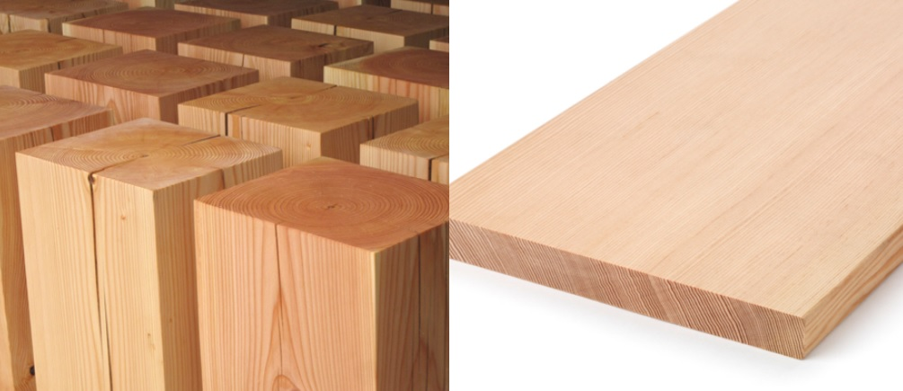

CASE STUDY 5
Energy saving comparison between different building systems in terms of heat transmittance.
The aim of the timber structures implementation is to replace the conventional construction systems, which present several issues in terms of sustainability.
Nevertheless, to check if these timber solutions are optimal for its use, it is very important to verify if they will accomplish all aspects in terms of insulation, and see if they even present improvements in comparison with the conventional ones.
Then,
given three different wall execution systems, what are the values of heat transmittance of each of them?
And,
Which one presents a better behaviour?
For the development of the study case, the following data is provided:
- The heat loss of each solution will be calculated in terms of $\frac{W}{m^{2}}$.
- The necessary layers for the conditioning of these walls will also be considered.
- These are the three wall construction systems to study:
Ceramic bricks wall
Concrete wall
Timber frame wall
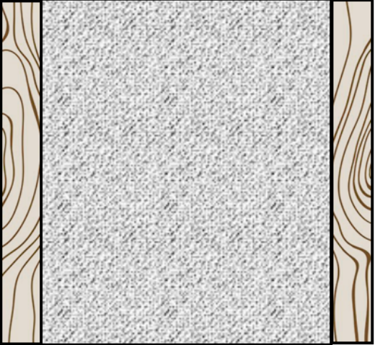
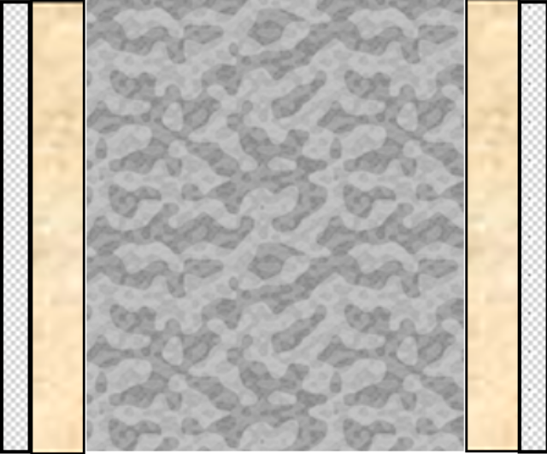
AIR

Solution

With the data provided by the exercise, checking the CTE, the following thermal conductivities and thicknesses can be identified for each constructive solution.

Ceramic wall:
- Inner panel, plaster panels: $λ$1 = 0.25W/m·°C, s1=1 cm.
- Air chamber: $λ$2= 0.024 W/m·°C, s2= 5 cm.
- Insulation, mineral wool: $λ$3 = 0.18 W/m·°C, s3=5 cm.
- Ceramic bricks wall: $λ4$ = 0.35 W/m·°C, s4=24 cm.

Concrete wall:
- Outer/inner panel, plaster: $λ$1 = 0.25 W/m·°C, s1=1 cm.
- Insulation, mineral wool: $λ$2= 0.018 W/m·°C, s2=5 cm.
- Reinforced Concrete: $λ$3 = 2 W/m·°C, s3=20 cm.

Timber wall:
- Inner panel, Wood panels: $λ$1 = 0.18 W/m·°C, s1=5 cm.
- Wood fiber: $λ$2= 0.040 W/m·°C, s2=25 cm.
- Outer panel, Wood panels: $λ$3 = 0.18 W/m·°C, s3=3 cm.

With the aim of calculating the heat transfer through the wall, the solution will be expressed with "Fourier's Law“:
$U=\frac{1}{R}$ = $\frac{1}{\frac{s1}{λ1}+\frac{s2}{λ2}+\frac{s3}{λ3}…}$
Q $=U·A·dT=\left(\frac{1}{R}\right)·A·dT$

Where:
q= $\left(\frac{Q}{A}\right)$ Heat transfer per unit area ($\left(\frac{W}{A}\right)$, $\left(\frac{J}{A·s}\right)$)
$λ$ = Total thermal conductivity of the material $\left(\frac{W}{m·K}\right)$
s = material thickness (m)
A = heat transfer area ($m^{2}$)
R = $\frac{s}{λ}$ = Thermal resistance ($\frac{m^{2}·K}{W})$
U = Coefficient of Heat Transfer or Thermal transmittance $\left(\frac{W}{m^{2}·K}\right)$
dT = $T_{1}-T_{2}$= temperature gradient - difference over the material (°C, °F).

Developing the formula, it would be expressed as follows:

Q $=U·A·dT=\left(\frac{1}{R}\right)·A·dT$ q = $\frac{Q}{A}$ $=\left(\frac{1}{R}\right)·dT=(\frac{1}{\frac{s}{λ}})·{(T}_{1}-T_{2})$
Then, the heat transfer for each constructive solution would be the following ones:

- Ceramic
AIR

q = $\frac{Q}{A}$ $=\left(\frac{\text{1}}{\frac{0.01}{0.25}+\frac{0.05}{0.024}+\frac{0.05}{0.018}+\frac{0.24}{0.35}}\right)\left(\frac{W}{m^{2}·\text{°C}}\right)·\left(20-5\right)\left(\text{°C}\right)$ $=0.182·15=$ 2.72 $\left(\frac{W}{m^{2}} \right)$

- Concrete

q = $\frac{Q}{A}$ $=\left(\frac{\text{1}}{\frac{0.01}{0.25}+\frac{0.05}{0.018}+\frac{0.2}{2.5}+\frac{0.05}{0.018}+\frac{0.01}{0.25}}\right)\left(\frac{W}{m^{2}·\text{°C}}\right)·\left(20-5\right)\left(\text{°C}\right)=0.1754·15= 2.63\left(\frac{W}{m^{2}} \right)$

- Timber

q = $\frac{Q}{A}$ $=\left(\frac{\text{1}}{\frac{0.05}{0.18}+\frac{0.25}{0.040}+\frac{0.05}{0.18}}\right)(\frac{W}{m^{2}·\text{°C}})·\left(20-5\right)(\text{°C})=0.1469·15=$ 2.21 $\left(\frac{W}{m^{2}} \right)$

Given the values of thermal transmittance of each wall solution, we can conclude that:
the wall with the best values in terms of thermal insulation is the wooden one.

Timber frame wall q = $\frac{Q}{A}$ $=$ 2.21 $\left(\frac{W}{m^{2}} \right)$

CASE STUDY 6
Energy saving comparison between different building systems in terms of process costs.

The aim of the timber structures implementation is to replace the conventional building systems, which present several issues in terms of sustainability.
Nevertheless, In real life all the companies look for the cheapest way to get their construction systems done. Then,

given three different wall execution systems, what are the costs of each one of their execution?

And, which one presents a better price?

Solution:

- In these cases only the process costs of the main materials and the insulation materials will be considered.
- For this, the costs of all the materials and the respective wall systems executions will determine the total price of the process.
- These are the three wall construction systems to study:

Ceramic bricks wall Concrete wall Timber frame wall
AIR

- Ceramic bricks wall
- Material costs:
Insulation: Mineral wool = 5€ $m^{2}$
Main material: Ceramic brick = 9,19€ $m^{2}$

- Execution costs:
Insulation: Mineral wool = 3,70€ $m^{2}$
Main material: Ceramic brick = 14,2€ $m^{2}$

- Total costs:
Insulation: Mineral wool = 8,70€ $m^{2}$
Main material: Ceramic brick = 23,4€ $m^{2}$

- Concrete wall
- Material costs:
Insulation: Mineral wool = 10€ $m^{2}$
Main material: Reinforced concrete = 80€ $m^{2}$

- Execution costs:
Insulation: Mineral wool = 7,40€ $m^{2}$
Main material: Reinforced concrete = 9,30€ $m^{2}$

- Total costs:
Insulation: Mineral wool = 17,40€ $m^{2}$
Main material: Reinforced concrete = 89,30€ $m^{2}$

- Timber frame wall
- Material costs:
Insulation: Wood fiber = 30€ $m^{2}$
Main material: Norther pine wood panels 40€ $m^{2}$

- Execution costs:
Insulation: Wood fiber = 4,43€ $m^{2}$
Main material: Norther pine wood panels = 29,20€ $m^{2}$

- Total costs:
Insulation: Wood fiber = 34,43€ $m^{2}$
Main material: Norther pine wood panels = 69,20€ $m^{2}$

In this case, it can be seen that the ceramic brick wall solution is the cheapest one. Nevertheless, timber frame wall solutions are still a little cheaper than concrete solutions.

CASE STUDY 7
Distinction between different organic isolation materials in terms of termal conductivity.
Since the recent world concern about the nature of the materials, and the aim of a whole substitution of synthetic materials for some more organic materials is present nowadays, it is necessary to be aware of the insulation material alternatives to the traditional ones.
Some of the most common organic materials are the following ones:
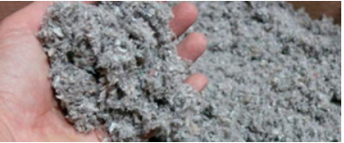Natural cellulose
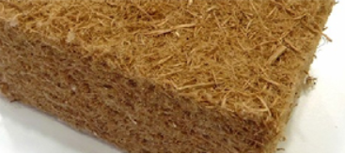Wood fibers
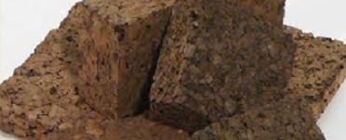Natural Cork
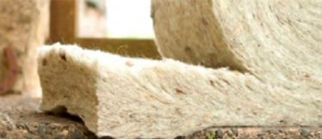Sheep wool
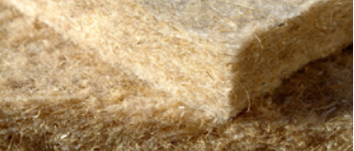Hemp insulation
For this reason, given a set of organic insulation materials.
What is their behaviour in terms of insulation?

Solution:
In order to get the thermal transmittance values of these insulation materials, different technical documents have been checked, determining the following data for each material:
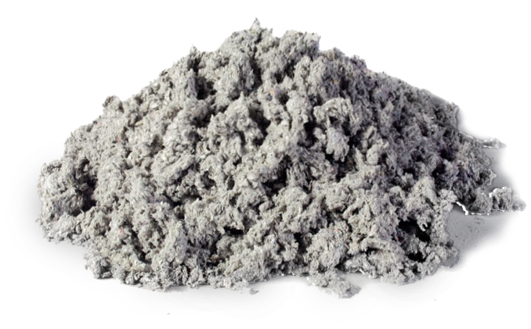
Natural cellulose
Thermal transmittance: 0,04 $\frac{W}{m^{2}·K}$

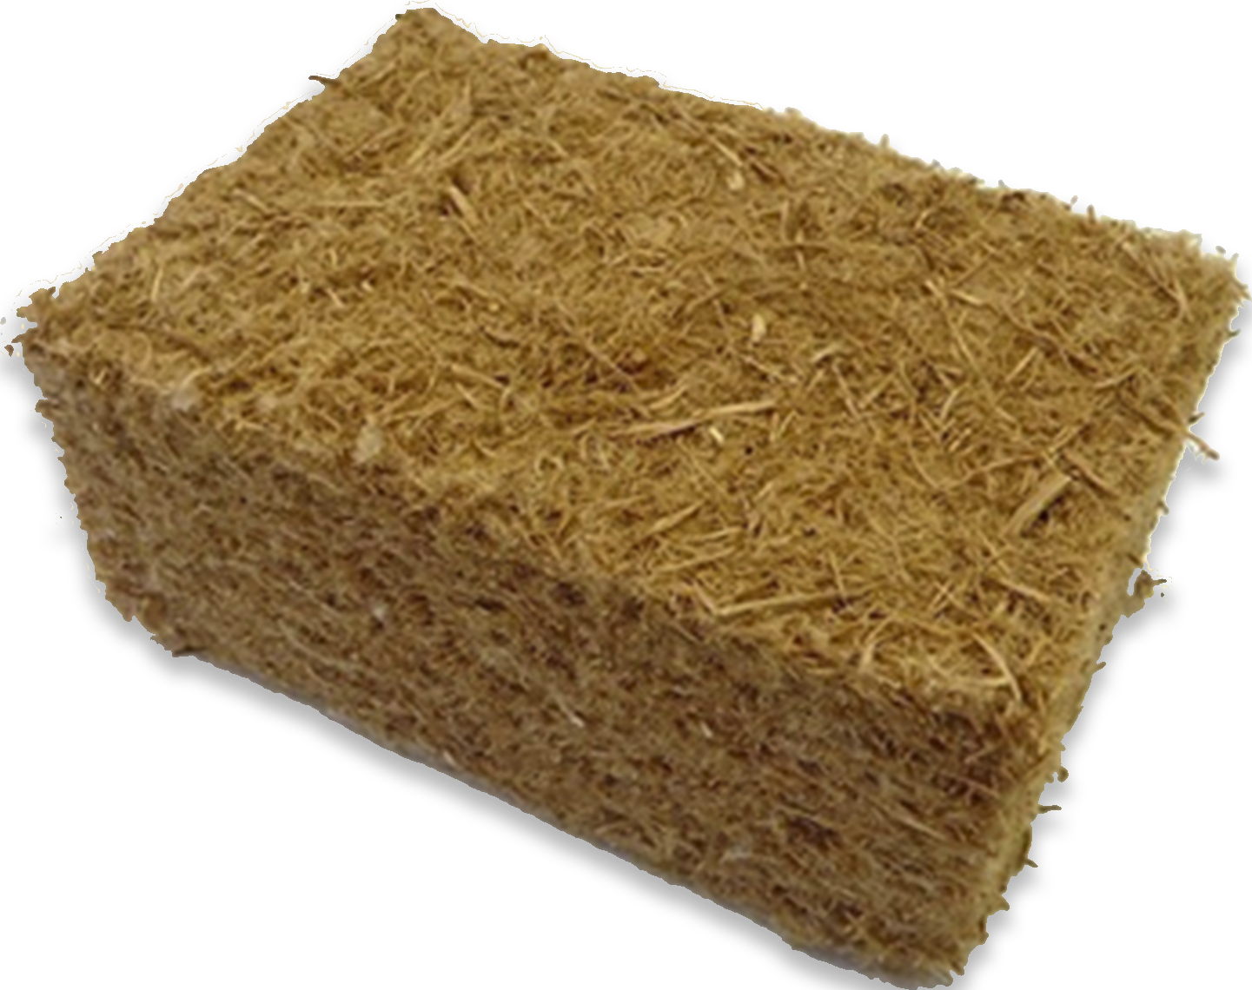

Wood fibers
Thermal transmittance: 0,048 $\frac{W}{m^{2}·K}$
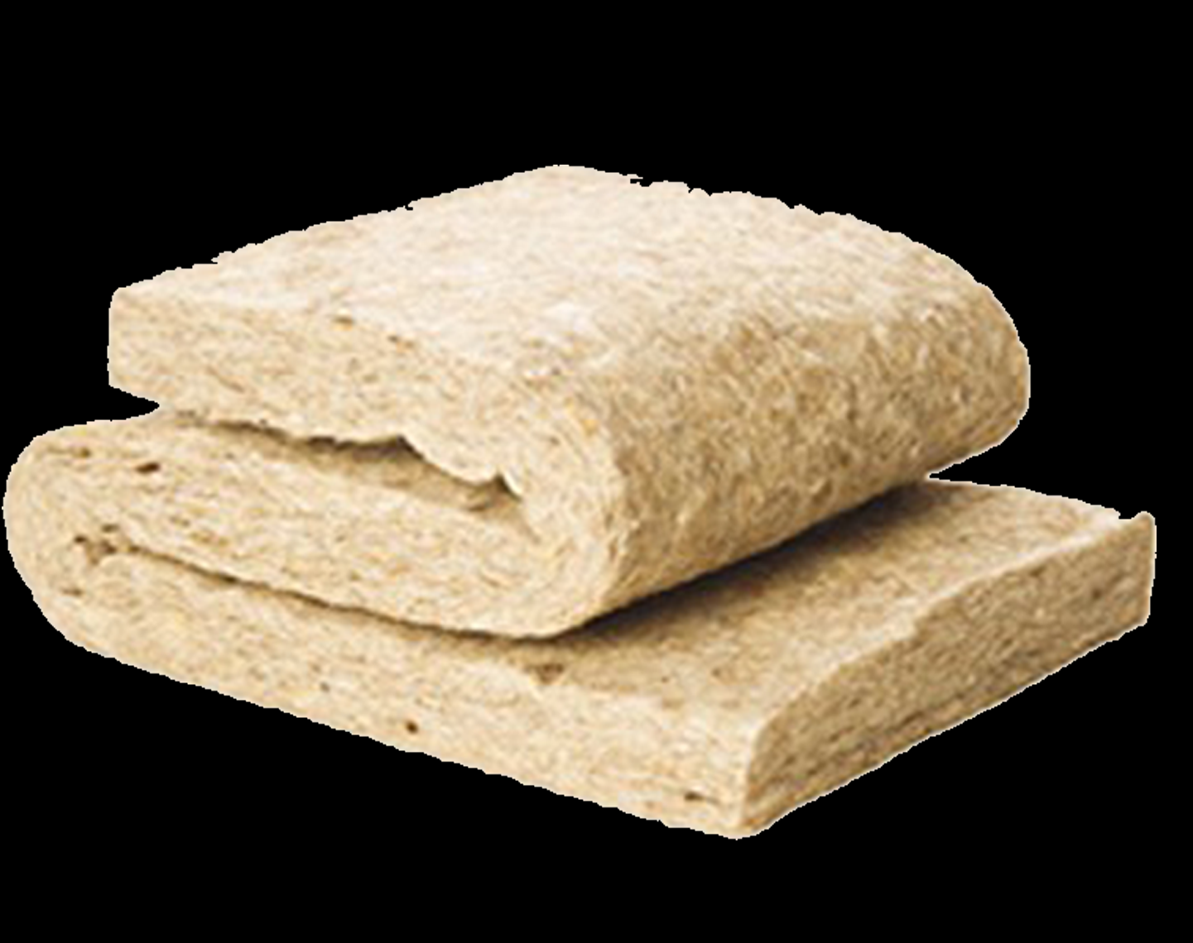

Sheepwool
Thermal transmittance: 0,042 $\frac{W}{m^{2}·K}$

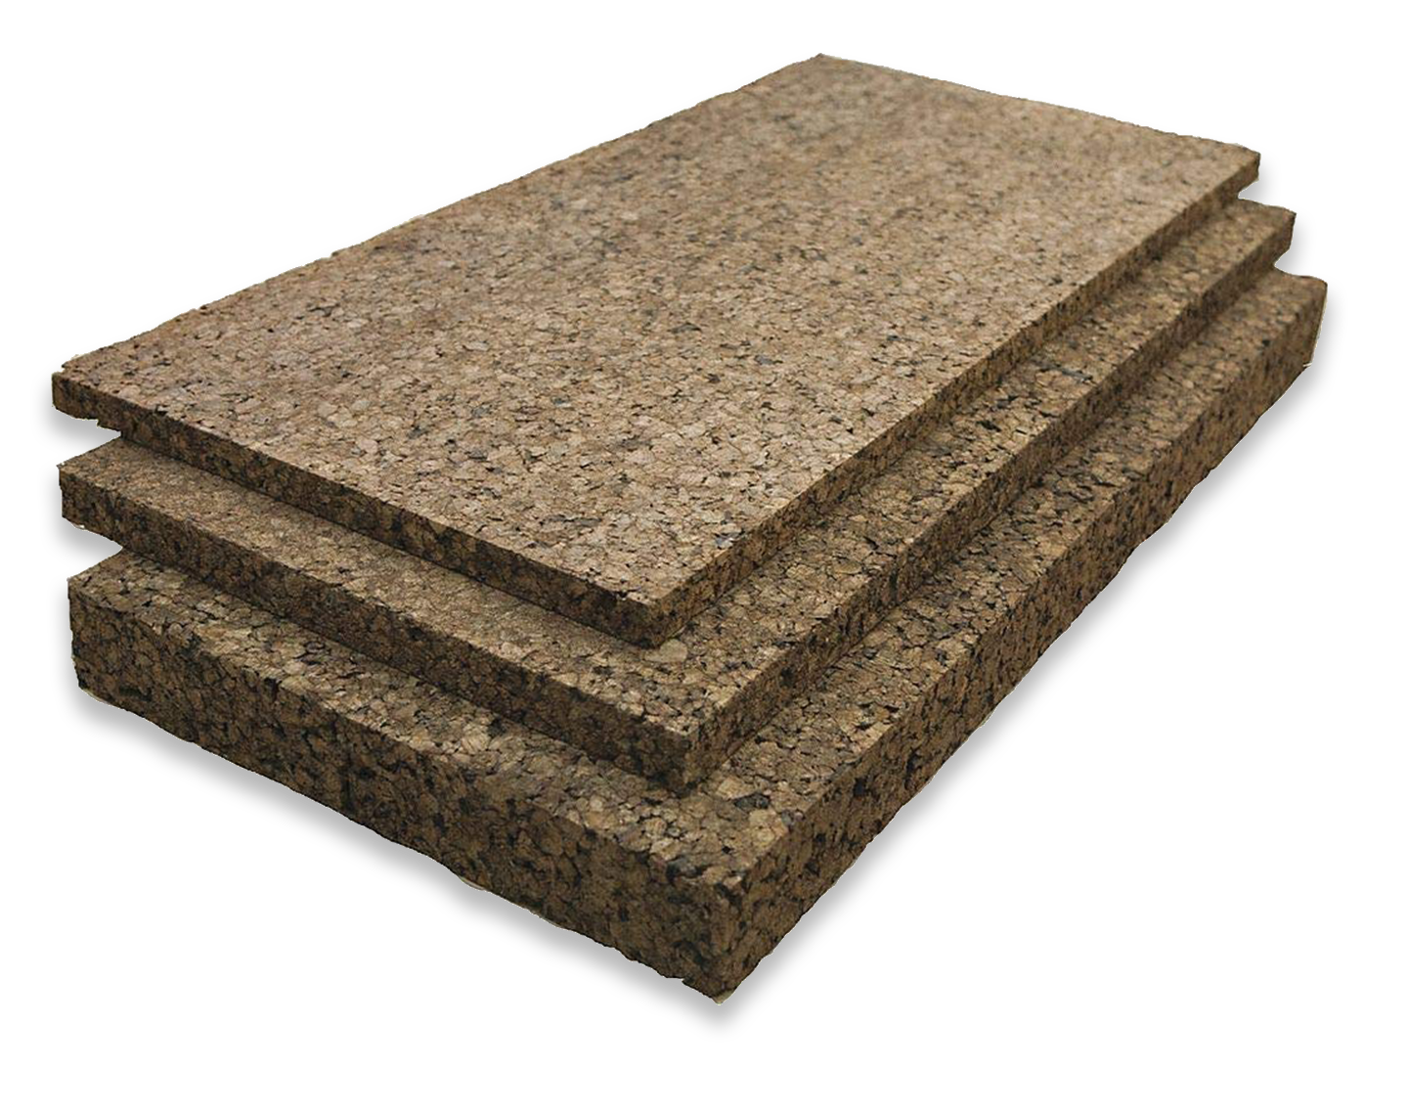

Natural cork
Thermal transmittance: 0,04 $\frac{W}{m^{2}·K}$

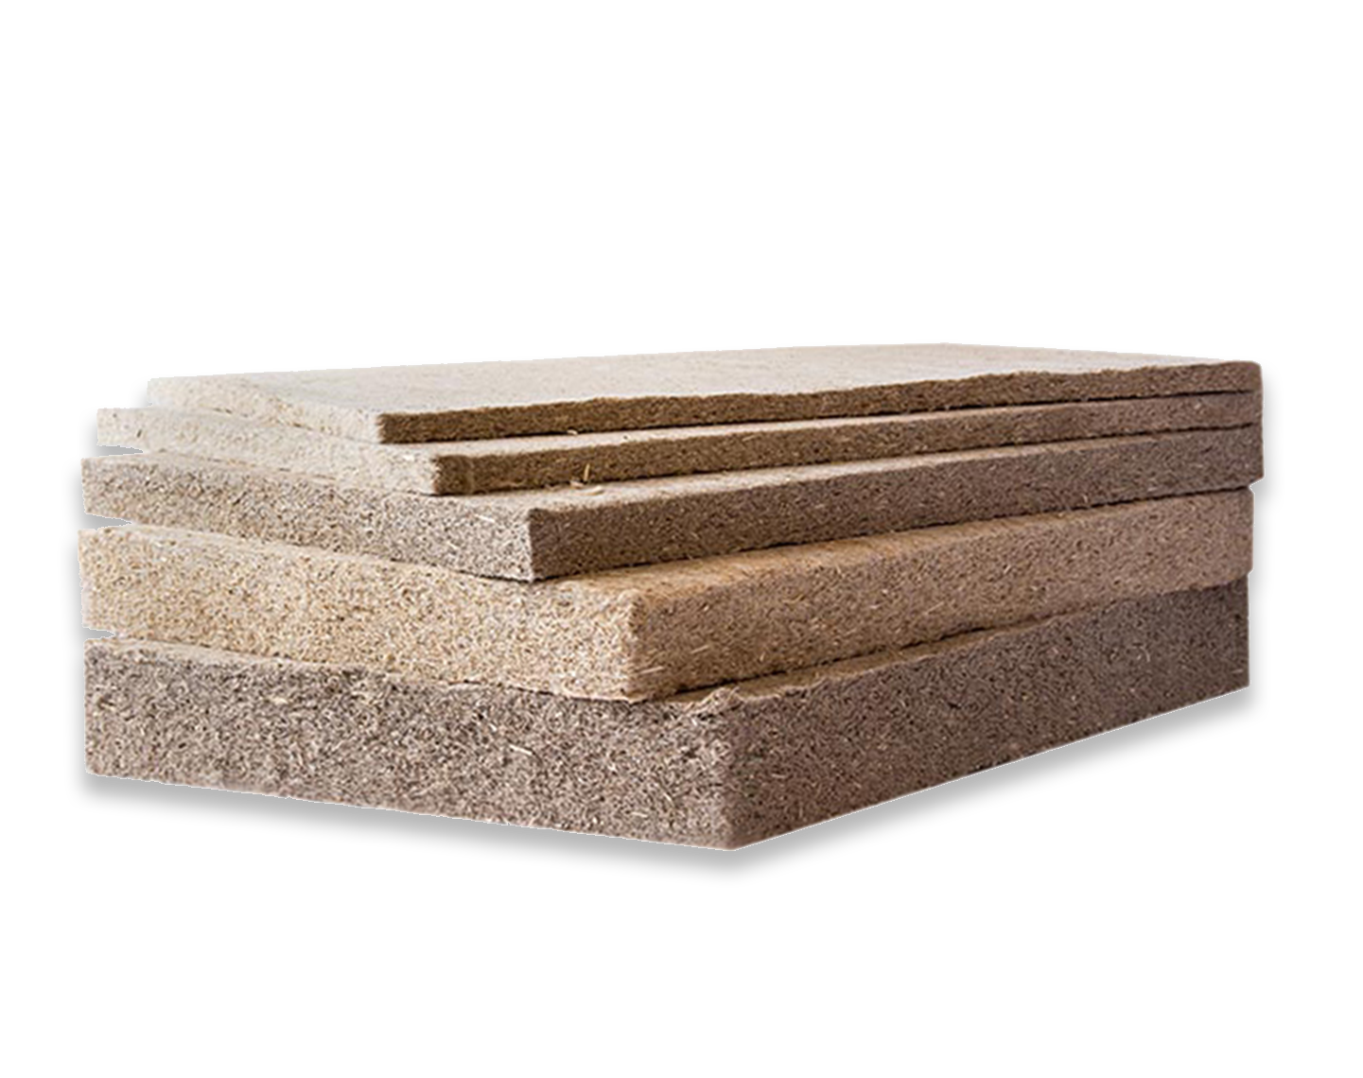

Hemp Insulation
Thermal transmittance: 0,038 $\frac{W}{m^{2}·K}$

In this case it can be visible that all these insulations present an average value of thermal transmittance of 0,040 $\frac{W}{m^{2}·K}$, which proves that organic insulations are as legitimate as the rest of conventional materials.

CASE STUDY 8
Required conditions to get the “passive house” recognition.
Nowadays, in a building construction it very important to have in consideration its energy-eficiency, since it establishes the consumption of the building.
For this reason, every day it is more important to look for the lowest possible consumption in the buildings.
There are already some recognitions which establish some requirements to get them, and get a recognition as a building with low consumption. This is the case of the recognition Passive House Institute, which is based on building constructions that have great thermal insulation, a strict control of infiltrations, and a maximum indoor air quality, in addition to taking advantage of the sun's energy for better air conditioning, reducing energy consumption of the order of 70% (over the conventional constructions).
To get this recognition there are some conditions to take in account, but some of them are essential to ensure a good quality place to live.

Some of these most important values to have in account are:
- Building orientation and Sun Energy exploitation.
- Control of infiltrations.
- Control of air renovation.
- Thermal insulation.

Having in account that in this program we aim to implement the use of wood in construction, the only value which depends entirely on the construction material is the thermal insulation, which requires a maximum thermal transmittance value of 0,12 $\frac{W}{m^{2}·K}$.
Then, assuming that the values of orientation, infiltrations control and air renovation control are adequate for obtaining the passive house recognition,
Set an example of timber frame wall which would accomplish the thermal insulation requirements to reach the passive house recognition.

Solution:
To get a case of timber frame wall which accomplishes the thermal insulation requirements of the passive house recognition, it is necessary that the thermal transmittance (U) of the wall has a lower value than 0,12 $\frac{W}{m·K}$.
This U-value is taken from the formula: $\frac{1}{s/λ}$
Where:
- s = Material thickness (m)
- $λ\text{ = Total thermal conductivity of the material }\left(\frac{W}{m·K}\right)$
So, if we aim to get a wall considered passive, the set of the parts of that wall need to reach a U value lower than 0,12 W/$m^{2}$K.

This means that, since the thermal conductivities of the materials ($λ$) are constant, the value which must be determined to raise the required U-value is the thickness of each material, until the thermal transmittance of the whole wall gets the required value of 0,12 $\frac{W}{m·K}$.
- Given the thermal conductivity of each material:

Timber wall:
- Inner panel, Wood panels: $λ$1 = 0.18 W/m·°C. ${ S}_{1}$
- Wood fiber: $λ$2= 0.040 W/m·°C. $S_{2}$
- Outer panel, Wood panels: $λ$3 = 0.18 W/m·°C.${ S}_{1}$

- And the stablished formula:
$$\frac{1}{s/λ}$$

The required thickness of each material is determined:
$$\frac{1}{S/λ}=0,12\frac{W}{m·K}$$

$$\frac{1}{\frac{S_{1}}{0,18}+\frac{S_{2}}{0,04}+\frac{S_{1}}{0,18}}=0,12\frac{W}{m·K}$$

$$S_{1}=0,075m$$
$$S_{2}=0,30m$$

It is determined that the required thickness of each layer is 0,30m for the wood fiber insulation material, and 0,18 m for each one of both wood panels.

CASE STUDY 9
Relative humidity control in a timber framed building

Usually, when talking about the comfort in interior spaces, the main focus is in the temperature control, but there is another factor which is as important: The relative humidity.
One of the best applicable properties of wood in interior spaces design is the control of the relative humidity in interior spaces. Given the hygroscopic properties of the wood, the timber buildings are great for the natural humidity regulation of the interior spaces.
The relative humidity is one of the main factors to regulate de comfort inside of a building. The appropriate humidity level is essential for a human body to regulate its temperature with regard to its surrounding air.
The humidity is variable during the time, and fluctuates specially between summer and winter.
Then, if the materials which compose the main surfaces of the interior spaces are composed of wood materials,
What is the behaviour of the wood about the relative humidity in interior spaces?
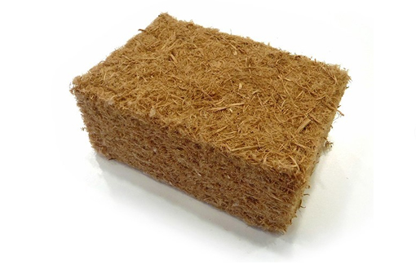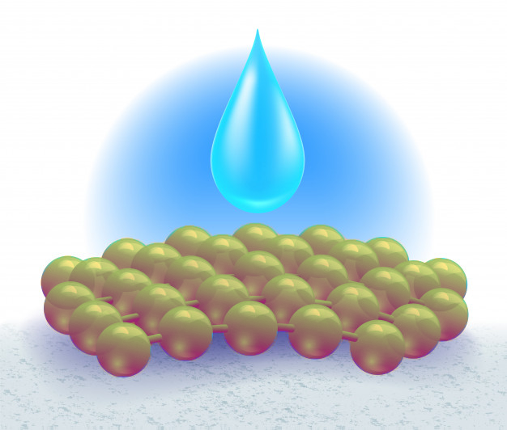

Solution:
These are some of the benefits that the Wood expose in terms of relative humidity control
Humidity conditions | Wood construction benefits
Interior humidity fluctuation control | The wood is an hygroscopic material, which can regulate the levels of relative humidity, thanks to the porous constitution of the wood, specially when it is not processed
Artificial ventilation frequency need | Given the hygroscopic properties of the wood, the air renovation is needed in a minor frequency.
Air quality | Those properties turn wood into a nice material to regulate the interior spaces air quality, and the life quality of those house residents

CASE STUDY 10
Thermal bridges in timber-structured buildings
In all the buildings, the thermal bridges are some of the hardest points to study, due to its position and objective in the building structure. In some cases, to break this thermal bridge, its is necessary to compromise the integrity of the structure, which is very hard to compensate.
Since the most controversial points of the buildings are the thermal bridges, which use to be mostly the structure elements in contact with the environment, it is important to stablish a good system to avoid these thermal bridges, which don’t compromise the stability of the building.
In this scenario, we need to know the properties of the wood to understand what will be its behaviour against the thermal bridges. For that reason, it is required to make a assessment of the conditions that a thermal bridge requires to be attended, and which of those fit in with the properties of the wood.
Make a board which expose the weaknesses of the thermal bridges, and how a timber structured building would work in this scenario
Solution:
Thermal bridge issues | Timber building strengths
Necessity of a higher inversion in insulation material to cover the thermal bridges | In timber construction, since the wood has a much lower thermal conductivity than the conventional materials, the thermal bridges are minimum
The structures may need to be discontinue for the integration of the insulation panels, breaking the thermal bridges | There is no need of compromising the structure, since the wood works as an insulation material
In some cases, the disposition of insulation is so hard, that requires very specific structural and insulation solutions | Even if some insulation was necessary, the dry condition of the timber construction would make much easier its disposition.
Some thermal bridges are simply inevitable, due to the complexity of the architectural disposition of some buildings | The amount of thermal bridges in the construction sector becomes minimum in the case of the timber framed buildings.

CASE STUDY 10
Wood material durability

One of the most controversial points nowadays around the wood use in construction is its durability.
Most people consider wood as a very poor material in terms of resistance, and it is well known for its good properties as fire feeding. Also, its vulnerability against xylophages does not help to make it more popular in the construction sector.
Nevertheless, it is very common to find some ancient buildings, with ages higher than 200 years, with timber structures, which remain intact.
On the other hand, the most common material to build nowadays, concrete, is well known for it’s resistance properties, as a very static and resistant material. Nevertheless, as many people does not know, the average lifetime of the concrete is around 50 and 150 years.

The point is that there are several factors which interferes on the durability of wood, as well as the concrete.
Some of these factors can be under control ensuring the durability of the material, and increasing the confidence in the construction sector to build with wood.
Then, given this information:
Enumerate the threats and weaknesses of wood in construction, and find some solutions to solve them, increasing the lifetime use average of wood.

Threats and weaknesses of Wood structures | Treatments
Structural forces | It is important to pay attention to the specie of wood used on this cases, and analyse which of them have a better behaviour against the forces. Using the appropriate specie of wood can be crucial to the durability of a timber structure
Fungus | Some of these threats are caused due to the humidity of the environment, and can be beaten with some superficial treatments, or even some treatment injections with a pressure method
Fire | Although the wood is considered as a very weak material against fire, the truth is that timber structure with the appropriate surface treatment can have a better behaviour against fire than concrete, since the concrete collapses with a high incrementation of the temperatures, making the collapse of the building very spontaneous, and the wood gets burned slowly from the outer faces to the inner ones keeping the stability during a higher amount of time.
Xylophage insects | As in the case of the fungus, the xylophage insects attack can be avoided with an adequate surface or injected treatment, ensuring the durability of the structure.

CASE STUDY 11
Climate impact of wood construction in comparison to cement construction.
Nowadays, the concrete is the most used material in the construction sector, which means that the industry of concrete production is one of the biggest in the whole world. For that reason, it is very important to have in account what is the impact of the concrete production the pollution of the planet.
Nevertheless, most of the material producers have implicit, in a smaller or bigger scale, a pollution footprint. This means that even if the wood is considered a very clean material, its “production” and collection have a negative effect in the environment, as well as the material discarding process.
For this reason, it is important to know what are the factors of each material which can be negative for the environment.
Then:
List some of the factors which can be harmful for the climate an the environment

Wood | Concrete
The wood material obtaining requires deforestation, which is very damaging for the ecosystem. | The cement material production is very pollutant since it’s obtention requires industrial ovens which rises very high temperatures, needing a lot of energy.
To discard the wood, it needs to be burned, which means a big amount of CO2 emission to the atmosphere. | When a building made out of concrete is demolished, the concrete discards become solid residue, which is hard to re-use, although this practice is improving its efficiency.
The deforestation which the massive use of wood could suppose, would affect seriously in the migration of the animals of those forests. | To make the concrete, some stones and rocks are required, which means that some quarries will be exploited, ending in landscapes destruction.

QUESTIONS AND ANSWERS (FAQS)
ENERGY EFFICIENCY
What is the difference between Coefficient of thermal conductance and Coefficient of heat transmission?
Coefficient of thermal conductance refers to the amount of heat conducted in one hour through 1 m2 of material, with a thickness of 1 m, when the temperature drop through the material under conditions of steady heat flow is 1 °C. On the other side, Coefficient of heat transmission designates the overall coefficient of heat transmission for any section of a material or a composite of materials.
Which are the most commonly used thermal insulation materials?
Depending on the construction typology of the building, the most used insulation materials are fiberglass, mineral wool or spray foam insulation. In case of timber buildings, wood fibers and cellulose fibers are also really commonly found.
Why should Organic insulation materials be used more often?
In order to improve the global sustainability conditions, it is important to enhance the use of sustainable materials. Since organic insulation materials provide the same or even better insulation properties than conventional materials, it is a really good alternative to those materials.
THERMAL BRIDGES
Which are the most common spots to be thermal bridges in a building?
The most susceptible spots to find thermal bridges are in the encounters between structural or carpentry elements with enclosure elements.

What is the relationship between thermal bridges and surface condensations?
Due to the heat variation that occurs on thermal bridge spots, the water condensates on spots where the materials are not ready to endure humidity. That is another reason why thermal bridges should always be avoided.
ENERGY EFFICIENCY CERTIFICATE
What does it mean to know the Energy Efficiency of a building?
Knowing the Energy Efficiency of a buildings means to have the value of the energy consumption needed by the building to satisfy the energetic demand in normal conditions of occupancy and use.
Which are the options available to obtain the Energy Efficiency qualification?
We have the general one which is based in the evaluation of the energetic demand of the buildings through the comparison of this one to another building of reference. The other option available is the simplified option that directly checks the energetic demand of the buildings.

CLIMATE INFLUENCE ON WOODEN BUILDINGS
Which are the most common agents that can become a threat to the wood?
Depending on the conditions of the surrounding environment of the timber materials, the most dangerous agents can be the sun and water for external uses, or the fungus and insects for places with high humidity values or dark conditions.
Which insect can be considered more harmful for the wood integrity?
Termites, since they are the most aggressive type of xylophage, and does not leave a trace at all.
INFLUENCE OF WOOD USE IN THE ENVIRONMENT
How can be the energy consumption of wood so low in comparison with other constructive materials?
Due to the low energy requirements for the development of timber pieces for the construction, it makes a great difference in contrast to conventional materials such as concrete or metal, which require high demanding industrial processes. Also, timber materials carry a consumption of CO2 which counters the negative emissions.
Is there any difference of CO2 consumption between an older and a younger tree?
A younger tree carries a higher rate of CO2 consumption than an older one. The younger one can carry a 25% more of consumption than the second group.
Source: https://www.europapress.es/ciencia/cambio-climatico/noticia-arboles-jovenes-son-25-mas-eficaces-absorbiendo-carbono-20190219111908.html

PLUMBING
Is there any special requirement for timber constructions, in order to dispose all the plumbing facilities?
Mainly, every plumbing system works the same, regardless of the material used for construction.
Which is the most recommendable plumbing material in a dwelling?
There is not such most recommendable plumbing material. The variety of materials is the result of different shapes and design requirements that exist in architecture design.

DRY CONSTRUCTION AND SEAL SYSTEM
Which are the advantages of this type of method?
The advantages of this type of construction in comparison to traditional methods are: low weight, high quality control and homogeneity of the product, large plastic possibilities.
Which are the elements that conform the light closures?
The three main parts are the panels, the auxiliar structure and the joints. The panels constitute the element that gives the external appearance of the closure depending on the texture, the colour and texture chosen. The auxiliar structure is the one transmitting the efforts that they receive, mainly their own weight and the action of the wind, to the load bearing structure of the building. The joint between panels is also necessary to ensure compliance with many of the requirements and behavioural conditions required by the panels themselves.

ELECTRICAL NOTIONS
Which are the parts of an electric installation?
1.General protection box
2.General power supply
--- general shunting breaker---
3. Meters
4. Individual line
5. Box for power control circuit breaker
6. General devices of control and protection
Interior installation:
7. Interior installation
NOTIONS OF VENTILATION
Which are the characteristics of general ventilation systems?
Intake openings are provided with aerators or fixed attachments of the carpentry, such as microventilation devices, the aerators must be arranged at a distance from the ground greater than 1,80 m. Kitchens, dining rooms, bedrooms and living rooms must have a complementary natural ventilation system. A practicable external window or an external door must be provided. The total practicable area of the windows and exterior doors of each room must be at least one-twentieth of the useful surface thereof.
NOTIONS OF AIR CONDITIONING
Which are the most used types of installation?
Purpose
-Industrial processes
-Comfort installation
Season
-Only winter
-Only summer
-All year
Refrigeration fluid
- Air
-Water
-Refrigerants
Installation
Unit
-For windows and portables
- Compacts and autonomous units’ condensate by air
- Compacts and autonomous units’ condensate by water
Parted system
-Split type (discharge by conducts or direct)
-multi-split
Centralized systems
-Mixed (induction or fan coil)
- All air (steady flow, variable volume, two conducts)

NOTIONS OF TELECOMUNICATIONS
Which is the aim of the telecommunication installation?
This type of installations capture, adapt and distribute to the houses and establishments all sort of telecommunication devices. The entire equipment must be sufficient for all the users of the building, containing all services such television, telephone, and telecommunication by line. The design of the building should take in consideration this kind of amenities and help the adaptation to future installations.

MULTIPLE CHOICE QUESTIONS
ENERGY EFFICIENCY
Which are the most important terms to have in consideration to develop the calculations of energy efficiency principles?
a) Heat energy, Thermal conductivity, Coefficient of thermal conductance, Thermal resistivity, Thermal resistance, Coefficient of heat transmission, Permeance to water vapour & resistance to water vapour.
b) Coefficient of thermal conductance & Thermal resistance
c) Temperature, weather forecast & material composition.

In terms of thermal conductivity, constructive timber material (made out of Nordic Pine) has:
a) Higher thermal conductivity than most of the conventional constructive material, so has a worse performance.
b) Higher thermal conductivity than most of the conventional constructive material, so has a better performance.
c) Lower thermal conductivity than most of the conventional constructive material, so has a better performance.

In order to calculate the thermal transmittance of a whole wall:
a) It is only necessary to calculate the surface layers transmittance find the thermal transmittance of the wall.
b) It is required to consider every layer for the calculation of thermal transmittance of the wall.
c) It is only required to consider the difference of temperature between interior space and the exterior.
THERMAL INSULATION
The main reason to install thermal insulation materials in the enclosure of a building is:
a) Assure water tightness against rain and snow.
b) Assure the thermal tightness of interior spaces, avoiding heat losses through the walls, in addition to reduce the energy consumption for the conditioning of interior spaces.
c) Assure protection against Xylophage insects that can damage building elements.

The performance of organic insulation materials is:
a) Worse than most common insulation material, reaching λ values higher than 0.060 W/(m·K).
b) Better than most common insulation material, reaching λ values lower than 0.015 W/(m·K).
c) Equal to the most common insulation material, reaching λ values lower than 0.035 W/(m·K).

Organic insulation materials should be used more commonly due to:
a) Their insulation properties, which are way better than most of the conventional insulation materials.
b) Their prices, which are really low due to the easy obtaining process of the material.
c) The fact of using eco-friendly materials which prevents the global warming, enhancing the reforestation and the reuse of organic materials such as wood for wood fibers or paper for cellulose insulation.
THERMAL BRIDGES
The term of thermal bridge is used to describe:
a) Sensible parts of a building which are susceptible of suffering a temperature flow, due to the lack of insulation in encounters or joints.
b) Elements of air conditioning or radiators that balances the temperature of interior spaces.
c) The room that is placed just in the entrance of the building, which has the function of balancing the temperature difference between interior and exterior spaces.

The most common spots where thermal bridges tend to happen are:
a) Spots integrated in the enclosure, joints between enclosure, corners, joints between partition walls and enclosure walls & joints between enclosures and carpentries.
b) Doors and windows, when they are opened.
c) In the most distant point from the structure of the enclosures.

What is the relation between thermal bridges and vapour condensations?
a) None. Those are completely different topics.
b) One effect of Thermal bridges is the increase towards the formation of superficial condensation in the exterior face of the constructive element existing cold points in the area affected by the thermal bridge.
c) The adequate disposition of a thermal bridge can work as a vapour barrier against condensations.

ENERGY EFFICIENCY CERTIFICATES
The achievement of a positive Energy efficiency certificate is important to consider the features of a building.
a) False. It is not necessary to get that certificate to be able to start the construction process.
b) False. Acquiring this certificate proves the bad performance of a building in terms of energy losses and consumption.
c) True. Acquiring this certificate proves the building quality of all the elements in the building, in terms of conditioning.

The Passive House Certificate is:
a) An easily reachable Certificate, since it is not very demanding in terms of efficiency.
b) A really valuable and hard to get certificate, since it requires a 75% reduction in necessities of heating and cooling.
c) The recognition that a building acquires when it is not provided with any facilities.

CLIMATE INFLUENCE ON WOODEN BUILDINGS
The most threatening agents that can damage timber buildings are:
a) Fire and water.
b) Small rodents.
c) Solar radiation, water, fungus and insects.

The most dangerous insect for the wood integrity is:
a) Termites, since is the most aggressive one and does not leave trace at all.
b) None of them can be consider a major threat to the integrity of wood.
c) Cerambycids, since it is hard to appreciate the attack until an advance step of the process, when most of the damage has already taken place. When a piece of wood is infested with this insect, it will probably lose

INFLUENCE OF WOOD USE IN THE ENVIRONMENT
Why is it important to use wood materials in the construction sector more often in the future?
a) Because it looks better in terms of design.
b) Because the CO2 emissions of wood construction are so low that even absorbs more than emits.
c) Wood should not be used in the future as the main constructive material, sue to the risk of deforestation.

Why does wood emit so low amount of CO2 compared to other constructive materials?
a) Because wood policies only allow to build timber construction without big machinery.
b) Because wood has no CO2 retained due to absorption.
c) Because the process of obtaining wood is really low demanding, and does not require any high demanding industrial process.

PLUMBING
What are the features that the water supply installation should have
a) Potability and endurance against corrosion.
b) Resistance to temperature fluctuations and the capability to distribute enough flow and pressure.
c) Both of them.

Why should Lead pipes be replace immediately if they are found in an old plumbing installation?
a) Because lead is toxic for humans and can be really dangerous.
b) Because this installations used to be connected to the electric line, and there is a high risk of getting electrocuted.
c) None of them is correct

Which should be the main conditioning to stablish the specific material for the plumbing installation?
a) It does not matter. All of them behave the same.
b) Only terms of design.
c) Specially the composition of the water, that sometimes can be incompatible with certain materials.

DRY CONSTRUCTION AND SEAL SYSTEM
What are the main advantages of dry and light construction systems to conventional ones?
a) The price is lower.
b) The construction process is lower, but is cleaner and less dangerous.
c) The constructive process is easier and faster, and provides large design possibilities.

Why is it so important to consider the sealing system in dry construction systems?
a) Because it provides extra stability to the wall.
b) Because it assures the tightness of every wall and encounter.
c) It is not really important is only a secondary possibility.

CASE STUDIES AND APPLICATION SCENARIO ANALYSIS
1. Considering all the provided information on this Learning Unit, design a 100 m² made out of wood. Stablish the typology of section and the wood specie to use, as well as the organic insulation material that suits better for the project. If the building has an inner temperature of 20ºC and the temperature outside is 5ºC, calculate the heat losses per each surface. In addition, enumerate the threats that the building will be exposed at, and the best way to protect the building.

2. Once the previous building is designed and stablished, please, develop the installation of the plumbing facilities, as well as every other facilities required for the house.
In addition, specify, step by step, the process that is required to install the partition walls, stablishing the used materials.

