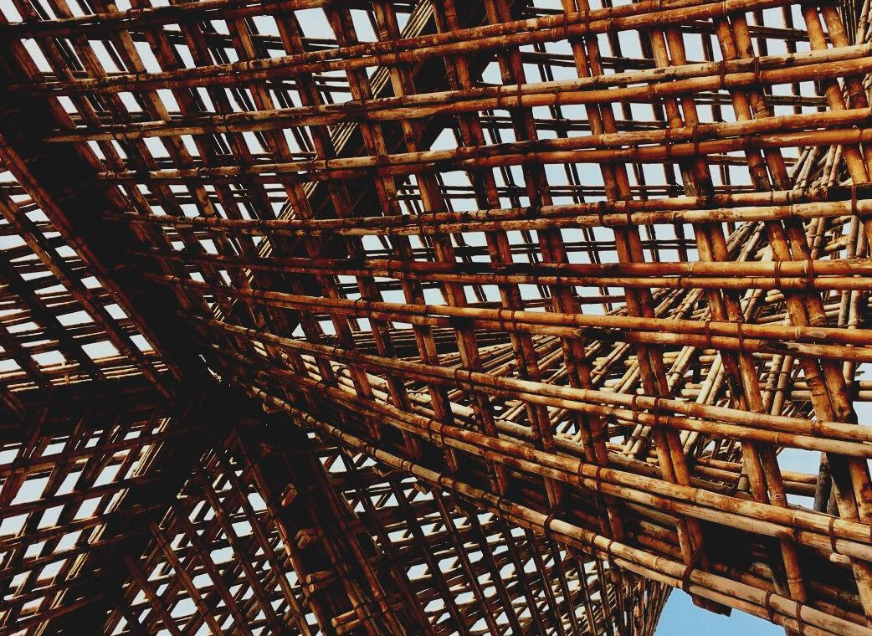
0

UPWOOD
Up-skilling construction workers in wood construction methods for energy-efficient buildings

UPWOOD
Up-skilling construction workers in wood construction methods for energy-efficient buildings

TRAINING & ASSESSMENT
MATERIAL

Learning Unit 3
- Lesson 4: Architecture Design

CONTENT
1. CONTENT 1
2. INTRODUCTORY PARAGRAPH 2
3. BUILDING DESIGN 3
4. BIBLIOGRAPHY 5

INTRODUCTORY PARAGRAPH
Before the construction of any building, the design of the whole edifice is mandatory, in order to guarantee some minimum requests of live quality.
This process requires the participation of architects and engineers at the same time, to provide the building of the best quality spaces, features, and facilities. From the adequate natural light and the disposition of big enough spaces to the equipment of water and electricity supplies, there is a very thin path to follow until the creation of an adequate building.
Also, It is important to take care of the outer look of the building, since the urban planning and the landscape design are two very important topics within the conception of a community.

BUILDING DESIGN
The concept of Building Design refers generally to the representation of elements related to architecture and engineer.
Usually, the one that makes the design is an architect in charge of representing the building trades, being able to reach the specific needs, being five steps leading to the final design of a building.
First sketches of the project-Jacobs Chang
Source: web 1
The schematic design is the first phase of the work, the architect speaks with the client and establish the requirements and objectives of the project.
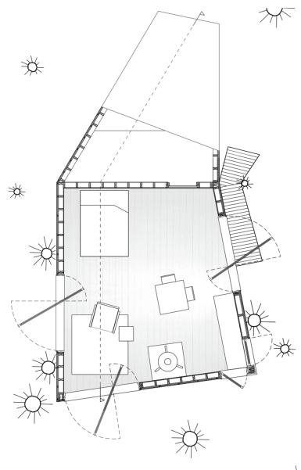
The architect starts with a series of sketches or simple renders to show the basic concepts of the design. This part includes special relations, scales, and basics shapes that the client could want. The approximate costs are presented to the client to take the opportunity on the decisions of the design and during this phase is still possible to make changes and decided shapes. After the schematic design, there is the proper design phase, with a resume of all the data collected in the previous steps.
The process analyses materials, positions of holes and general structural details.
Half Tree House-Jacobs Chung Source: web 1
Reached this part of the design, when architect and client are comfortable with all the process carried out, constructive documents can be filled.
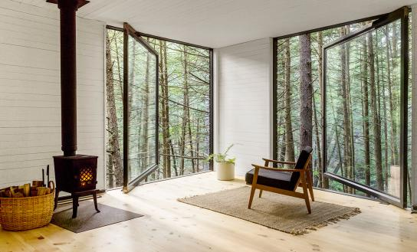
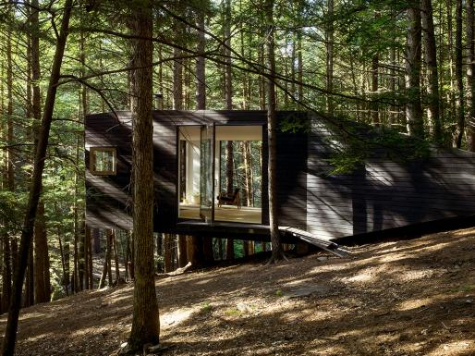
The designs now are much more detailed and are used for the construction phase and the final decisions on materials. When this part is completed, the design is sent to contractors for price reports and to the construction department for construction licences. Depending on the type of projects, a negotiation phase is required. This part of the work is a focal point in big projects being them residential or commercial.
Half Tree House-Jacobs Chung Source: web 1
The last phase is the construction, thanks to the building design, it is possible to achieve the complete realization of the finish proposal.
Half Tree House-Jacobs Chung Source: web 1
The design process is a sort of cycle where the idea change taking the shape of a graphic model, exists the possibility of changes and modifications, then again, in a sort of simulation of the reality that finally take place in the final synthesis of the finish building.

BIBLIOGRAPHY
-web1:
https://www.architectmagazine.com/project-gallery/half-tree-house_o
-web2:
https://www.teknoring.com/wikitecnica/rappresentazione-e-media/disegno-architettonico/
-web3:
http://www.sted.com/assets/img/blog/evoluzione-del-disegno-tecnico.pdf
-web4:
https://aibd.org/what-is-a-building-designer/
-web5:
https://www.arkiplus.com/que-es-el-diseno-arquitectonico/

