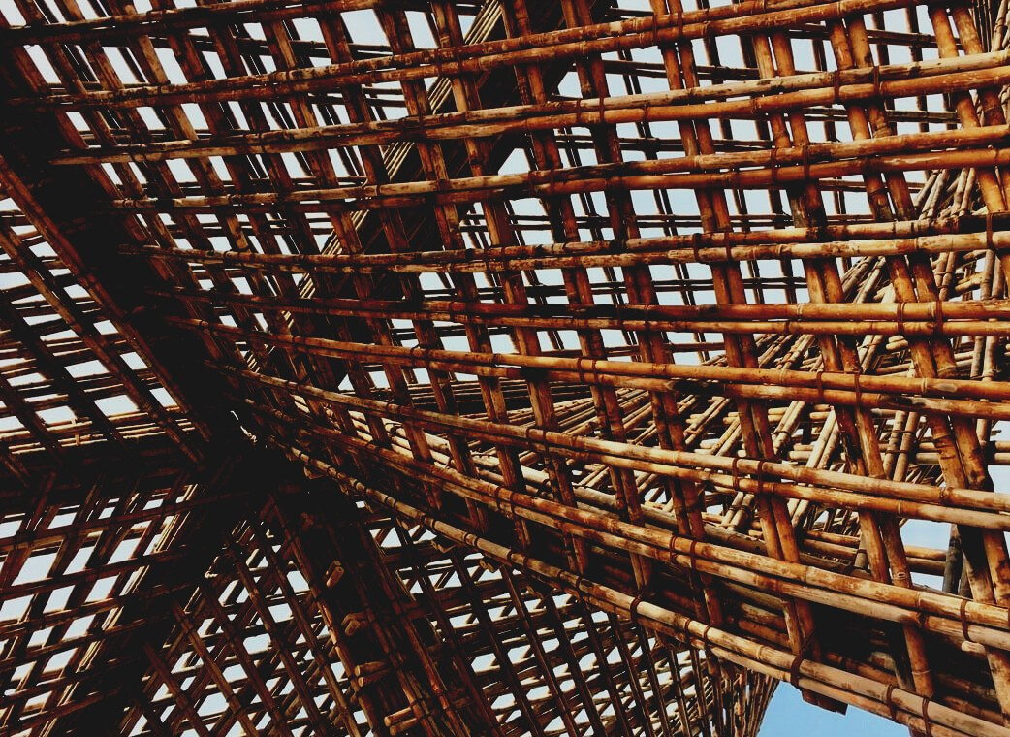

TRAINING MATERIAL

Learning Unit 2
GENERAL INSTRUCTIONS FOR THE USE OF WOOD MATERIAL AND WOOD BASED PANELS
UPWOOD
Up-skilling construction workers in wood construction methods for energy-efficient buildings

UPWOOD-PUU
Rakennustyöläisten ammattitaito energiatehokkaiden rakennusten puurakentamisenmenetelmissä

Table of contents
1. CE marking 3
2. Sawn timber 3
2.1 Heat-treated timber 5
2.2 Pressure impregnated wood 6
2.3 Glulam 7
2.4 Finger-jointed timber 7
3. The most common damage to lumber 8
4.1. Pest damage 8
4.2. Bacterial, mold and fungal damage 8
4.3. Drying damages 8
4. Wood quality classes 9
5. Strength sorting 9
6. Wood based panels 9
6.1 EWP 10
6.2 LVL 11
6.3 Plywood 11
6.4 PSL (Parallel Strand Lumber) 12
6.5 Chipboard 13
6.6 OSB (Oriented Strand Board) 13
6.7 LSL (Laminated Strand Lumber) 14
6.8 Flakeboard and Waferboard 14
7. Fibreboards 15
7.1 MDF (Medium Density Fibreboard) 16
7.2 HDF (High Density Fibreboard) 17
7.3 LDF (Low Density Fibreboard) 17
8. Glulam and solid wood panels 17
8.1 CLT (Cross Laminated Timber) 17
8.2 Solid wood panels without glue 18
8.3 NLT (Nail Laminated Timber) 18
8.4 MHM (Massiv- Holz-Mauer ®) 18
8.5 DLT (Dowel Laminated Timber) 20
8.6 Nail plate structures 22
9. Other wooden construction products 23
9.1 Plastic wood 23
9.2 Wood composite 23
9.3 Cement particleboard 23
10. List of references 24

CE marking
The CE marking is a mark of conformity that indicates that a construction product conforms to the relevant harmonized product standard and meets the essential safety and health requirements of the Construction Products Directive. A CE-marked construction product can be exported and sold freely in the European internal market. The conformity of a CE-marked product placed on the market shall be demonstrated by in-house quality control by the manufacturer and by certification, inspection, and testing by a notified body. Market surveillance of construction products ensures that there are only CE-marked construction products in the European internal market that meet the requirements set for them.

Sawn timber
The log is sawn into the timber of the desired size, which is planed after drying, if necessary. Solid wood refers to timber sawn from logs. Sawn timber takes into account its challenges posed by wood raw material, as each log is unique in quality, size, and shape. In addition, customers also want abnormal dimensions and special lengths.
The right wood in the right place means that when the internal quality differences of the wood are considered, taking into account the final product, it is possible to get quality products and blanks from the wood. The best starting point for good sawing is to get the right kind of wood. Wood is chosen for the carpentry industry, which is good for making quality products.
The different parts of the log are of different qualities. With a small sawmill, sawing can be done individually, and more sawn timber can be obtained from a single log than with large sawmills designed for fast and quantity-efficient mass production.
The strength of small sawmills is precise, versatile, individual, and customer-oriented production. In addition to special lengths, the individual sawing method allows different parts of the wood to be used efficiently, minimizing sawing errors. Production flexibility is also a marketing advantage: a small sawmill can quickly switch to sawing products of different sizes.
In the sawn timber industry, various concepts and definitions are used to describe the main classifications of products. Timber is a general term for sawmill and planing mill products as well as round wood.
Sawn timber is a general term for timber sawn on all sides and planed timber is a general term for timber planed on at least three sides.
Sawn timber sawing methods include core-free sawing, core piece, and surface product. Core-free sawing means a sawing method that produces sawn timber without the core of the wood. By core piece is meant a piece of timber obtained from the middle of a log, in which case the piece of wood contains the core of the wood. The surface product is made from outside the middle of the log.
The concepts of surface roughness of sawn timber are divided as follows:
Coarse planing, where a high feed rate and a small planing depth are used as the planing method. Due to these, the planing mark is rough and there may be unplaned areas and ridges due to planing.
A fine-sawn surface is created when sawing from a dry timber blank or with a separate device, for example in connection with planing.
Dimensioned sawn timber means sawn timber pieces that have been roughly planed to dimensional accuracy.
Smooth planing means a planing method in which the planing mark is smooth, and the product does not show any sawing irregularities or ridges due to planing.

Heat-treated timber
Heat-treated timber is further processing of wood, which is produced by a heat-treatment process. In the process, the properties of the wood are changed by heat. Heat-treated timber is made from pine, spruce, or hardwood. The manufacturing process is based on the use of high temperature and water vapor. No chemicals are added to the wood during the process.
Heat-treated wood is produced by heating the wood under controlled conditions to a temperature of + 170- + 230 ° C. The temperature controls the desired properties of the wood, in addition to which the temperature is affected by the type of wood. In heat treatment, the cellular structure of the wood changes and corresponds structurally to the wood that has dried over hundreds of years. According to the degree of treatment, the wear resistance of the wood improves because it becomes lighter.
Heat treatment causes the following changes in the wood. The color of the wood changes from light brown to dark brown and the deformation due to moisture changes decreases as well as the thermal conductivity. In heat-treated wood, the elasticity of the wood decreases, but the stiffness increases, which reduces the flexural strength by up to 30%. The biological durability of heat-treated wood is improved because terpene gases and extractives are reduced, and resin is removed from the wood.
Heat-treated wood has a lower moisture life compared to unheated wood. In addition, heat treatment can change the color of the wood to more shades of hardwood, so that the color changes throughout the piece of wood, i.e., the product is dyed-through. Therefore, the quality of heat-treated timber is not considered according to the quality classification of untreated sawn timber.
In the ThermoWood® process, softwood and hardwood have their classification based on the degree of heat treatment. The processing temperatures are determined by optimizing the requirements for the end-use. The product categories are Thermo-S and Thermo-D.
Thermo-S (Stability) class heat treatment improves the dimensional stability of the wood and gives a brown tint.
Also, the heat treatment of the Thermo-D (Durability) class improves the wood's rot resistance properties and gives the Thermo-S class a darker brown color tone.
In addition to the general product classification, timber delivered to an industrial customer for further processing can be heat treated in accordance with an agreement between the buyer and the producer, so that the degree of treatment can be precisely optimized, taking into account the requirements of the end-use.
The most common uses of firewood indoors are sauna interiors, wall and ceiling panels, floorboards, and furniture. Outdoor applications include cladding, grilles, terraces, fences, and carpentry products.

Pressure impregnated wood
Pressure-impregnated timber is a further process in which wood preservatives have been introduced into the wood utilizing overpressure. Pressure-impregnated lumber is pinewood impregnated with an impregnating agent containing copper compounds for categories A and AB. In the Nordic countries, there are more impregnation classes (A, AB, B, and M). In addition to the traditional green, the colors are brown, which is prepared by adding a color pigment to the impregnating agent. Pressure impregnation is an effective way to improve the rot resistance of wood in humid outdoor conditions. Impregnated wood lasts 3-5 times longer in outdoor use than unsaturated wood. Impregnation does not have a significant effect on the strength properties of sawn timber.
Impregnated wood is slightly more flammable than untreated wood and burns slowly. The production of impregnated wood is subject to quality control. In pressure-impregnated wood, the preservative is applied to the wood in an impregnation using water and pressure. The preservative penetrates the surface wood cell prone to rot.

Glulam
Glulam is further processing of sawn timber, which is made by gluing at least four lamellas, not more than 45 mm thick. The lamellae overlap and their grain direction is in the longitudinal direction of the glulam product. Glulam must meet the requirements of standards SFS-EN 14080 and SFS-EN 386.
Glued sawn timber is also further processing of sawn timber, which is made by gluing but does not meet the standards of glulam.
Laminated Veneer Lumber (LVL) is a wood product made by gluing at least five veneers, not more than 6 mm thick. The autumn direction of the veneers is the longitudinal direction of the veneer product. Veneer wood must meet the requirements of standard SFS-EN 14374.

Finger-jointed timber
Structural sawn timber is extended with finger joints when it is desired to be longer than normal or when certain properties of the sawn timber piece are desired. Using finger joints, it is possible to produce, for example, pieces of lumber that are completely heartwood, completely branchless, and very straight. Such specialty products are commonly used in the furniture and window industries.
Finger-jointed lumber is available sawn, dimensioned, and planed. The maximum length varies from manufacturer to manufacturer but is usually between 12 to 14 meters. The manufacture of finger-jointed sawn timber for structural use is a licensed activity and such sawn timber must bear a finger-jointing stamp in accordance with the product standard used.

The most common damage to lumber

Pest damage
Well-dried wood material decays when weather protection is broken or failed. Wood-destroying insects are usually found in buildings that have already been preliminarily damaged by decaying fungi, but damage occurs between fresh wood and bark when the air temperature begins to exceed + 5 ° C. Insects carry the spores of rot fungi and thus contribute to the mycelial growth of mold, bluish and rot fungi due to moisture. Decaying fungi that have spread to the tree makes the cells of the tree more suitable for insect food.

Bacterial, mold and fungal damage
Moist wood is a good growing environment for bluing and rot fungi as well as mold. If the wood is used without drying, unwanted organisms can enter the wet wood and cause problems when using the product. Decay and mold degrade the structure of wood, spoil its appearance, and can cause human exposure and allergies.

Drying damages
Due to the removal of water, there are always changes in the sawn timber during drying. Improper sawing increases the deformation of the wood due to poor drying. If the water drains too quickly or unevenly, drying defects such as cracks or warping will occur.

Wood quality classes
The wood quality classes are (old quality code in parentheses) US I - US IV (A1- A4), V (B), VI (C), and VII (D). The sorting instructions are based on the fact that the sawn timber to be sorted has been sawn in accordance with Nordic sawing practice. In the quality classification of sawn timber, all sides of the timber are examined separately, in which case the quality class is determined based on the surface patch and the appearance of each edge. The appearance of the heart patch may be one grade lower.
The sawn timber is sorted visually or mechanically into grades US I to US IV, as well as grades V, VI, and VII, which is the lowest grade. Besides, sawmills create customer- or product-specific quality assortments by combining the features of different quality categories. For example, pine timber can also be sorted into a composite grade, such as ST (sawn yield) or BC (grades B and C included).

Strength sorting
Timber can be strength sorted visually or mechanically. Strength grading can be done with softwood to either strength classes according to EN 338 or the common Nordic standard INSTA 142. Visual strength grading examines the thickness of the annual stock of sawn timber and visual defects, deformations, twisting, or, for example, the number of branches, their location, and quality. The mechanical strength sorting method can be machine vision measurement, specific frequency measurement, X-ray measurement, ultrasonic measurement, or more traditional bending.

Wood based panels
Nowadays, it is possible to industrially produce a wide range of wood-based panels suitable for different applications, in which by-products of the wood industry can be used. Sheet material made from by-products is cost-effective to manufacture, and raw materials for the wood industry can be utilized efficiently. By-product boards are various fibreboards and particle boards. In addition to the furniture industry, wood panels are commonly used in construction, vehicles, and interior upholstery materials.
Depending on the application, wood panels can be coated with various veneers, laminates, plastic coatings, films, and surface treatments.
Sawn timber, plywood, fibreboard, veneer, glulam, and thermal wood are used for load-bearing and non-load-bearing structures. Companies in the carpentry industry manufacture timber-framed and log-structured house packages and timber-framed building structures such as windows, frames, roof trusses, eaves, underlays, floor structures, floor and wall claddings, stairs, railings, and terraces. Other wooden components to be manufactured include columns, moldings, tiles, and floorboards.

EWP
Wood panels are often referred to as Engineered Wood Products. An engineered wood product (EWP product) refers to building components made by gluing wood.
Glulam means a product used in the load-bearing structures of houses, which is made of lamellae by gluing. Laminated Veneer Lumber (LVL) is made of a veneer-based material such as plywood. The LSL (Laminated Strand Lumber) used as the frame material for the houses is made by cutting the barked wood into chips, drying and gluing the chips, then pressing them into the desired shape. I-beams manufactured in a multi-stage process are used as lower and intermediate floor beams in houses and as support structures for molds. CLT (cross-laminated timber) is a building material made of solid wood, which consists of at least three layers of cross-glued laminated wood.

LVL
LVL means wood that is turned into veneer and laminated together into lumber.
The cross veneers placed in the product stabilize the product very effectively, reduce moisture living and allow the production of wide tiles without the risk of warping. Cross veneers can also be used to increase the compressive strength of the product in the height direction of the beam.
Typical applications include beams, columns, trusses, perimeters, and window and door industry components. Thanks to its layer structure, LVL is stronger than solid wood, which also makes it possible to implement bridge structures. The tools used in traditional wood construction are suitable for machining.
LVL beams are suitable as load-bearing beams for aggregate-framed buildings. The beams are used as a subfloor, midsole, opening, roof, and support beams, among others. LVL beams can be used to easily implement high and spacious rooms, large windows, bay windows, lofts, and balconies. The structure of the LVL beam is slim and high, but rigid. The beams are available in a wide range of standard cross-sections, but the beams are also made to order.

Plywood
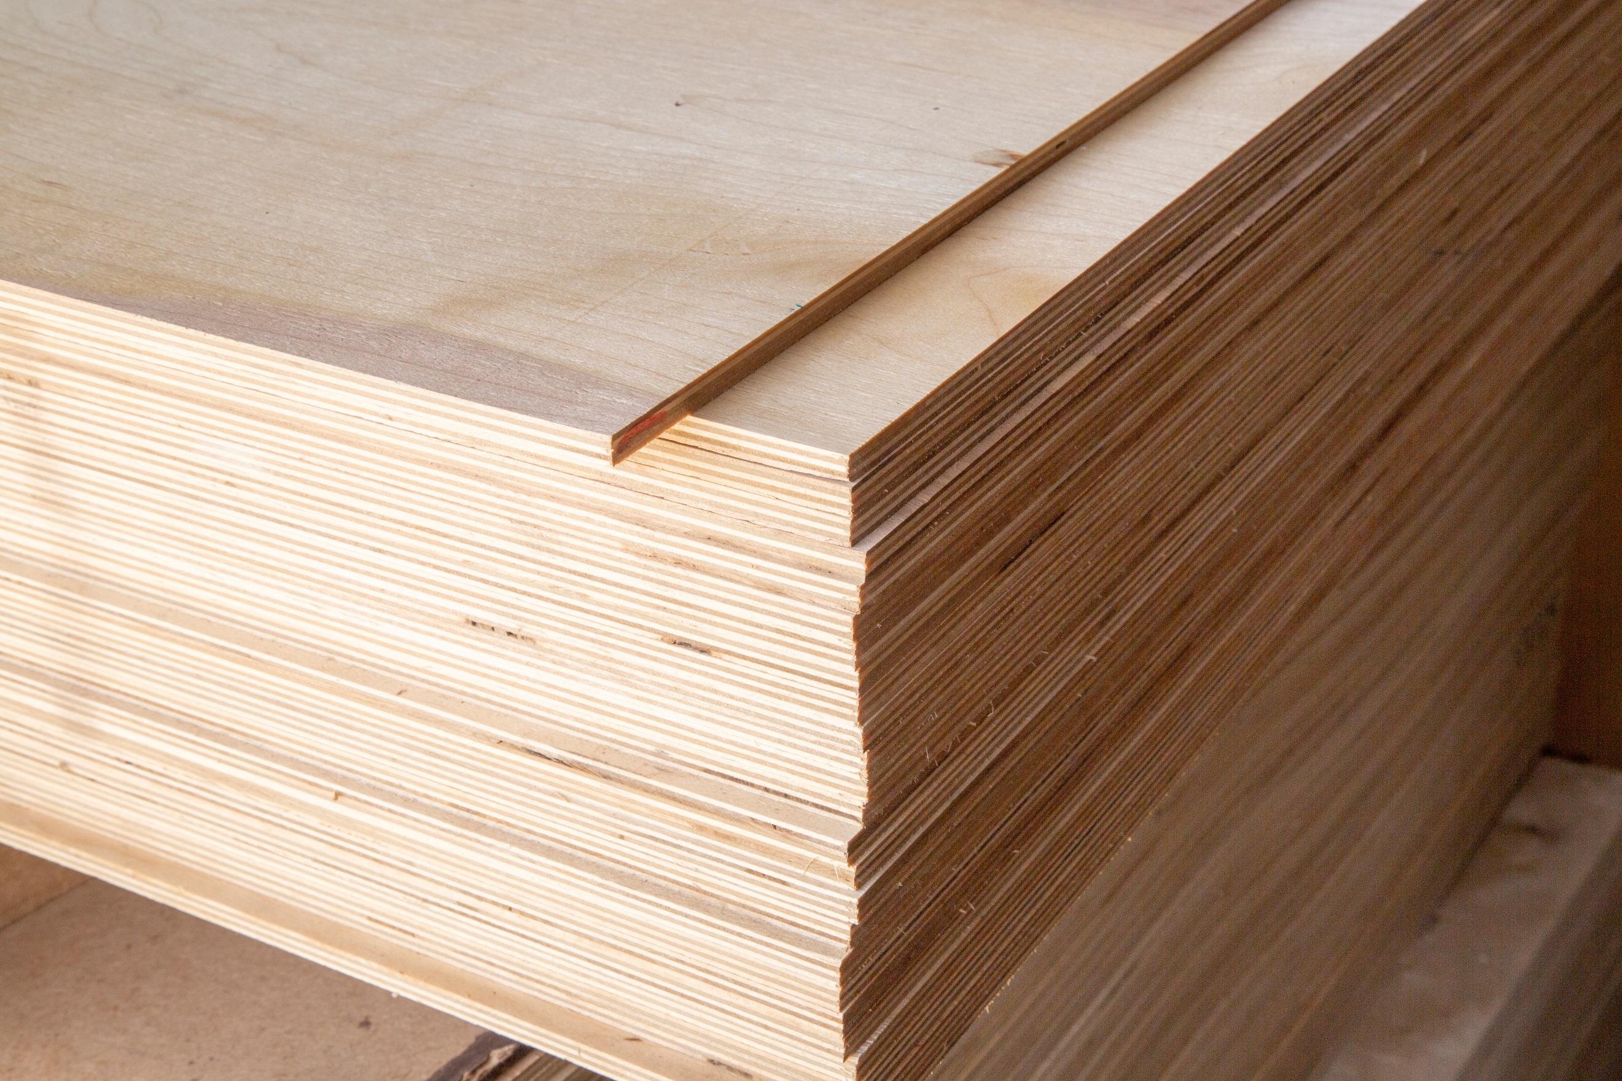
Plywood is made of thin turned veneers, alternately cross-glued. Birch and spruce are commonly used as raw materials for veneers. Types of veneers used in imported plywood include teak, mahogany, and poplar.
Image 1 Plywood © Alexandr Potashev, Shutterstock
Plywood is used in many different applications for indoor and outdoor use, including furniture, packaging, base plates for vehicles, traffic signs, car upholstery, molds, ornaments, floor, and wall structures and temporary structures.
Plywood is coated with different surface materials. The most common coating for plywood is a dark brown phenolic resin film. The plywood coated with it is called film-faced plywood. Film plywood can be made in different colors and with different surface shapes, for example, smooth, wire surface, non-slip pattern, and combinations of these.
The good properties of plywood are especially evident in outdoor use because it is strong and durable in humid conditions, it can be bent, and it does not change much under stress. The fasteners stay well and in addition, the plywood is light compared to other wood-based boards. The expensive properties of plywood compared to other board products are considered to be bad properties. The surface of the plywood will crack if it is not coated and the boards can often be crooked.
The use of plywood products is affected by the way they are glued. Plywood products assembled with phenolic glue are suitable for outdoor use, but urea and urea-melamine glued products are only for indoor use. Most plywood products are used for different types of construction, which can be divided into three parts: 1) The use of plywood during construction, when the boards do not remain in the structures but can be moved to another construction site. For example, plywood for concrete casting. 2) Use of plywood in load-bearing structures. And 3) the use of plywood primarily in structures and structural components that are not load-bearing, such as various upholstery and certain parts of furniture.

PSL (Parallel Strand Lumber)
PSL (Parallel Strand Lumber) board is glued to one of the parallel oriented narrow veneer strips. PSL beams can be made from PSL sheets with properties suitable for applications where high bending strength is required. The shrinkage of the PSL is slight, it does not warp or crack. PSL beam is used in frame construction, especially in column-beam construction. It is very suitable for long-span structures.

Chipboard
Chipboard is a wood-based board where the raw material is typically wood chips, sawdust, and shavings, as well as small wood and recycled wood. Sawdust used in chipboard is a raw material comparable to recycled material and therefore an environmentally good material. If sawdust is burned for energy, its carbon dioxide is immediately released into the air.
Chipboard can be used as such as raw board or processed. The most common product is Melamine Faced Chipboard (MFC). In addition, chipboard can be coated with laminates, plastic films, paper, phenolic films, wood veneers, metal films, and primer papers. To prevent the plate from curling, coat the plate on both sides. On the backside, a counter-coating material can be used on the surface side.
The moisture resistance, biological resistance to rot, and fire resistance of the board can be improved by adding the additives needed in the process to the adhesive or by coating the board. Biologically, the properties of particleboard are similar to those of the wood raw materials from which the board is made. In humid conditions, the plates may be exposed to rot fungi.
Chipboard is a versatile wood-based panel used in construction, the furniture and furniture industry, and numerous other applications. The most common applications in construction are interior cladding, floor structures, and concrete molds.

OSB (Oriented Strand Board)
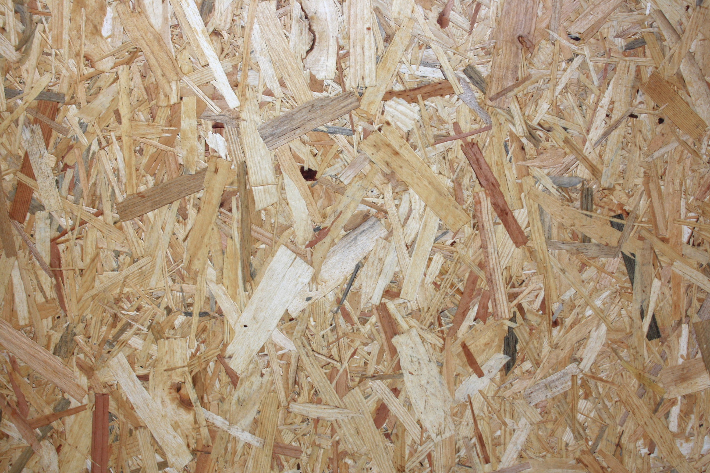
OSB (Oriented Strand Board) is made of long wood chips glued into a structural wood board. The product features are closer to veneer sheets. OSB has good strength and stiffness properties and is easy to machine. The furniture industry uses OBS board as chair seats and backgrounds, furniture frames, and laminated levels. It can be used to make temporary walls, vehicle interiors, trade fair structures, warehouses, protective walls, as well as packing boxes and pallets.
Image 2 OSB © Lionel Allorge, Courtabœuf

LSL (Laminated Strand Lumber)
LSL board is a wood board glued from chips. LSL products are used, for example, beams, roof supports, parts of stair elements, walls, floors, and ceilings.

Flakeboard and Waferboard
Flakeboard is chipboard and non-structural interior product made from wood particles, which are often by-products of wood and paper processing. Flakeboard is made from chips that are mixed with resin and formed under heat and pressure into a strong, solid sheet.
Waferboard is a board that consists of flakes that are compressed to create a sturdy and functional building material. It can be used in construction projects replacing the traditional plywood. The most common uses of waferboard are furniture materials such as TV countertops, Computer desks, and various types of shelves. The pieces are often covered with a laminate designed to mimic the appearance of the cause of the wood.

Fibreboards
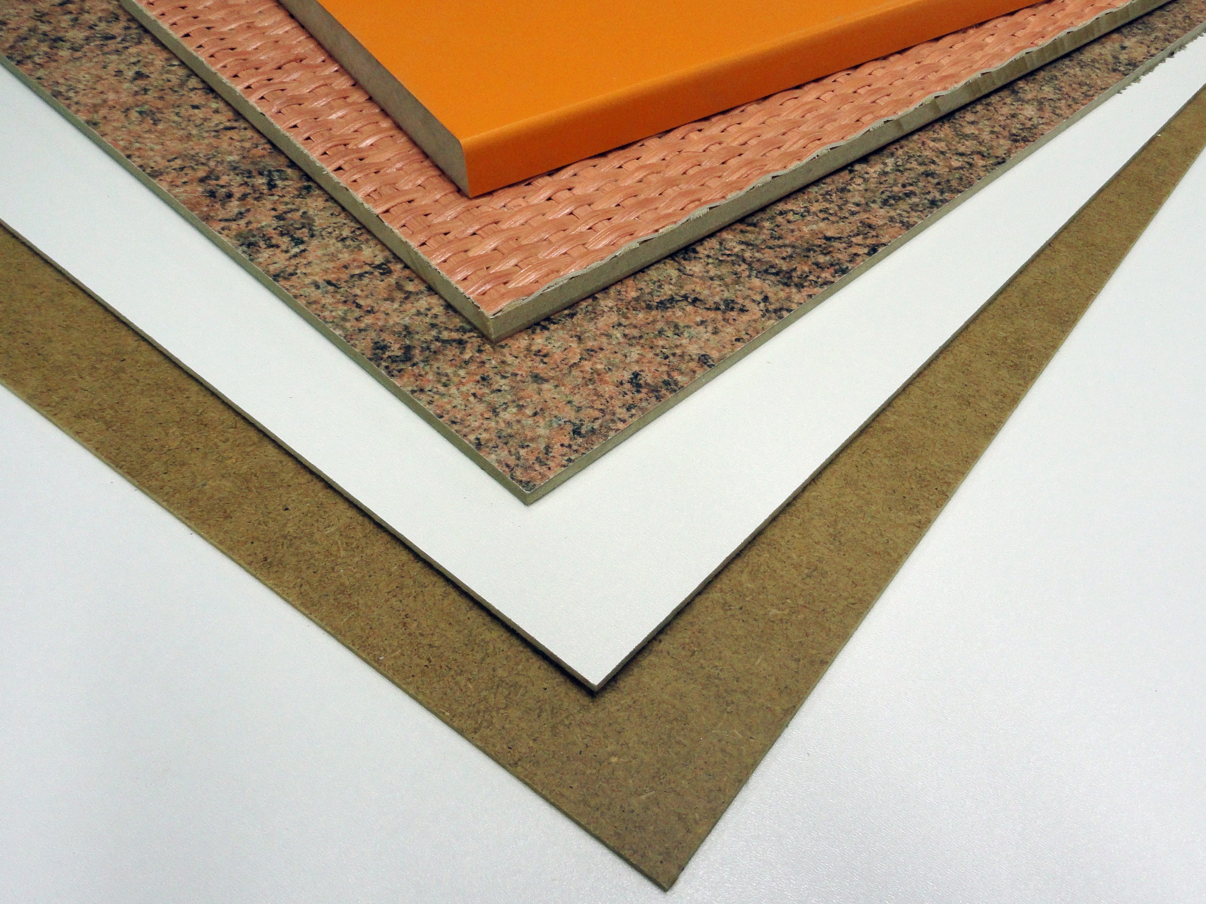
Fibreboard is made from wood fibers that are joined together by heat and pressure. Glue and other additives can be used to improve the properties of the board and to smooth out variations due to raw material and manufacturing methods. The properties of the wood fiber provide the strength, toughness, and warmth of the board. The plates are tight but breathable. They are also easy to work with normal woodworking methods.
Image 3 Fibreboards © Андрей Перцев
In connection with the production of fibreboards, the boards can be heat-treated, i.e. hardened, which improves the strength and moisture resistance of the boards. The most typical of the fibreboard extension process is painting. Pure wood fibreboards are environmentally friendly and ecological materials with breathability, strength, and insulation suitable for all wood construction. They contribute to the implementation of energy-efficient structural solutions, as fibreboard creates tight and insulating sheathing for the building. During their life cycle, like other wood materials, they sequester carbon and can be recycled into energy or recycled products when buildings are demolished.
Fibreboards can be divided into a) hard fibreboards and b) porous fibreboards. Hard fibreboards are used as packaging material (fruit boxes, pallet pack lids, base plates, and spacers), in the manufacture of furniture and furnishings (sofa and armchair frames, bed bases, cabinet backplates, doors, box base plates, and room dividers). In the door industry, the so-called hardboard is used as a surface material. In the automotive industry, hardboard is used in dashboards, hat racks, trunk, caravan and car interior upholstery.
In the renovation and finishing phase of new buildings, a hardboard is used to protect finished sensitive surfaces, such as floors, from soiling and knocking. Other hardboard applications are extensive. Hardboard is used in, among other things, temporary structures such as trade fair walls, store holdings, and interiors. Tool boards, billboards, chalkboards, and whiteboards, as well as signs, are the uses of the hard drive.
Porous fibreboards are mainly used in construction. Porous fiberboards are windbreak boards on both exterior walls and ceilings. In addition to protecting the wind, they also stiffen the wall structure. The boards have low thermal conductivity, so they also improve thermal insulation.
It is also used in interior cladding as an additional insulation board. As an interior board, the porous fiberboard is a sound-insulating and acoustically improving material. Thin porous fiberboard is also used as a substrate for laminate flooring and parquet.

MDF (Medium Density Fibreboard)
MDF is an intermediate form of fibreboard and particleboard. MDF boards are made from wood chips, generated as by-products in the sawmill industry. Sawdust can also be used to a limited extent. MDF is used as a frame material for laminated floorboards, in the carpentry industry for manufacturing furniture and furnishings. In construction, there are applications from interior to outdoor use.
In furniture, MDF is used in the manufacture of sofas, armchairs, beds, children's furniture, and shelves. In furniture, doors, shelves, levels, and moldings are made of MDF board, which is most often covered with films, laminates, or paint. The door industry is also a major user of MDF. Moisture-resistant, film-coated MDF boards are used to make billboards, signs, garden furniture, pet rooms, and children's playground equipment suitable for outdoor use.

HDF (High Density Fibreboard)
HDF board is a thin hardwood fibreboard made of finely structured wood fiber. The surface of the plate is very dense, smooth, and hard. The structure is homogeneous throughout. The plate is straight, dimensionally accurate, rigid, and easy to machine even by milling and drilling. For example, the plates can be bent. As a raw board, both surfaces of the HDF board are smooth. The boards can also be coated on one side: veneered, painted or film-coated, and also differently perforated.
HDF is widely used in, for example, the interior board, the furniture and furnishing industry, the frame structure of parquet materials, the automotive industry, and the door industry. Due to their lightness and affordability, HDF backboards are well suited as backboards for cabinets and shelves, for example. Due to their strength, they can be used for the bottoms of drawers and as advertising boards. Versatile coating options also allow the board to be used for various interior claddings and door mirrors.

LDF (Low Density Fibreboard)
LDF is low-density chipboard made of wood. LDF board is made from wood chips, sawdust, or sawdust combined with synthetic resin, or other suitable binders. It replaces plywood when costs are more important than strength and appearance.

Glulam and solid wood panels

CLT (Cross Laminated Timber)
CLT boards are made of cross-glued solid wood boards, cross-lamination guarantees the strength of the CLT boards and the retention of their shape. Thick CLT boards are mainly used in building construction as solid wood elements. The thickness of the elements is 60–400 mm. The maximum width of the board is 3,2 meters and the length up to 12 meters.
Thinner 3-layer CLT boards are made for carpentry, packaging, and mold use. CLT solid wood panel can be used to make all above-ground load-bearing structures in a building. CLT structures are well suited for walls, midsoles, and ceilings. The load-bearing vertical and horizontal elements of the building are solid wood panels glued crosswise from the boards. CLT elements can also be well combined with any other building materials.
Due to its good structural strength as well as easy joint technology and frame stiffening, CLT is competitive, especially in demanding construction sites and high-rise buildings. The capacity of the CLT board is sufficient for houses up to 30 stores.

Solid wood panels without glue
Solid wood panels are also made without glue. Brettstapel and Dübelholz are especially well-known in Europe. Brettstapel generally refers to solid wood panels made without glue, in which the boards are fastened together with nails or wooden pegs.

NLT (Nail Laminated Timber)
NLT sheets are made by nailing parallel peripheral boards to each other layer by layer. Manufacturing can take place either on-site or at the factory. Different surface profiles can be made by varying the thicknesses of the timber and the profile of the visible edge. If necessary, the stiffening of the board can be carried out with plywood or chipboard. Traditional NLT is no longer produced in very large quantities. The material is evolving in the direction of using wooden pins instead of nails in the product, which improves the machinability of the board.

MHM (Massiv- Holz-Mauer ®)
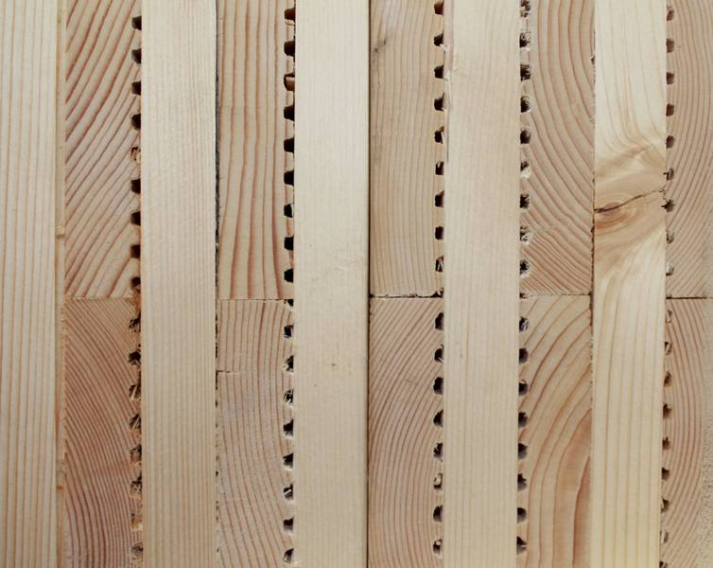
The MHM (Massiv-Holz-Mauer®) element consists of cross-stacked layers of softwood boards, which are fastened together with aluminum nails. Boards of different widths can be used on the board. The board layers are nailed together with grooved aluminum nails layer by layer. Nailing is done with a device specially designed for this.
Image 4 MHM © Massiv-Holz-Mauer®
In the finishing phase, the plate is processed into a ready-to-install element and the necessary CNC machining and perforations are performed. Aluminum nails do not interfere with CNC machining.
MHM does not need a separate stiffener. The parallel nailed element is not airtight and needs a separate structural layer to ensure tightness. Due to the grooving of the boards, air pockets remain inside the MHM structure, which improves the thermal insulation of the board. Due to the air pockets and slots in the MHM plate, it is difficult to dimension the carbon. If a fire-resistance requirement has been set for the structures, it is recommended that the MHM board be covered to a full minute.
Like other solid wood panels, the sound insulation of the MHM board is poor. In addition, the cracks in the board weaken its insulating properties. Sound insulation is improved by layered dense structures by adding mass and sound-absorbing insulation layers to the structure.
If the board is left exposed, untreated wood will act as a humidifier for indoor air. MHM does not form an air- and moisture-tight structural layer in the structure without a separate air and moisture barrier.
The MHM element can be used as a load-bearing or non-load-bearing wall structure. MHM board is not suitable as a slab for intermediate or upper soles or as a beam.
Because MHM does not form an air- and moisture-tight structural layer, separate air, and vapor barrier are always required. If the wall structure is made solid without external insulation, air and vapor barrier should be placed on the inner surface of the board. The MHM external wall element can also be made insulated from the outside, in which case the plate is dimensioned according to the loads it can carry. The insulation is placed outside the massive wooden element. An air and vapor barrier can be placed between the board and the insulation.
Surface cladding is possible and often also desirable. On the inside, the surfaces can be painted, paneled, and leveled or, if desired, an interior panel can be installed on them. Wooden cladding or other cladding can be added to the outside.

DLT (Dowel Laminated Timber)
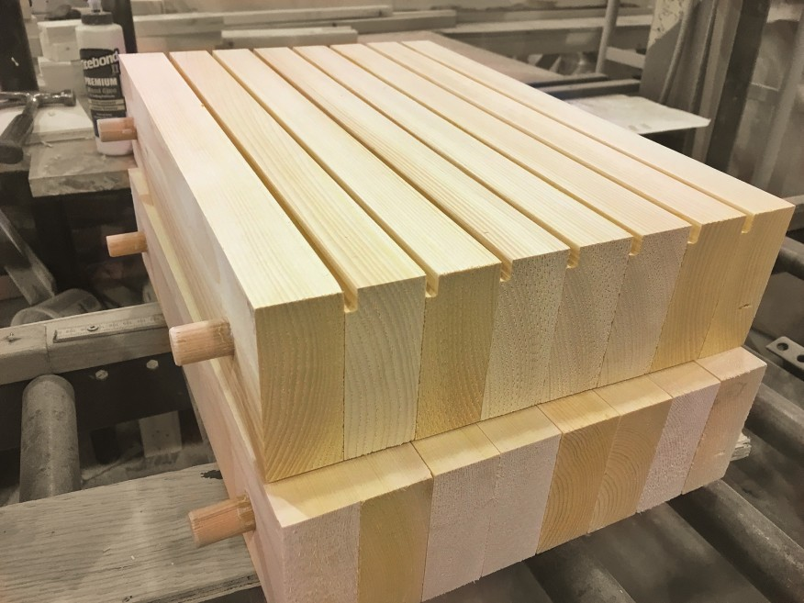
Dowel Laminated Timber (DLT) is a further developed version of nailed solid wood board, or NLT, in the early 2000s. The structural principles of DLT boards are similar to those of NLT boards, but the metal nails have been replaced with hardwood pins. Thanks to the different moisture resistance of different types of wood, a strong connection between the boards and the pins are achieved. Depending on the type of disc, DLT discs can be used in both wall and slab structures.
Image 5 DLT © StructureCraft
In the most common type of structure, the dowels pierce the boards perpendicularly, but a diagonal dowel is also used.
The production utilizes the variation of moisture contents of different wood species. The boards are usually either spruce or pine and the pins are beech. When drier pins are installed on wetter boards, they absorb moisture from the surrounding wood and swell. This creates a strong connection between the pin and the board.
In the case of DLT boards, it should be noted that large variations in temperature and humidity, for example on a construction site, can cause deformations and cracks in the board. Sometimes this can be anticipated by the addition of mechanical fasteners or adhesives. Diagonally mounted pins also eliminate this problem by stiffening the plate structure, reducing plate warping and cracking.
DLT sheets and elements are machined to size. The parallel DLT board is suitable for walls and intermediate and top floor tiles. In tile structures, it can be left visible as it is. Different acoustic and visual surfaces are obtained, for example, with different board widths and edge profiling. Another way to make a DLT board is to stack the board layers crosswise like CLT and MHM and fasten them with wooden dowels. For example, the Austrian company Thoma manufactures such a product under the name Holz100 (Wood100).
In cross stacked DLT, the boards are stacked crosswise at three different angles. Some of the board layers are horizontal, some are vertical, and some are diagonally at a 45° angle. The number of layers of boards varies depending on the application of the product. In some wall elements, the boards are grooved to improve the thermal insulation of the board. Slabs are designed, dimensioned and manufactured on a case-by-case basis to optimize the structure for each application.

Nail plate structures
Nail plate structure means a wooden structure assembled by joints made with nail plates. It can be in the form of a lattice, a perimeter, a beam, etc. A nail plate is a steel plate on which the spikes are pressed by cutting and bending perpendicularly. These are pressed into the wood on an assembly table or line.
The nail plate joint is easy to design so that the plate does not come off the wood but breaks itself. The strength of the joint can be in the order of almost intact wood.
The plates must be approved, and the design of the joints must be done according to official instructions. Products manufactured in Finland under Inspecta's quality control are marked with the FI / NR stamp and VTT / NR approved by VTT.
Sawn timber used for load-bearing nail plate structures must be strength graded. Official NR quality control covers all stages of manufacturing, including strength grading and finger jointing.
The lateral stiffness of the nail plate structures is usually quite low. This must be especially remembered during transport, storage, and installation. If the position of the supports on top of their load-bearing supports is not unambiguous, the points under which the supports must fall must be marked on the grid. In addition, the locations of the buckling supports are marked on the inner bars of the NR structures. The marking method is presented in the support and installation instructions that come with the products.
Nail plate structures are mainly used in covered rain-protected areas (humidity class 2) where there are no wood-decomposing or steel-corrosive factors. When unprotected, nail plate structures generally do not have fire resistance.

Other wooden construction products

Plastic wood
Plastic wood means a product in which the pores of the wood are filled with plastic. Plastic changes the appearance of wood and improves the use properties of wood, above all hardness. Several methods have been developed for the production of plastic wood, which differs mainly based on the plastic raw material and the polymerization. The main applications of plastic wood are floor coverings, handrails, and wall panels.
In most cases, plastic wood is only made into a surface layer that is glued to a wooden substructure.

Wood composite
The use of wood composite materials for new purposes is becoming more common. Well-established products include terrace furniture and, as new, Woodio Bathroom Furniture. Environmental friendliness and impact resistance are the strengths of wood composite, about 80% of the mass of the finished sink is wood chips. For bathroom furniture, sinks and bathtubs are molded from resin and wood pulp into a fiberglass mold.

Cement particleboard
The cement particleboard is pressed with a flat press from wood chips and Portland cement. 70% by weight of cement 30% wood, respectively 65% by volume of wood 35% cement. The minerals saturate and surround the wood chips making them weather, rot fungus, termite, and fire-resistant. Building board combines the best properties of cement and wood. The plate is sprinkled with so-called. variable-grained so that the fine chip is on the surface and the size increases as it goes toward the center. The surfaces of the board are smooth, and the color is cement gray.

List of references
Finland’s Ministry of the Environment [referred 15.11.2020]. Available: https://ym.fi/en/front-page
Laki metsätuhojen torjunnasta. 2013. 01.01.2004/1087.
Vuotilainen, M., Möttönen, Luostarinen, K., Haapala, A., Kiilunen, R., Etelä, R. & Laitinen, E. Metsästä tuotteeksi, puualan perusteet. 2018. Juvenes Print – Suomen Yliopistopaino Oy.
RT 42-10643. Puuovet. 1997. Helsinki: Rakennustieto
RT 21-11289 SIT 24-610147 Infra 064-710190. Helsinki: Rakennustieto
RT 21-10978. Helsinki: Rakennustieto
Kilpeläinen, H. Puun liimaus. 1989. Espoo: VTT Technical Research Centre of Finland
Saksa, J. & Kilpeläinen, H. Liimauksen teoria. 1989. Espoo: VTT Technical Centre of Finland
Puuinfo website [referred 15.11.2020]. Available: https://puuinfo.fi/
Puuproffa website [referred 15.11.2020]. Available: https://puuproffa.fi
SWM-Wood website [referred 15.11.2020]. Available: https://www.swm-wood.com/
Finnish Forest Association website [referred 8.11.2020]. Available: https://smy.fi/en/
Varis, R. Puulevyteollisuus. 2017. Porvoo: Bookwell Oy
Koponen, H. Puutuoteteollisuus 4. Puulevytuotanto. 2010. Helsinki: Edita Prima Oy
Tolppanen, T., Karjalainen, M., Lahtela, T. & Viljakainen, M. Suomalainen puukerrostalo. Rakenteet, suunnittelu ja rakentaminen. 2013. Tampere: Juvenes Print - Suomen Yliopistopaino Oy
Siikanen, U. Puurakentaminen. 2008. Rakennustieto Oy. Tampere: Esa Print
Siikanen, U. Rakennusaineoppi. Rakennustieto Oy. Hämeenlinna: Karisto Oy
Sementtilastulevyt. 2013. Mäntsälä: Elam Oy. Referred 19.12.2020. https://www.elam.fi/sites/default/files/2017-08/sementtilastulevyn-tekninen-esite.pdf
McFadden’s website. Referred 19.12.2020. https://mcfaddens.com/default.aspx
Wisegeek’s website. Referred 19.12.2020. https://www.wisegeek.com/
Indian Institute of Technology’s website. Referred 19.12.2020. http://iitk.ac.in/
Varis, R. Sahatavaran jalosteet (265-269). 2017. Suomen Sahateollisuusmiesten Yhdistys ry. Saarijärvi: Kirjakaari Oy
Virtanen, S. Sahateollisuus (58-64). Sahatavaran valmistuksen vaiheet. 2017. Porvoo: Bookwell Oy
Hänninen R., Toppinen, A., Verkasalo E., Ollonqvist, P., Rimmler, T., Enroth, R. & Toivonen, R. 2007. Puutuoteteollisuuden tulevaisuus ja puurakentamisen mahdollisuudet. Helsinki: Working Papers of the Finnish Forest Research Institute.

