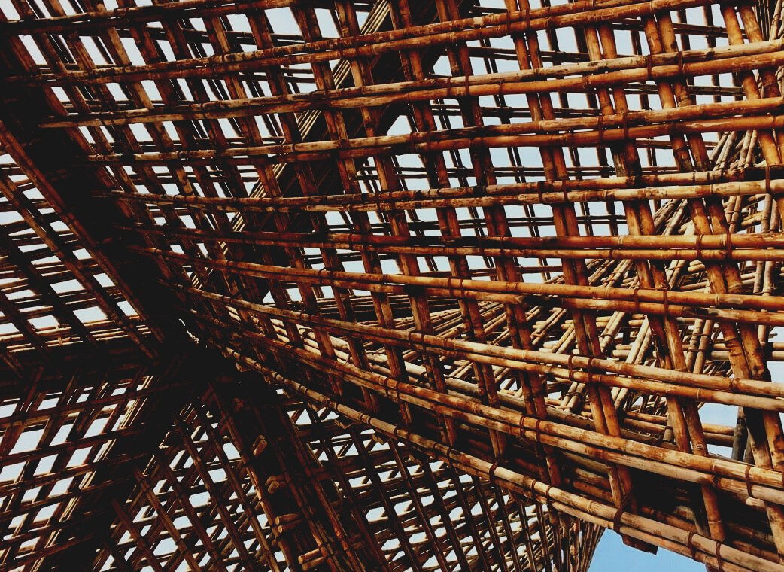

ASSESSMENT MATERIAL

Learning Unit 2
CONNECTORS AND ADHESIVES
UPWOOD
Up-skilling construction workers in wood construction methods for energy-efficient buildings

UPWOOD-PUU
Rakennustyöläisten ammattitaito energiatehokkaiden rakennusten puurakentamisenmenetelmissä

UPWOOD
Rakennustyöläisten ammattitaito energiatehokkaiden rakennusten puurakentamisenmenetelmissä

UPWOOD-PUU
Rakennustyöläisten ammattitaito energiatehokkaiden rakennusten puurakentamisenmenetelmissä

UPWOOD
Rakennustyöläisten ammattitaito energiatehokkaiden rakennusten puurakentamisenmenetelmissä

UPWOOD-PUU
Rakennustyöläisten ammattitaito energiatehokkaiden rakennusten puurakentamisenmenetelmissä

UPWOOD
Rakennustyöläisten ammattitaito energiatehokkaiden rakennusten puurakentamisenmenetelmissä

UPWOOD-PUU
Rakennustyöläisten ammattitaito energiatehokkaiden rakennusten puurakentamisenmenetelmissä

Table of contents
1. Frequently asked questions 2
2. Multiple choice questions 3
3. Case studies 3
3.1 Case study 1 3
3.2 Case study 2 3

Frequently asked questions
Question: What does wood welding mean?
Answer: Welding wood is a method of replacing gluing.
Question: What adhesives are available for different structures or structural conditions?
Answer:
- Weatherproof adhesives: Adhesives must be more durable than wood in all conditions.
- Moisture-resistant adhesives: Adhesives are suitable for indoor use where the relative humidity may be quite high.
- Adhesives for indoor use: Adhesives do not withstand water soaking and will last for a limited time in humid conditions.

Multiple choice questions
- For gluing load-bearing structures, what type of adhesive is most suitable from given options below:
  - natural glue
  - resorcinol adhesives
  - epoxy adhesives
- Phenol adhesives are
  - used in the plywood industry as a high frequency adhesive.
  - suitable for indoor use as it do not withstand water soaking.
  - classified into 4 main types, two- or one-component reaction adhesives, solvent adhesives and aqueous dispersion adhesives.
- Cohesion means
  - the internal strength of the adhesive and the adhesive joint.
  - the process where the adhesive penetrates to pores of the wood.

Case studies

Case study 1
Name at least 5 different joining techniques. Describe both pros and cons of them. Do you notice some joining techniques used in your room’s window frames or furniture?

Case study 2
Wood welding is alternative method where two pieces of wood can be joined without using glue. Describe the method of wood welding in words.

